US ENVIRONMENTAL PROTECTION AGENCY, REGION 8
BASIC WATER INFORMATION FORM

Submit form to Region 8 Drinking Water Section B
Email: R8DWU@epa.gov
Mail: US Environmental Protection Agency, Region 8
Mail code: 8WD-SDB
1595 Wynkoop Street
Denver, Colorado 80202
Attn: Inventory Team
Fax: 1-877-876-9101

If you have questions, please contact the Regulatory Oversight Coordinator, Angela Mendrala at mendrala.angela@epa.gov, or 1-800-227-8917, ext. 312-6533, directly at 303-312-6533.

Wyoming Resources:
For Wyoming Systems, the Wyoming Department of Environmental Quality (DEQ) has regulatory and permitting requirements that must be addressed prior to making alterations to public water systems. Please visit Water Quality Division of WY DEQ for more information or contact Keenan Hendon, Wastewater Section Manager, at 307-777-7075 or by e-mail at keenan.hendon2@wyo.gov.

The WY State Engineer’s Office (SEO) has requirements for new, modified or abandoned water
sources. Please visit WY State Engineer’s Office Forms for further information.

Please be advised that this document and other sources will be used to determine your status as a Public Water System.

THE FOLLOWING INFORMATION IS REQUIRED FOR YOUR WATER SYSTEM
“Serving water” includes providing individuals with drinks containing water and/or ice prepared with water. It also includes water for bathing, showering, hand washing, teeth brushing, food preparation, and dish washing. Please identify all types of facilities for which the system serves water (e.g., residential, mobile home park, restaurant, campground, resort, factory, industrial, school, medical, etc.):

WATER SYSTEM INFORMATION
Start Up Date:
Name of Facility (what you would want us to call your water system):
Facility Address:
Facility Mailing Address (if different):
General Location (Longitude/Latitude, if known):
County or Reservation in which Facility is located:
CONTACTS (Please include Business contact information below).
Note: If you prefer to use personal contact information, please note that such information is displayed on a publicly accessible portal such as the Region 8 Drinking Water Watch. (If there are additional contacts you would like to add, please include them as an attachment.)
Comments to use of Personal information:________________________________________________
Administrative Contact Information (AC) (person who should receive all EPA correspondence)
Name of Administrative Contact:
AC Title:
Mailing Address:
Business Phone #:
Business Cell Phone #:
Email Address:
Owner Information
Facility Owned By:
Owner Type (Bold or circle one): Federal, State, Local, Tribal Government; District; Corporation;
Individual Owner; Other (describe):
Owner Title:
Business Mailing Address:
Business Phone #:
Cell Phone #:
Email Address:
Operator Information
Facility’s Water System Operator:
Operator Title:
Mailing Address:
Business Phone #:
Business Cell Phone #:
Email Address:

SOURCE INFORMATION (Please indicate all your water sources. Where does your drinking water come from?)
Water Source Type | How many? | For Wells Only: Statement of Well Completion #  (If available, attach a copy) | FREQUENCY OF USE (Mark One)  P-Permanent, I-Intermittent, S-Seasonal, E-Emergency |  |  |  | Are you able to collect a sample directly from each source?
 |  |  | P | I | S | E
Well(s)
Spring(s)
Stream
Lake/Reservoir
(Include names of sources and longitude/latitude of sources, if known, when providing the schematic drawing information, page 5.)

Does your system purchase water from another water system? (circle one): ☐Yes ☐ No
If yes, from whom (Name of Water System):
If known, EPA Water System ID#:
If water is hauled, Water Hauler’s Name:
Does your System have Collection and Treatment Facilities? (circle one): ☐Yes ☐No
(If yes, please complete the Water System Facilities (WSF) section below.)

TREATMENT

Is raw water (water source) treated before consumption? | ☐Yes ☐No
If yes, what kind(s) of treatment is used  (see following and mark as appropriate)? | ☐ Chlorination ☐ UV  ☐ Filtration ☐ Ion Exchange  ☐ Softener ☐ Other:
Please describe below the steps of the treatment process in order from the water source to distribution (For more space, please include them as an attachment.)

WATER SYSTEM FACILITIES (WSF): Please indicate the types and number of water system facilities you have. Please complete a schematic drawing or sketch of your water system, showing the facilities by using the sample template found on page 5.

☐ Storage Tank (s) | ☐ Pressure Tank (s) | ☐ Ion Exchange
☐ UV | ☐ Pump (s) | ☐ Cistern
☐ Clear Well | ☐ Intake | ☐ Infiltration Gallery
☐ Other (describe):

SERVICE CONNECTIONS
A pipe or constructed conveyance for human consumption which includes drinking, bathing, and cooking, or handwashing. (Ex. metered multi-family dwelling units, single family homes, camp spigots, commercial buildings, mobile home trailers, etc.)
How many service connections do you have?
POPULATION
Does the system serve water to the public year-round (operate all year)? ☐Yes ☐No
What months are the system open to the public? Please list all months that water is served to the public. (i.e., 5/1 to 9/30, include all periods of operation): _________________________________________________
Please complete the table below by estimating the number of people water is served. The following indicates the types of people served for use in completing the table.
Resident (R) = A permanent consumer/user. Year-Round residents whose primary residence is served by the water system.
Non-Transient (NT) = A regular consumer/user. Same persons who do not reside permanently but have a regular opportunity to consume/use the water provided by the water system more than 6 months per year. (e.g., students, employees, etc.)
Transient (T) = An individual who consumes/uses the water provided by the water system but is not a permanent or regular consumer/user and consumes/uses for less than 6 months per year. (e.g., visitors, seasonal employees, attendees, etc.)
Number of days  Each Month Water is Provided |  | Number of people served daily  based on each population type summarized above
Month | # of Days | Residents  (Set Number) | Non-Transient  (Av. #Daily Users) | Transient  (Av. #Daily Users)
January (31)
February (28)
March (31)
April (30)
May (31)
June (30)
July (31)
August (31)
September (30)
October (31)
November (30)
December (31)

ADDITIONAL COMMENTS ABOUT YOUR WATER SYSTEM:

SCHEMATIC, NOT TO SCALE, OF YOUR WATER SYSTEM
Include a schematic, diagram or sketch depicting the flow from each source to the distribution. Please provide names or label all facilities (wells, storage tanks, treatment plants, etc.)
Indicate all applicable entry point sample sites.
Entry Point to the Distribution (EPTD) sample sites are places (faucet, spigot, access point) samples can be collected from. The site must be after treatment (if any), but before it reaches the distribution.

Do you have a Statement of Completion and/or Well Log for your source water? ☐Yes ☐No
Please include the Statement of Completion for all wells, if available.

Example Schematic (not to scale)
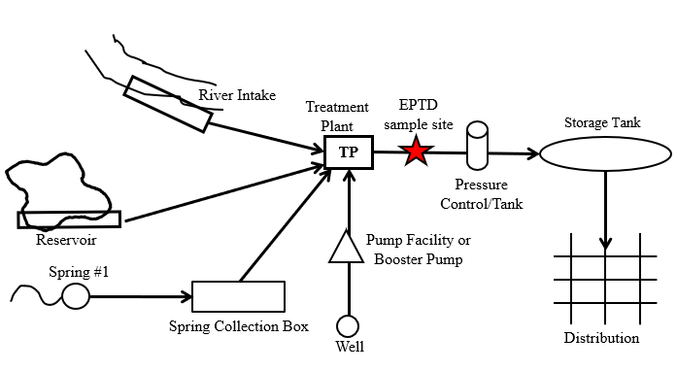

Source |  | Name  (If known) | Longitude |  |  | Latitude | Statement of Completion or Well Log (Wells only)
Well #1
Well #2
Well #3
Well #4
Spring #1
Stream
Lake/Reservoir
Collection Box
Pump Facility
Pressure Tank
Storage Tank
Treatment Plant
CERTIFICATION:
(There can be criminal sanctions for providing false, fictitious, or fraudulent statements or representations to EPA.)

I, the owner or responsible party for the water facility named above, hereby certify that all statements provided above are true and accurate to the best of my knowledge (18 USC § 1001).

 | Name (please print) |  |  |  | Title (please print)
 | Phone (please print) |  |  |  | Email (please print)
 | Signature |  |  |  | Date

