# 

# U.S. EPA Templates for Creating a National GHG Inventory System Manual

# 2. Institutional Arrangements

|  |  |
| --- | --- |
|  | **1: How to Use the Templates** |
|  | **2: Institutional Arrangements** |
|  | **3: Methods and Data Documentation** |
|  | **4: QA/QC Procedures** |
|  | **5: Key Category Analysis** |
|  | **6: Archiving System** |
|  | **7: National Inventory Improvement Plan** |

Staff member responsible for populating the template - Contact Information

|  |  |  |  |
| --- | --- | --- | --- |
| Name: |  | Organization name: |  |
| Title/Position: |  | Organization postal address: |  |
| Phone number: |  | Organization web address: |  |
| Email: |  | Organization phone number: |  |

## Introduction to Template 2. Institutional Arrangements

In the U.S. EPA's *Templates for Creating a National GHG Inventory System Manual*, this is Template 2. Its purpose is to help you establish or improve the institutional arrangements (IA) that are the foundation of your National Inventory System (NIS). The template helps countries improve current management and reporting of inventory arrangements but is also consistent with guidance under the Enhanced Transparency Framework (ETF)[1] for National GHG Inventories. Institutional arrangements are legal or procedural agreements[2] between the lead inventory agency, national inventory management team, and other institutions supporting inventory compilation, for example, by providing data, estimating emissions or removals, or performing quality control. Additional guidance on inventory institutional arrangements and quality assurance and quality control (QA/QC) that complement this Toolkit are also provided in the [2019 Refinement to the 2006 IPCC Guidelines](https://www.ipcc-nggip.iges.or.jp/public/2019rf/vol1.html), Volume 1, Chapter 1: Introduction to National GHG Inventories. For the most recent recommendations for institutional arrangements, see the UNFCCC’s [*Handbook on institutional arrangements to support MRV/transparency of climate action and support Consultative Group of Experts*](https://unfccc.int/sites/default/files/resource/Hand%20book_EN.pdf), Figure 1 on page 12 “Key components of institutional arrangements”.

Your country’s IA defines the responsibilities associated with preparing the national inventory, including which agencies and experts will provide what information and what tasks they will perform. This IA template will help your current and future inventory teams:

* Document all parties involved, and their roles and arrangements by sector;
* Archive key contacts for each sector/source of activity data;
* Record the inventory schedule and coordinate future inventories;
* Assess how existing arrangements can be improved, and document the proposed improvements;
* Distribute arrangements externally, such as to the United Nations Framework Convention on Climate Change (UNFCCC); and,
* Inform new team members of their country’s IA.

You may find that using the Memorandum of Cooperation (MoC) supporting template from EPA’s [Toolkit for Building National GHG Inventory Systems](https://www.epa.gov/ghgemissions/toolkit-building-national-ghg-inventory-systems) (“Toolkit”) helps you formalize your IA. The MoC template provides the parties to the MoC with a clear format for describing their mutual objectives, their shared and differentiated responsibilities and activities, their conditions for meeting and corresponding, their points of contact, and the duration of their arrangement.

***When the tables are complete, delete the green text throughout this template. You may use the remaining text or tables for reporting or for your National GHG Inventory System Manual.***

To complete this template, the National Inventory Coordinator (NIC) will carry out the steps enumerated below by following the instructions above each table in this template, with support from other key inventory team members as required.

|  |  |
| --- | --- |
| Step | Purpose |
| 1. Identify current core inventory compilation team and potential contributors to the inventory | To identify people who could contribute to the creation and updating of the GHG inventory. |
| 1. Identify sector roles and arrangements | To improve efficiency by stating clearly who should take the lead on creating each sector of the inventory, reporting the inventory, and checking the work. It may not be necessary to have a large number of people working on the inventory, especially for simpler inventories. Having one person in charge of the whole inventory can be helpful. You can also include here potential consumers or users of the information, if applicable. |
| 1. Identify improvements to institutional arrangements | To help your country institutionalize inventory processes and systems, and thereby improve institutional memory and make updating the inventory easier and more efficient. Continuous improvement should be a theme that underpins the inventory cycle. |

### STEP 1: Identify current inventory agencies or staff in Tables 2-1 and 2-2.

* In Table 2-1, record the name of the agency or organization that will lead inventory compilation, your country’s UNFCCC focal point and focal point agency, and the arrangements or relationship between the lead inventory agency and UNFCCC focal point agency. Add rows as necessary.

Table 2-1: Designated national GHG inventory agency and UNFCCC focal point

| Designated National GHG Inventory Compilation  Agency/Organization | UNFCCC Focal Point (Name) and UNFCCC Focal Point Agency | Arrangements/relationship between Inventory Agency/Organization and UNFCCC Focal Point Agency, if different |
| --- | --- | --- |
|  |  |  |

* In Table 2-2, list core inventory coordination and compilation teams.
  + The national inventory coordination and compilation team may have just a few or many leads, coordinators, or staff. One of these individuals (or perhaps a small team of them) should assume the role of National Inventory Coordinator (NIC) and coordinate the development of the national GHG inventory. For a list of the typical responsibilities of the NIC, see the supporting guide on National Inventory Coordinator: Responsibilities and Qualifications in EPA’s [Toolkit](https://www.epa.gov/ghgemissions/toolkit-building-national-ghg-inventory-systems).
  + For a list of typical responsibilities of the sector leads, see the supporting guide on Sector Lead Roles and Responsibilities for each sector (Energy, IPPU, Agriculture, LULUCF, and Waste) in EPA’s [Toolkit](https://www.epa.gov/ghgemissions/toolkit-building-national-ghg-inventory-systems).
  + The **Role column** is prefilled with typical inventory roles. You may keep them or modify them according to your national circumstances. For example, you may combine roles, add roles, or remove roles. You may also assign multiple roles to the same person. For example, the three Energy sector leads in the table may be the same person.
  + In the **Comments related to role column**, you may wish to note the status of institutional arrangements. Also, you may find it effective to use the Memorandum of Cooperation (MoC) supporting template from EPA’s [Toolkit](https://www.epa.gov/ghgemissions/toolkit-building-national-ghg-inventory-systems) to formalize the assignment of responsibilities for sector leadership and to record the title of each such MoC in the Comments related to role column.
  + For a detailed list of emission/removal categories according to the 2006 IPCC Guidelines, see Appendix 1. If your country assigns inventory leads at the category or subcategory level, you may wish to record their names in that list.
  + If your institutional structure is more easily communicated with a diagram, you may insert one in the box below the table.

Table 2-2: National Inventory Leads/Coordinators

| Role | Name | Organization | Contact information | Comments related to role |
| --- | --- | --- | --- | --- |
| National Inventory Coordinator |  |  |  |  |
| Energy (Stationary sources) Sector Lead |  |  |  |  |
| Energy (Mobile sources) Sector Lead |  |  |  |  |
| Energy (Fugitive sources) Sector Lead |  |  |  |  |
| IPPU Sector Lead |  |  |  |  |
| Agriculture Sector Lead |  |  |  |  |
| Land Use, Land-Use Change, and Forestry (LULUCF) Sector Lead |  |  |  |  |
| Waste Sector Lead |  |  |  |  |
| Archive (Data and Document) Manager/Coordinator |  |  |  |  |
| QA/QC Coordinator |  |  |  |  |
| Uncertainty Analysis Coordinator |  |  |  |  |
| Other: e.g., GHG Emissions Policy Specialist who tracks capacity building efforts and IPCC processes or may use inventory information for mitigation tracking |  |  |  |  |

**Institutional arrangements chart**

In the box below (Figure 1), you may insert a diagram showing the structure of your country’s institutional arrangements for the compilation and reporting of its GHG inventory. The diagram should include inventory stakeholders outside of the core coordination/compilation team, such as the ministries, departments and agencies, non-governmental organizations (NGOs), civil society organizations (CSOs), or others that participate in compiling the national GHG inventory or are important consumers of the information. Clearly indicate the hierarchy and relationships between them in the diagram. It should also show the lead inventory agency, the agency responsible for inventory management and reporting, the GHG inventory sector leads (or sector lead agencies), and the person responsible for coordinating QA/QC and improvement activities.

Three sample diagrams are provided below the box. The first (Figure 2) shows Chile’s institutional arrangements, while the second (Figure 3) and third (Figure 4) show those of the U.S and U.K. These examples should be removed once you have updated this template with a diagram illustrating the structure of your country’s arrangements for compilation and reporting of the GHG inventory.

Figure 1. Institutional Arrangements of [insert name of your country]

|  |
| --- |
|  |

Figure 2. Institutional Arrangements of Chile. [(*click here for more information)*](https://unfccc.int/documents/193971)

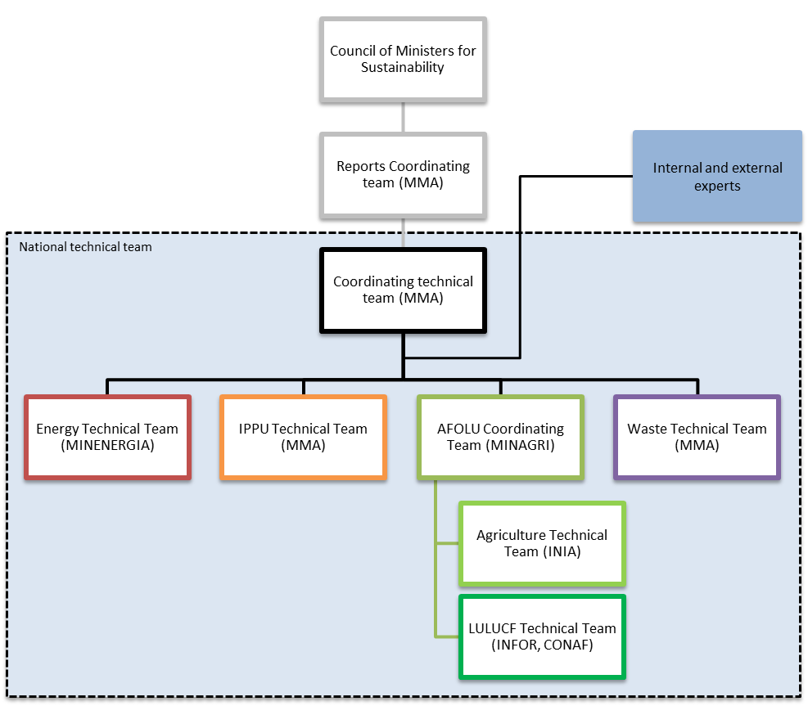

Source: Technical Team Coordinator, Ministry of Environment (Ministerio del Medio Ambiente (MMA))

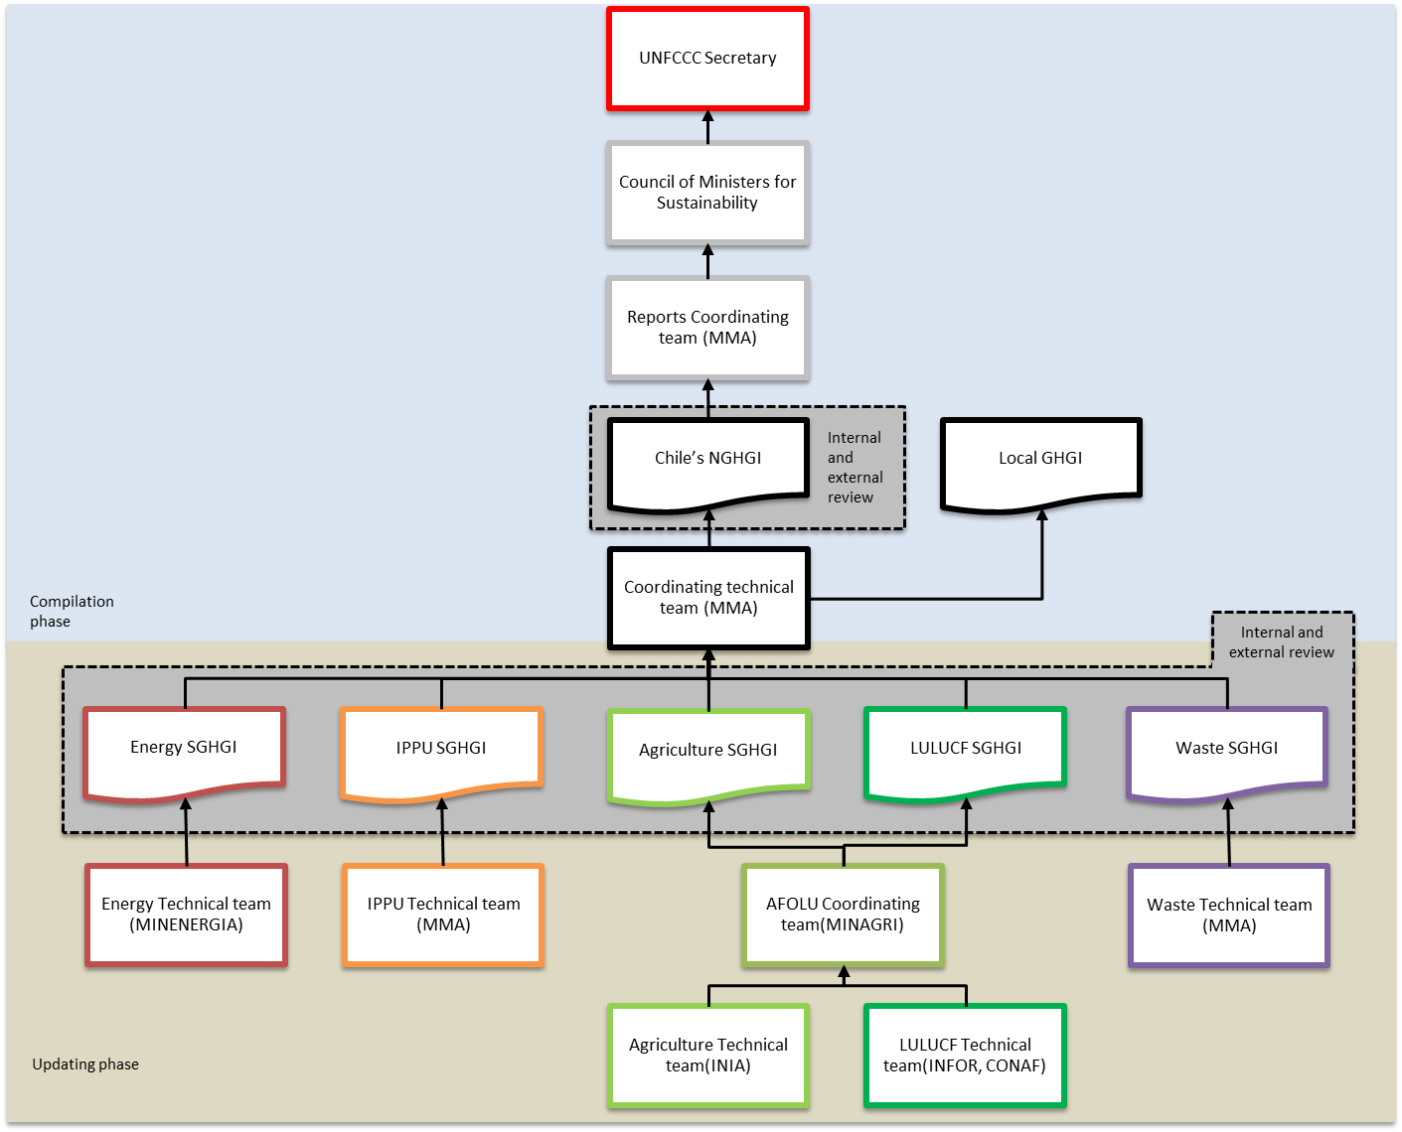

Figure 3. Institutional Arrangements of the U.S. ([*click here for more information*](https://www.epa.gov/ghgemissions/inventory-us-greenhouse-gas-emissions-and-sinks-1990-2019)*)*

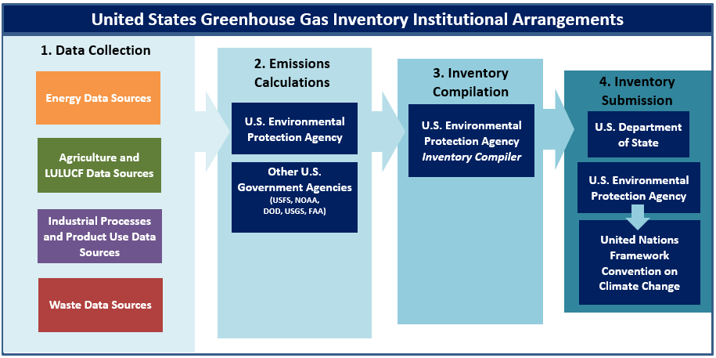

*U.S. GHG Inventory Data Sources by Sector*

|  |  |  |  |
| --- | --- | --- | --- |
| **Energy** | **Agriculture and LULUCF** | **IPPU** | **Waste** |
| Energy Information Administration | EPA Office of Land and Emergency Management | EPA Greenhouse Gas Reporting Program (GHGRP) | EPA Greenhouse Gas Reporting Program (GHGRP) |
| U.S. Department of Commerce – Bureau of the Census | Alaska Department of Natural Resources | American Chemistry Council (ACC) | EPA Office of Land and Emergency Management |
| U.S. Department of Defense – Defense Logistics Agency | National Oceanic and Atmospheric Administration (NOAA) | U.S. Geological Survey (USGS) National Minerals Information Center | Data from research studies, trade publications, and industry associations |
| Federal Highway Administration | Association of American Plant Food Control Officials (AAPFCO) | American Iron and Steel Institute (AISI) |  |
| EPA Acid Rain Program | U.S. Census Bureau | U.S. Aluminum Association |  |
| EPA Office of Transportation and Air Quality MOVES Model | USDA Animal and Plant Health Inspection Service (APHIS) | U.S. International Trade Commission (USITC) |  |
| EPA Greenhouse Gas Reporting Program (GHGRP) | EPA Office of Air and Radiation | Air-Conditioning, Heating, and Refrigeration Institute |  |
| U.S. Department of Labor – Mine Safety and Health Administration | U.S. Department of Agriculture (USDA) National Agricultural Statistics Service and Agricultural Research Service | Data from other U.S. government agencies, research studies, trade publications, and industry associations |  |
| American Association of Railroads | USDA U.S. Forest Service Forest Inventory and Analysis Program |  |  |
| American Public Transportation Association | USDA Natural Resource Conservation Service (NRCS) |  |  |
| U.S. Department of Homeland Security | USDA Economic Research Service (ERS) |  |  |
| U.S. Department of Energy and its National Laboratories | USDA Farm Service Agency (FSA) |  |  |
| Federal Aviation Administration | U.S. Geological Survey (USGS) |  |  |
| U.S. Department of Transportation &Bureau of Transportation Statistics | U.S. Department of the Interior (DOE), Bureau of Land Management (BLM) |  |  |
| Data from research studies, trade publications, and industry associations | Data from research studies, trade publications, and industry associations |  |  |

### Flow diagram of institutional arrangements in the UKSTEP 2: Identify sector roles and arrangements

Figure 4. Institutional Arrangements of the U.K. ([*click here for more information*](http://naei.beis.gov.uk/about/national-inventory-system)*)*

* In Table 2-3, below, you will identify arrangements for obtaining, compiling, reviewing, and reporting inventory data by sector by recording information about the contacts/experts for inventory development for each sector.

Complete one version of this table for each of the following sectors. You may divide these sectors into subsectors, or combine them, according to your needs. For example:

* + Energy (stationary sources)
  + Energy (mobile sources)
  + Energy (fugitive sources)
  + Industrial Processes and Product Use
  + Agriculture
  + Land Use, Land-Use Change, and Forestry (LULUCF)Waste
* **Role** column instructions:
  + This column is prefilled with typical sector-specific inventory roles. You may keep them or modify them according to your national circumstances. For example, you may combine roles, add roles, or remove roles. You may also assign multiple roles to the same person.
  + Note that the first two roles, “Technical Coordinator” and “Consultant(s) compiling estimates,” may be the source/sector lead named in Table 2-2 or Appendix 1.
  + If you plan to engage consultants to compile estimates or to serve other roles during inventory preparation, you may find it helpful to first outline the consultants’ responsibilities using the National GHG Inventory Scope of Work supporting template in EPA’s [Toolkit](https://www.epa.gov/ghgemissions/toolkit-building-national-ghg-inventory-systems).
* **Comments** column instructions:
  + Provide information about, for example:
    - the status of the institutional arrangements,
    - any special knowledge or skills that the assigned staff has,
    - the responsibilities of each role,
    - how different roles will collaborate, or
    - the degree to which the assigned staff participates in GHG inventory meetings (e.g., low, medium, or high participation).
  + This information will serve as a reference for future GHG inventory compilers. If necessary, explain in detail how the arrangements were established. For example, if you used the Memorandum of Cooperation (MoC) supporting template from EPA’s [Toolkit](https://www.epa.gov/ghgemissions/toolkit-building-national-ghg-inventory-systems) to formalize the assignment of responsibilities in the table below, you should cite each specific MoU in effect.
* **Mechanism of data collection** row instructions:Describe the strategies used to collect the necessary inventory data from an organization. Address the following questions and add additional comments as necessary:
  + When and how was the request for data made? At what level of management was the request made?
  + Were there difficulties in obtaining the data for the inventory? If there were, what were they, and how can they be addressed? Was the organization motivated to share its data and information with the inventory agency? If so, how?
  + Is there a formal legal contract between the organizations (e.g., the Memorandum of Cooperation (MoC) supporting template from EPA’s [Toolkit](https://www.epa.gov/ghgemissions/toolkit-building-national-ghg-inventory-systems))? Is it an informal arrangement (e.g., written or verbal communication with staff) given it is collected regularly for other purposes?
  + Was there a meeting with the experts, data providers, and other key contributors to explain the background and purpose of the inventory? Did the person or organization participate in meetings on GHG inventory development?
  + Please note that information on institutions providing data, such as the Ministry of Energy, Bureau of Statistics, or similar institutions noted in this table, might also be covered in Template 3, Methods and Data Documentation. Recording this information in only one of the templates is acceptable. If you record information on data providers here and not in Template 3, you may wish to include a note in Template 3 such as, “For information on data providers, please see 2. Institutional Arrangements.”

Table 2-3: Institutional arrangements for [sector, e.g., Energy (stationary sources)]

| Role | Name | Organization | Contact information | Comments |
| --- | --- | --- | --- | --- |
| Technical coordinator |  |  |  |  |
| Consultant(s) compiling estimates |  |  |  |  |
| Expert reviewer(s) |  |  |  |  |
| Institution(s) providing data |  |  |  |  |
| Reporting Manager(s) |  |  |  |  |
| QA/QC Manager(s) |  |  |  |  |
| Uncertainty Assessment Manager(s) |  |  |  |  |
| Other |  |  |  |  |
| Mechanism of data collection: | | | | |
|  | | | | |

### STEP 3: Complete Table 2-4 and Table 2.5 to document improvement options for institutional arrangements

* **Strengths in management structure of national GHG inventory system** Table 2.4 instructions: For each sector, describe in what way institutional arrangements that support inventory preparation are well established and likely do not require improvement. For example, communications between the institutions may be active and positive, the institutions may have worked together before and have a good working relationship, or data may be collected and managed adequately.
* **Potential improvement** Table 2.5 instructions: Taking key categories and existing institutional arrangements within each sector into account, describe potential ways to enhance those institutional arrangements. Consider whether any important tasks for inventory preparation have not been assigned or delegated, and determine whether they could be. Also consider whether the Memorandum of Cooperation (MoC) supporting template from EPA’s [Toolkit](https://www.epa.gov/ghgemissions/toolkit-building-national-ghg-inventory-systems) may help improve the institutional arrangements for each sector. Where you decide it may be helpful, record this decision as a needed step in this column.
* Record these improvements in Template 7, National Inventory Improvement Plan

Table 2.4 - Strengths in management structure of national GHG inventory system

|  |  |  |  |
| --- | --- | --- | --- |
| Sector | Strengths in management structure of national GHG inventory system | Key conditions for maintaining strengths | Staff in charge of managing arrangements |
| Energy (stationary sources) |  |  |  |
| Energy (mobile sources) |  |  |  |
| Energy (fugitive sources) |  |  |  |
| IPPU |  |  |  |
| Agriculture |  |  |  |
| Land Use, Land-Use Change, and Forestry (LULUCF) |  |  |  |
| Waste |  |  |  |
| Other *(Optional)* |  |  |  |

Table 2.5: Potential improvements in management structure of national GHG inventory system

|  |  |  |  |
| --- | --- | --- | --- |
| Sector | Potential improvement | Staff in charge of leading this improvement | Priority of improvement  (Low, Medium, High) |
| Energy (stationary sources) |  |  |  |
| Energy (mobile sources) |  |  |  |
| Energy (fugitive sources) |  |  |  |
| IPPU |  |  |  |
| Agriculture |  |  |  |
| Land Use, Land-Use Change, and Forestry (LULUCF) |  |  |  |
| Waste |  |  |  |
| Other *(Optional)* |  |  |  |

### 

**Appendix 1: Detailed list of GHG categories from the 20 06 IPCC Guidelines, by sector and category lead**[3]

| **Greenhouse Gas Categories** | | **Category Lead** |
| --- | --- | --- |
| **1** | **Energy** |  |
| 1.A | Fuel combustion activities |  |
| 1.A.1 | Energy industries |  |
| 1.A.2 | Manufacturing industries and construction |  |
| 1.A.3 | Transport |  |
| 1.A.4 | Other sectors |  |
| 1.A.5 | Non-specified |  |
| 1.B | Fugitive emissions from fuels |  |
| 1.B.1 | Solid fuels |  |
| 1.B.2 | Oil and natural gas |  |
| 1.B.3 | Other emissions from energy production |  |
| 1.C | Carbon dioxide transport and storage |  |
| 1.C.1 | Transport of CO2 |  |
| 1.C.2  1.C.3 | Injection and storage  Other |  |
| **2** | **Industrial processes and product use** |  |
| 2.A | Mineral industry |  |
| 2.A.1 | Cement production |  |
| 2.A.2 | Lime production |  |
| 2.A.3 | Glass production |  |
| 2.A.4 | Other process uses of carbonates |  |
| 2.A.5 | Other (please specify) |  |
| 2.B | Chemical industry |  |
| 2.B.1 | Ammonia production |  |
| 2.B.2 | Nitric acid production |  |
| 2.B.3 | Adipic acid production |  |
| 2.B.4 | Caprolactam, glyoxal and glyoxylic acid production |  |
| 2.B.5 | Carbide production |  |
| 2.B.6 | Titanium dioxide production |  |
| 2.B.7 | Soda ash production |  |
| 2.B.8 | Petrochemical and carbon black production |  |
| 2.B.9 | Fluorochemical production |  |
| 2.B.10 | Other (please specify)[4] |  |
| 2.C | Metal industry |  |
| 2.C.1 | Iron and steel production |  |
| 2.C.2 | Ferroalloys production |  |
| 2.C.3 | Aluminum production |  |
| 2.C.4 | Magnesium production |  |
| 2.C.5 | Lead production |  |
| 2.C.6 | Zinc production |  |
| 2.C.7 | Other (please specify)[5] |  |
| 2.D | Non-energy products from fuels and solvent use |  |
| 2.D.1 | Lubricant use |  |
| 2.D.2 | Paraffin wax use |  |
| 2.D.3 | Solvent use |  |
| 2.D.4 | Other (please specify) |  |
| 2.E | Electronics industry |  |
| 2.E.1 | Integrated circuit or semiconductor |  |
| 2.E.2 | TFT flat panel display |  |
| 2.E.3 | Photovoltaics |  |
| 2.E.4 | Heat transfer fluid |  |
| 2.E.5 | Other (please specify)[6] |  |
| 2.F | Product uses as substitutes for ozone depleting substances |  |
| 2.F.1 | Refrigeration and air conditioning |  |
| 2.F.2 | Foam blowing agents |  |
| 2.F.3 | Fire protection |  |
| 2.F.4 | Aerosols |  |
| 2.F.5 | Solvents |  |
| 2.F.6 | Other applications (please specify) |  |
| 2.G | Other product manufacture and use |  |
| 2.G.1 | Electrical equipment |  |
| 2.G.2 | SF6 and PFCs from Other Product Uses |  |
| 2.G.3 | N2O from product uses |  |
| 2.G.4 | Other (please specify) |  |
| 2.H | Other |  |
| 2.H.1 | Pulp and paper industry |  |
| 2.H.2 | Food and beverages industry |  |
| 2.H.3 | Other (please specify) |  |
| **3** | **Agriculture, forestry, and other land use** |  |
| 3.A | Livestock |  |
| 3.A.1 | Enteric fermentation |  |
| 3.A.2 | Manure management |  |
| 3.B | Land |  |
| 3.B.1 | Forest land |  |
| 3.B.2 | Cropland |  |
| 3.B.3 | Grassland |  |
| 3.B.4 | Wetlands |  |
| 3.B.5 | Settlements |  |
| 3.B.6 | Other land |  |
| 3.C | Aggregate sources of non-CO2 emissions sources on land |  |
| 3.C.1 | Emissions from biomass burning |  |
| 3.C.2 | Liming |  |
| 3.C.3 | Urea application |  |
| 3.C.4 | Direct N2O emissions from managed soils |  |
| 3.C.5 | Indirect N2O emissions from managed soils |  |
| 3.C.6 | Indirect N2O emissions from manure management |  |
| 3.C.7 | Rice cultivations |  |
| 3.C.8 | Other (please specify) |  |
| 3.D | Other |  |
| 3.D.1 | Harvested wood products |  |
| 3.D.2 | Other (please specify) |  |
| **4** | **Waste** |  |
| 4.A | Solid waste disposal |  |
| 4.A.1 | Managed waste disposal sites |  |
| 4.A.2 | Unmanaged waste disposal sites |  |
| 4.A.3 | Uncategorized waste disposal sites |  |
| 4.B | Biological treatment of solid waste |  |
| 4.C | Incineration and open burning of waste |  |
| 4.C.1 | Waste incineration |  |
| 4.C.2 | Open burning of waste |  |
| 4.D | Wastewater treatment and discharge |  |
| 4.D.1 | Domestic wastewater treatment and discharge |  |
| 4.D.2 | Industrial wastewater treatment and discharge |  |
| 4.E | Other (please specify) |  |
| **5** | **Other** |  |
| 5.A | Indirect N2O and CO2 |  |
| 5.B | Other (please specify, e.g. precursor emissions of NOX, CO, NMVOC, and SOX) |  |

1. See 18/CMA.1, Modalities, Procedures and Guidelines (MPGs), Annex Chapter II, [Section B. National Circumstances and Institutional Arrangements](https://unfccc.int/sites/default/files/resource/CMA2018_03a02E.pdf) guidance for National Greenhouse Gas Inventory Report (available at http://unfccc.int/decisions).
2. Most arrangements will be formal, but a situation could exist where an arrangement is informal. The informal arrangements may evolve to be formal overtime. Depending on national circumstances, arrangements with data suppliers may initially be informal because the data is already collected regularly for other purposes (e.g. economic statistics, energy data, etc.). The informal arrangements may involve regular consultation with an institutional program and dedicated point of contact to understand trends, completeness, etc. The point of contact should be included in planning meetings, etc. to understand when data will be required and any required formats.
3. This is the person responsible for developing the GHG estimates for each category.
4. If you are also using the 2019 Refinement, you may be including this additional category: hydrogen production.
5. If you are also using the 2019 Refinement, you may be including this additional category: rare earth metals production.
6. If you are also using the 2019 Refinement, you may be including this additional category: microelectromechanical systems (MEMS).