Communication Materials on Climate Change, Health, and People with Disabilities
Summary Points from the U.S. Climate and Health Assessment

Background

In April 2016, the United States Global Change Research Program (USGCRP) released a new assessment report about a growing threat to public health: climate change. Drawing upon decades of research on the physical science of climate change, The Impacts of Climate Change on Human Health in the United States: A Scientific Assessment presents information on the increased risks that climate change poses to human health.
The U.S. Climate and Health Assessment significantly advances what we know about the impacts of climate change on public health. It also highlights factors that make some individuals and communities especially vulnerable to these threats.
During public forums, scientific conferences, webinars and meetings, as well as in public comments submitted during the development of the U.S. Climate and Health Assessment, the U.S. Environmental Protection Agency (EPA) received multiple requests for summary materials that would help communicate the message that certain populations are disproportionately vulnerable to the health impacts of climate change. In response to these requests, EPA has summarized information from the U.S. Climate and Health Assessment focusing on impacts of climate change on the health on eight populations of concern:
- Communities with environmental justice concerns
- Indigenous peoples
- Pregnant women
- Children
- Older Adults
- Occupational groups
- People with pre-existing health conditions
- People with disabilities
For each of these groups, EPA has compiled a suite of communication materials for use by stakeholders who are looking for concise, accurate language to aid conversations with their constituent groups on climate and health impacts. Communication materials specific to each of the populations listed above, as well as general summary messages on climate change, health, and populations of concern, can be found here: https://www.epa.gov/climate-impacts/climate-change-health-and-populations-concern.

How to Use These Materials
Public health workers, local and state government officials, educators, advocacy organizations, and community leaders have a critical voice in communicating important health information to the people who need it the most.
In response to request from stakeholders, EPA has prepared materials to help communicate key messages on the impacts of climate change on human health. The information in these materials is tailored for anyone interested in environmental health risks to people with disabilities.
These communication materials, derived from the U.S. Climate and Health Assessment, include:
- A factsheet, in English, Spanish, and large font size, available online and as a printable PDF.
- A customizable PowerPoint presentation.
- High-Resolution images.
- An introductory paragraph on vulnerable populations
- Key points about risks to people with disabilities.
- Shorter messages about risks to people with disabilities.
Because the availability of good information leads to better public health and environmental protection, these materials are designed to be used or modified to inform conversations about climate change and health impacts to vulnerable populations. For questions or assistance, please email climatehealth@epa.gov.

Electronic and Print Resources
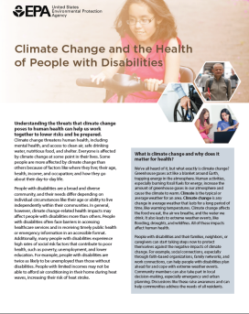 | A Factsheet on Climate Change and the Health of People with Disabilities (four pages) is available in web and print formats, in English, Spanish, and large font size. | https://www.epa.gov/climate-impacts/communicating-vulnerabilities-climate-change-people-disabilities
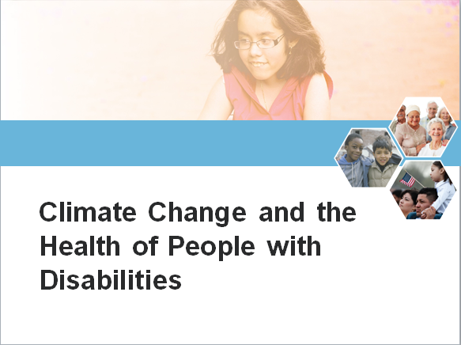 | A customizable PowerPoint template with talking points can be used at conferences and meetings as a standalone presentation or added to existing slides.
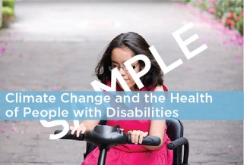 | High Resolution Images can be compelling when paired with other outreach materials. Images are sized for various uses and platforms.
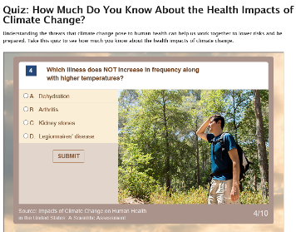 | A clickable map with examples of state-by-state health impacts and resources to prepare and respond to climate threats | https://www.epa.gov/climate-impacts/climate-change-and-human-health-risks-your-state
 | A ten-question interactive online quiz- challenge your friends on social media! | https://www.epa.gov/climate-impacts/quiz-how-much-do-you-know-about-health-impacts-climate-change
 | Climate Change Impacts Website | https://www.epa.gov/climate-impacts
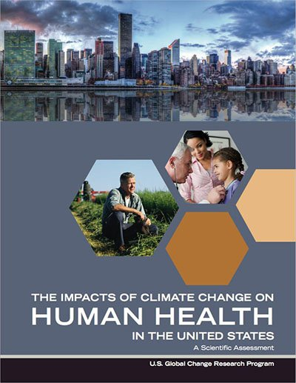 | U.S. Climate and Health Assessment Chapter 9: Populations of concern | https://health2016.globalchange.gov/populations-concern
Summary text
The language below can be used or modified for different formats or mediums, to communicate how climate change threatens the health of people with disabilities.

Introductory Paragraph
People with disabilities are especially vulnerable to the impacts of climate change because they often face barriers in accessing healthcare services and receiving timely public health or emergency information in an accessible format. The United States Global Change Research Program’s (USGCRP) new report, The Impacts of Climate Change on Human Health in the United States: A Scientific Assessment, presents information on the factors that make people with disabilities more sensitive to environmental hazards related to climate change. More information about these impacts and disparities, as well as outreach and communication materials including a factsheet (in English, Spanish, and large font), summary key points, a customizable PowerPoint presentation, and high-resolution images, can be found here: https://www.epa.gov/climate-impacts/communicating-vulnerabilities-climate-change-people-disabilities

Key Points
- Climate change affects the food we eat, the air we breathe, and the water we drink. It also leads to extreme weather events, like flooding, droughts, and wildfires. All of these impacts have an effect on human health.

- The United States Global Change Research Program’s (USGCRP) new report, The Impacts of Climate Change on Human Health in the United States: A Scientific Assessment, presents information on the increased risks that climate change poses to human health and welfare and highlights factors that make some individuals and communities especially vulnerable.

- People with disabilities are vulnerable to climate change-related health impacts because they often face barriers in accessing healthcare services and receiving timely public health or emergency information in an accessible format. A new factsheet from the U.S. Environmental Protection Agency, Climate Change and the Health of People with Disabilities presents information on the factors that make people with disabilities more sensitive to environmental hazards related to climate change.

- People with disabilities may also be more vulnerable to climate change-related health impacts than others because they often face high rates of social risk factors that contribute to poor health, such as poverty, unemployment, and lower education. For example, people with disabilities are twice as likely to be unemployed than those without disabilities.

- During extreme events, people with disabilities may face physical challenges associated with evacuations, which can make health impacts worse, especially if local emergency response plans do not adequately anticipate and address the special needs of these populations.

- Understanding the threats that climate change poses to human health can help us work together to lower risks and be prepared. People with disabilities and their families, neighbors, or caregivers can start taking steps now to protect themselves against the negative impacts of climate change.

Shorter Messages
- Climate change-related health impacts may affect people with disabilities more than others. go.usa.gov/xkspy
- People with disabilities have high rates of illness, injury, or death from extreme weather events. go.usa.gov/xkspy
- People with disabilities are especially susceptible to heat-related illness and death. go.usa.gov/xkspy
- If an extreme event requires evacuation, people with disabilities are at high risk for physical and mental health impacts. go.usa.gov/xkspy
- People with disabilities may have reduced ability to receive or act upon emergency instructions during extreme events. go.usa.gov/xkspy

Shorter Messages (Spanish)
- Los impactos en la salud relacionados con el cambio climático pueden afectar más a las personas con discapacidades que a las demás. go.usa.gov/xkspy
- Las personas con discapacidades tienen tasas altas de enfermedad, lesiones o muerte debido a eventos extremos del clima. go.usa.gov/xkspy
- Las personas con discapacidades son especialmente susceptibles a las enfermedades y la muerte resultantes del calor. go.usa.gov/xkspy
- Si un evento extremo exige salir de un lugar, las personas con discapacidades tienen mayor riesgo de sufrir impactos en su salud mental y física. go.usa.gov/xkspy
- Las personas con discapacidades quizá tengan menos habilidad para recibir o seguir instrucciones de emergencia durante eventos extremos. go.usa.gov/xkspy

