Lean Project Report-Out Presentation Template
About the Template
This resource describes a template for developing a standard Lean Project Report Out presentation. Most Lean events or projects end with a presentation to report on accomplishments and any pending team activities. Each project is unique, so feel free to customize slides as needed to capture the project.

This template includes an appendix of several optional slides that you may choose to include in your presentation. You can move those slides into any point in the presentation if you decide to use them. You may also alter the order of any of the other slides as appropriate.

Overview of Template Slides
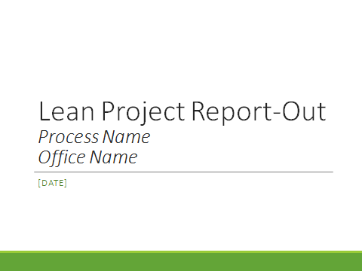
Slide 0: Title Slide
- Process and Office name, e.g. “Region 7 SIP Kaizen Project”

- Record the date of the report-out presentation.

Slide 1: Project Summary
- Using information from the Team Charter in addition to information from the project, briefly describe what the process is, why it needed to be leaned, and a few high-level bullet points about the benefits and results from the process improvement project.
- As you develop your presentation, you can skip this slide and come back to fill it in after you have completed the rest of the presentation, as it may be easier to write an project summary after you have worked through the rest of the slides.
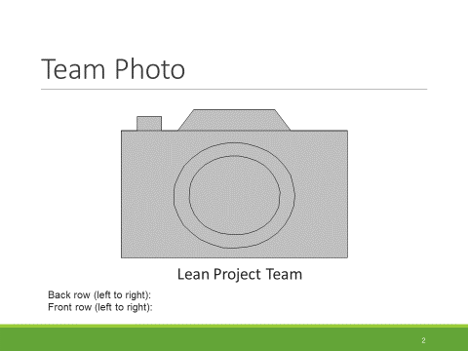
Slide 2: Team Photo
- Insert a photo of the lean project team.
- Note: Could also use the photo on the title slide.

Slide 3: Participants
- List the project or project participants, including their functions in the process (e.g., supervisor, quality control, etc.).
- If appropriate, you can add participants’ titles to this slide as well. Consider adding a second slide to allow adequate space to list all members and observers.
- This info is included in the Team Charter.

Slide 4: Project Scope and Boundaries
State the project scope, which is in the Team Charter (if modified during the project/project, include these changes). The scope should include the process start and end points. If the team has decided that anything is specifically out-of-scope or other boundary conditions, mention those here.
- Example: This project examined the process from the time the States and Region negotiate and agree on performance criteria and measures to when EPA completes a performance report. Out of scope: Changes to regulations.
Slide 5: Goals and Objectives
- List the quantitative and qualitative goals and objectives of the project. You can draw these from the Team Charter.
- Lean project goals are statements of intent that focus team attention on the areas in which improvement results are desired.
- Lean project objectives differ from goals in that they are specific and measurable. Objectives should include the goal, metrics associated with the goal, targets, and timeframes.
Examples:
- Goal: Improve participant satisfaction throughout the process
- Objective: Reduce lead time by 50%

Slide 6: Current State Process MAp
Insert a photo of the current state process that the team developed.

Slide 7: Process Changes Made
List the process changes and improvements that the team accomplished during the project or project. Use multiple slides as needed.
Examples:
- Created a standard work checklist
- Eliminated unnecessary approvals
- Trained staff on the new process to coordinate permit and enforcement reviews
- Developed a spreadsheet to visually track the process status

Slide 8: Recommendations
List any other process changes and improvements the team will undertake after the project. Use multiple slides as needed.
Examples:
- Coordinate with others to share successes and lessons from this project
- Formalize the standard work developed in the project for the new process
- Educate stakeholders about the new process

Slide 9: Future State Process Map

Insert a photo of the future state process that the team developed.

Slide 10: Results

Fill in the current and future state metrics as appropriate for your project. Note the percent change (with up/down arrows, if desired) to show how the future state will be an improvement over the current state.

Example Process Metrics and Definitions:
- Lead time (business days): Lead time is the total time from the start of the process to the end point of delivering a service to a customer, including wait time. The start and end of the process are defined in the planning stage when you determine your project scope: beginning with the “trigger” that sets the process in motion and ending with the final step in the process.
  - Example: For a permitting process, lead time would be the time between when a permit application is submitted and when a customer receives a permit (e.g., 50 business days).
- Processing time (hours or days): This metric measures the time to complete the process, excluding wait time. Processing Time, like Lead Time, is an effective metric for telling the improvement story for projects focused on reducing time-related waste in their processes.
  - Example: The number of working hours when permit reviewers actually review the permit application (e.g., 20 hours), excluding the time when it is waiting to be reviewed.
- Number of Process Steps: Every process is comprised of a series of tasks or activities, each considered to be a "step" in the process. Improving a process commonly changes the overall number of process steps. Often, the number of process steps decreases as a result of Lean, but increases are possible if steps are added to improve product quality or reduce variation.
- Percent Complete and Accurate (%C&A): Percent of occurrences that work in process (e.g., a permit application) released to the next step does not require a downstream customer to make corrections or request information that should have been provided initially. For each process step, ask what percentage of the product/work-in-process is complete and accurate the first time it is received. This is the %C&A. Multiply those values together to get the rolling %C&A for the entire process. For more information, see the Lean Metrics Guide: https://www.epa.gov/lean/lean-government-metrics-guide
- Participant Satisfaction: Participants choose from the options “1, 2, 3, 4, 5” with 1 defined as “Very dissatisfied” and 5 defined as “Very satisfied” as they respond the following questions:
  - Beginning of project: “How satisfied are you with the current process?”
  - End of project: “How satisfied are you with the proposed new process?”
  - Average the ratings across all participants in the project to achieve the current state and future state values.
- You may also wish to report on other results, depending on your goals and objectives for the project.

Slide 11: Implementation Plan: Next Steps

Describe the steps that the team will take to implement the process. Include the name of the person who will be responsible for leading each implementation item. If you cannot fit the full implementation plan on the slide, you could select key actions to provide an example of how the changes will be implemented, or present the actions that will be implemented first.
- See the Lean Project Implementation Plan Template for more details on how to show the status of each action.

As part of your implementation plan, be sure to clarify follow-up roles. Who will lead and manage the overall follow-up and implementation effort? What roles will each person serve in the follow-up effort, and who will be responsible for which tasks? It will be critical to actively manage the follow-through after the Lean event. The implementation plan helps you clarify these roles and set a timeline for completion.

Action Item Examples:
- Modify the IT Tracking System for use in property inventory
- Purchase new equipment
- Create a checklist of tasks to complete the annual property inventory
- Communicate with colleagues in EPA and state offices about the new process
- Conduct a briefing for staff not at the Lean event on the new process
Slide 12: Benefits of the Future State
Examples:
- Improved communication between offices
- Faster time to approve permit applications
- Reduced frustration from everyone involved in the process

Slide 13: Lessons Learned

Describe lessons learned about the lean process.

Examples:
- Project pre-work is key to the success of the project
- The size of the scope is important, because there wasn’t enough time to discuss everything during the rapid improvement event
- It makes a big difference when senior managers actively support the project
Slides 14-17: Close-OUt and Beginning of Optional Slides
Optional Slides 18-19: Implementation/Tracking Progress
Optional slides to discuss how follow-up/implementation of the implementation plan will happen. Include dates of follow-up meetings, information about the implementation team leader and what support is needed from managers and senior leadership.

Optional Slide 20: Project Quotes

If appropriate, include quotes and/or project/project feedback from team members.

Examples:
- “The LEAN process provided a rare opportunity for a large team of people, customers and keepers of the process, to take the process apart piece by piece and examine it for redundancy, relevancy and efficiency.”
- “One of the most gratifying parts of the process was that, once the process was laid out and the LEAN team could see the entire process, there was a greater appreciation of the complexity of the process and the fiscal responsibilities that are handled during the day-to-day fees work.”
- “We still have some laborious processes related to fees that this team could not resolve.”

Optional Slide 21: Parking Lot

