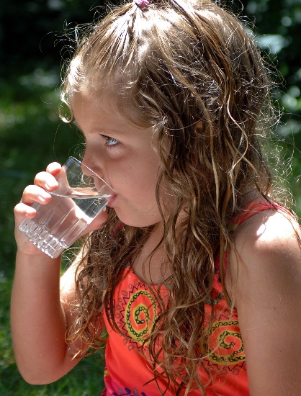
Assistance from Partner Organizations
Ensure that communications with partners are documented and kept in a centrally accessible repository, either online or in the facility. Documenting who the school or child care facility is working with and how partners are supporting the program will provide staff with additional points of contact if additional information is needed.

Use the table to identify and record contact information for partners from various organizations and groups described in this section.

Organization | Position within Organization | Name | Email/Phone Number
Local Health Office
State Drinking Water Program
Public Water System
Certified Laboratories
Local Community Organization

