

MEGACITIES PARTNERSHIP

Information Collection Report (ICR) Template

May 2021

Table of Contents

1. Introduction 1

1.1. Objective and Proposed Process for the Project 1

1.2. Overview of Air Quality Management Context 4

1.3. Organization of Report 5

2. Previous and Current Air Quality Management Efforts and Results 6

2.1. Legal Structure, Organization, and Key Players 6

2.2. Overview of Prior and Ongoing Efforts 7

2.3. Optional: Success Story Example 7

3. Current Air Quality Conditions 8

3.1. Existing Air Quality Network and Monitoring Capabilities 8

3.2. Literature Review of Other Air Quality Studies 10

3.3. Preliminary Assessment of Key Air Quality Problems and Priority Areas 10

4. Status of Emissions Inventory and Emissions Trends 11

4.1. Emission Inventory and Main Sources 11

4.2. Expected Emissions Trends 11

5. Air Pollution and Associated Impacts 12

5.1. Health Impacts 12

5.2. Economic Welfare Impacts 12

6. Recommendations and Next Steps 14

6.1. Summary of Air Quality Management Capacity and Partnership Status 14

6.2. Next Steps in the Process 15

References 16

# Introduction

*Throughout this template, suggestions for what to include in each section are described in italics.*

## Objective and Proposed Process for the Megacities Project

This first section of the ICR should outline the objectives, goals, and approach for the Megacities Partnership overall. This section will articulate how the Megacities Partnership fits into local air quality management and differs from other donor efforts in air quality management within the city. For example, this section typically states that:

The Megacities Partnership at its best is a collaboration with local governments to achieve relevant, locally motivated, and evidence-based air quality management goals, including an Air Quality Management Plan (AQMP), development of policies and future air quality scenarios, and/or analysis of baseline health burden and others. The Megacities Partnership does not provide financing for equipment or capital, but rather focuses on capacity building and coordination between local agencies to enhance air quality management. Overall, the partnership will provide local and national policy makers with a framework by which to develop and implement a comprehensive action plan to address air quality and improve public health in urban centers.

The Integrated Air Quality Management Model shown below in **Figure 1**, adapted from Bachmann (2007) and Johnson et al. (2011), is frequently used to illustrate the Megacities Partnership framework for air quality management, and may be useful to include as part of the ICR. The circular diagram displays the evolution of air quality management and the ongoing cycle of monitoring, evaluation, and needs assessment that occurs in air quality policy.

The ICR is designed to address, but not complete, the first two steps shown in **Figure 1** (i.e., 1: Gather Available Air Quality Data and Information; 2: Assess Current Situation: Identify Key Sources and Hotspots of Exposure), using preliminary information available prior to an initial in-country kick-off mission. The ICR relies on available literature, publicly available data, and current air quality policy to provide a baseline understanding of the context, players, sources, and efforts related to air pollution in the city.

Thus, the ICR development process may be more or less useful/needed, depending on what step along this circular model a city/country finds itself. For example, Accra and Addis Ababa Megacities Partnerships initially found it useful to focus on steps 1 through 3 of the model, including developing an ICR, while, the Santiago Megacities Partnership was able to take advantage of previous air quality management planning at the city-level to focus on Step 5, enhancing data collection capacity to evaluate progress on emission mitigation actions, which falls outside of the ICR development process.

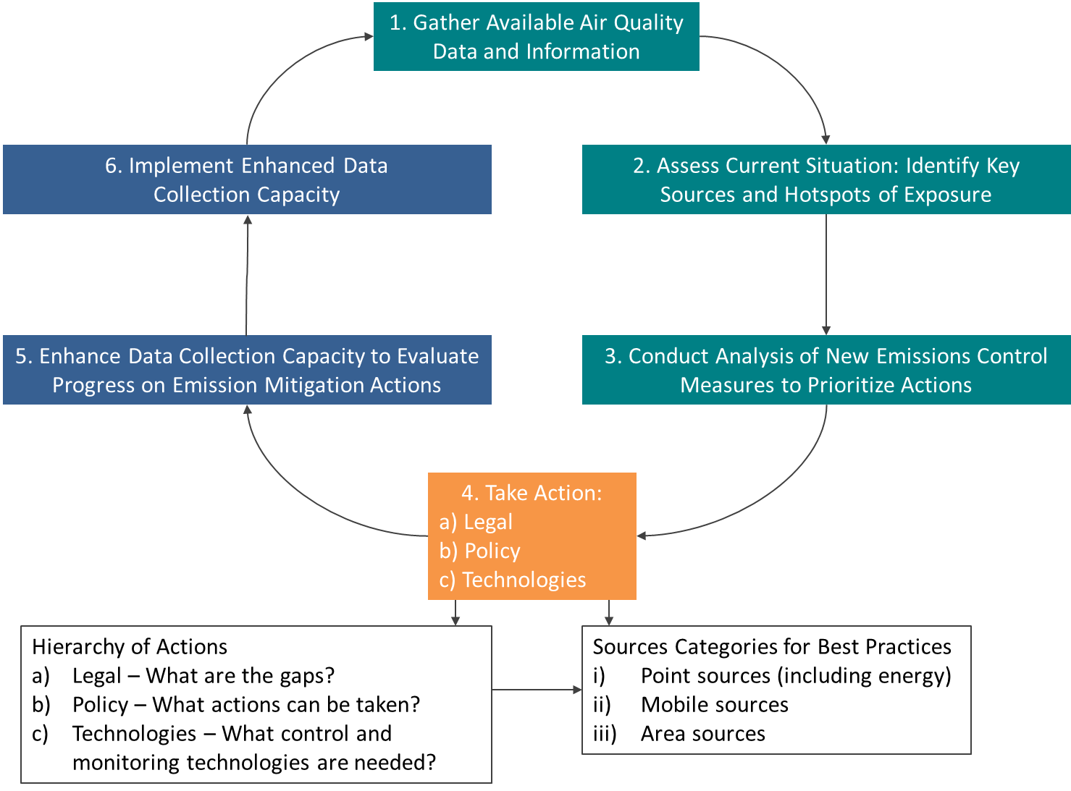Figure1. Integrated Air Quality Management Model

Sources: Johnson et al. (2011), Bachman et al. (2007)

The Information Collection Report typically includes standard language about **Figure 1** and about air quality management systems. The Megacity Partner organization can include the following language about air quality management systems in their reports:

To lay the groundwork for completing the remaining steps in **Figure 1**, further work may be required to clarify the suitability of the air monitoring network and other sources of information to support some preliminary conclusions about source apportionment; to assess the availability of emissions inventories and other information to support air pollution impacts analyses; and to gauge the level of interest in building capacity for both “top-down” and complementary “bottom-up” tools for a more comprehensive air quality management system.

In this regard it is helpful to consider the “top-down,” or monitor-based, and “bottom-up,” or emissions source based, approaches to air quality management described in the World Bank publication, Tools for Improving Air Quality, (Johnson et al., 2011). A top-down approach relies first on data from air quality monitors of increasing sophistication and includes a step to disaggregate the monitor readings to facilitate source apportionment (the “Receptor Model” step in the right panel of **Figure 2**, below). Johnson et al. (2011) is focused primarily on recommendations for developing countries to take these steps in order to establish priorities for AQMP. The top-down approach is excellent for programs that are getting started in the process of air quality management – it is a cost-effective way to generate actionable data for emissions management and air quality improvements. The top-down approach, however, does not necessarily support benefit-cost comparisons of alternative strategies for achieving ambient air quality improvements, or provide all the information on avoided health effects and economic benefits of taking action that is needed to present a compelling policy case.

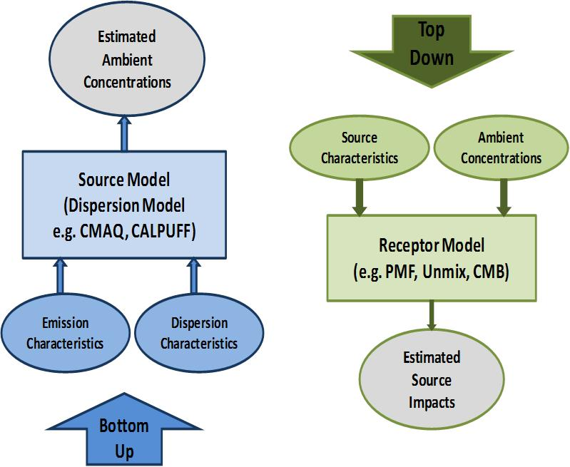Figure 2. Bottom-up (left) and top-down (right) approaches to air quality management

Source: Adapted from Johnson et al. (2011) by Sonoma Technologies, Inc., used with permission

The bottom-up approach, by contrast, is more resource intensive, requiring the construction of a comprehensive emissions inventory, which is then used to support air quality modeling and fate and transport estimations – effectively simulating air quality conditions across the relevant land area. These air quality simulations can then be compared to monitor data, sometimes in a process called bias correction, to “ground truth” them to measured conditions. Once confidence is established in these simulated air quality estimates, the results can be used to estimate marginal costs and benefits of specific actions, with complete spatial coverage, often covering even those areas where monitors are sparse or non-existent.

*Each megacity will need to determine which of these approaches, bottom-up or top-down or both, it wants to pursue and state that in the ICR, with an explanation of how it intends to move forward to collect the necessary information.*

The first section of the ICR should include the pollutants of interest and focus of the Megacities Partnership. Language below describes the most frequently analyzed pollutants in the partnership and should be included to the degree applicable.

We expect that the focus of this work will be on pollutants already established to be of concern: primarily PM10 and PM2.5; black carbon components of particulate matter (PM); and to a lesser extent, ambient ozone (O3). These pollutants not only represent an important priority from the perspective of public health, but the control of their precursor emissions lend themselves most readily to the type of air quality control programs envisioned in **Figure 1** above. Further, some of the precursor emissions represent areas of concern for which financing for pollutant controls may be most readily available – for example, black carbon, methane, precursors of PM and O3, are also short-lived climate pollutants (SLCP) which are the focus of UN and other programs for emissions controls. Cookstove smoke is an important indoor air pollutant which also represents a potentially important contributor to ambient air pollution and is the focus of active programs for emissions control.

## Overview of Air Quality Management Context

This section of the ICR addresses step 2 in **Figure 1** above: Assess Current Situation. This step provides a high-level overview of the current air quality management system and factors impacting air quality within the Megacity and country of interest. This includes, but is not limited, to the following:

* Demographics of the city;
* *Relevant geographic features and meteorological variables, including seasonal effects, impacting air quality;*
* *Current laws and standards regulating air quality; and*
* *Agencies (both municipal and federal) responsible for monitoring, evaluation, assessment, and enforcement.*

Each of these topics will be expanded upon in other sections of the report; this section is a place to highlight key findings and start to weave a narrative of air quality management in the city and country of interest.

## Organization of Report

Each report can have its own organization, there is no right or wrong way to do it. Some reports may be quite substantial, so it may be helpful to include this section, which outlines the organization of the report, describing each section. This provides the reader a sense of what it to come and how the various sections relate to each other.

# Previous and Current Air Quality Management Efforts and Results

As part of the information collection process, this chapter will focus on collecting information on the legal framework, current policies, and previous efforts related to air quality. The chapter should highlight the agencies and partners involved, potential data sources, important planning documents, and areas of success.

## Legal Structure, Organization, and Key Players

This section will include important laws regulating air quality and air quality management, including but not limited to standards by industry or sources; laws granting authority over air quality management, compliance, and enforcement; and key agencies involved in air quality management and regulation. Legal documents typically outline the responsibilities and roles of certain agencies in air quality management or related activities. **Table 1** provides examples of key agencies, their potential roles in air quality management, and potential data they could supply, that the Megacity Partner organization may find through its research.

**Table 1. Example Agencies, Responsibilities, and Data**

| Example Agency | Example Role or Responsibility | Potential Data Available |
| --- | --- | --- |
| *Ministry of Transport* | * *Track vehicle registrations, including year and model* * *Ensure compliance with tailpipe standards* * *Restrict certain fuel blends* | * *Number of registered vehicles over time* * *Model, make, and fuel type of registered vehicles* |
| *Environmental Protection Agency or Authority* | * *Design and implementing air quality monitor network* * *Establish air quality standards for point sources* * *Determine compliance of standards* * *Model future air quality scenarios* * *Analyze health and economic burden of air pollution* | * *Air quality monitor data for various years and pollutants* * *Ambient air quality standards* |
| *Ministry of Health* | * *Maintain data on morbidity and mortality health endpoints, hospital admissions, and emergency department visits* | * *Geographically resolved cause-specific incidence rates* |
| *Statistical Agency* | * *Collect and publish population and demographic data at various geographic scales* | * *Population projections* * *Census data, including socioeconomic indicators and demographics* |
| *Urban Planning Department* | * *Maintain relevant spatial data (e.g., neighborhoods, land use, roads)* * *Develop green city plans* * *Track ongoing and future infrastructure upgrades* | * *Spatial data files of land use, city boundaries, neighborhoods, parcels, road networks* |

While researching the responsibilities and roles of each relevant agency, it is important to catalog available data, reports, and figures that can be later used in health burden or economic impact analyses. Summary statistics and graphs can be included in the ICR with available data from agencies listed above.

## Overview of Prior and Ongoing Efforts

This section will detail the evolution of air quality management within the city and country of interest. Discuss plans that guide major air quality action and decisions (e.g. standards) and the agencies responsible for implementation, monitoring and evaluation. The projects can include those undertaken by the government, non-profits, or private sector and project description should include length, major outcomes, and current status. This section will provide concrete examples of previous or current air quality management in the city or country.

## Optional: Success Story Example

This section is an opportunity to highlight an area of significant progress in air quality management in the city or country. For example, the section could detail a project that required collaboration and cooperation across governmental agencies or a successful partnership with an NGO. This is a chance to analyze previous efforts and identify effective strategies in the specific cultural context.

# Current Air Quality Conditions

The goal of this chapter is to identify air quality monitors or sensors located in the city and possible sources of air quality measurements. The data collected can be used in future health impact analysis to identify priority areas (either sources or neighborhoods). Potential data sources are government-run air quality monitors, air quality modeling efforts, academic pilot studies, or source apportionment studies.

## Existing Air Quality Network and Monitoring Capabilities

This section compiles data on the previous and current air quality monitor networks, if available, and provides context for the magnitude of the air pollution problem. Summaries of air quality concentrations, from monitor measurements or satellite data, can be contextualized using municipal or national air quality standards; if there are no standards available, the World Health Organization (WHO) guidelines for the pollutant of interest can be used.

A data catalog of monitor characteristics including the location, status (e.g., collecting data, maintenance required, historic), data steward, pollutants collected, frequency of measurements, and accessibility of data should be maintained to understand current capacity. An example of a data catalogue is shown in Table 2. It is important to take stock of potential data sources and the organizations responsible for air quality monitors as air quality concentrations will be the crux of an evidence-based AQMP.

Table 2. Example Data Catalog for Air Quality Monitors

| Monitor / Sensor Location | Monitor Maintained By | Pollutants Measured | Years of Data Collected | Frequency of Measurements | Data Available for Download? | Point of Contact |
| --- | --- | --- | --- | --- | --- | --- |
| *e.g. Central Train Station* | *Ministry of Transport* | *PM2.5, Ozone* | *2014-2018* | *Hourly* | *No, must contact Ministry of Transport* | *Data manager* |

If local air quality data are available, preliminary analyses, such as time series graphs of each monitor and average daily, monthly, or yearly concentrations, should be presented. These graphs will display diurnal or seasonal patterns in air quality concentrations. A map of air quality monitors within the city can be created to illustrate the spatial distribution of monitors across the city. An example graph of summary air quality concentrations and an example map are shown in **Figures 1** and **2**, below.

Figure 1. Ex: monthly concentrations of air quality in Addis Ababa

Source: US EPA AirNow

**Figure 2. Example map of monitor locations in Addis Ababa**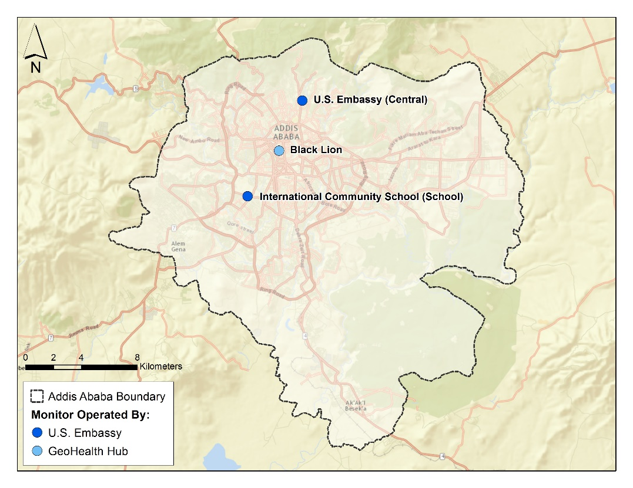

*Sources: US EPA AirNow, Esri, DeLorme, HERE, USGS, Intermap, iPC, NRCAN, Esri Japan, METI, Esri China (Hong Kong), Esri (Thailand), MapmyIndia, Tomtom*

Additionally, publicly available satellite data can be used to estimate air quality concentrations, to understand spatial variability across the city, to compare monitor data, if available, and to determine the range of air quality concentrations in the absence of on-the-ground measurements.

Plans for future investments in monitors or sensors should also be included in this section.

## Literature Review of Other Air Quality Studies

In addition to government-run monitors, academic institutions often perform pilot studies of air quality or source apportionment analyses. The pilot studies typically collect data or a limited time period and for a specific purpose; for example, a study may look at roadside concentrations during rush hour or concentration changes during the summer. This section can include results of published research and the range of air quality concentrations measured in the studies under specific conditions.

Pilot studies further contextualize air quality within the city, but are likely not comprehensive enough for reliable, long-term air quality monitoring and evaluation. On the other hand, source apportionment studies provide valuable insight into priority emission sources or industries heavily impacting pollution load and can inform future policy formulation.

## Preliminary Assessment of Key Air Quality Problems and Priority Areas

Using results from Sections 3.1 and 3.2, Megacity Partner organizations and host city agencies should begin identifying priority emission sources, industries, and neighborhoods experiencing higher health or pollution burden. We recommend initiating a discussion around the exposed population, including demographics and socioeconomic indicators. Considering data availability, a more detailed distributional analysis may be possible.

# Status of Emissions Inventory and Emissions Trends

## Emission Inventory and Main Sources

Developing a comprehensive emissions inventory is necessary to implement the bottom-up approach to air quality management. This section of the ICR will describe the data necessary and data sources available to compile an emissions inventory. Additional analysis on capacity to complete the inventory can also be assessed.

There are four primary emissions inventories that make up the bottom-up approach; each are defined below and require related data sources to estimate. For example, local ministries of transport typically maintain data related to vehicle registration, vehicle standards, years and models of vehicle and bus fleet.

Standard definitions of different inventories that can be included in this section are:

1. A mobile source inventory. It is not practical to measure pollutants from all mobile sources, so emissions are estimated from data on the population of vehicles by vehicle class, estimates of their activity (where, when, and how far they are driven), and the emissions characteristics of those vehicles.
2. A point source inventory. Point sources are stack emissions from major industrial and commercial facilities. The total emissions from a large point source can also include fugitive emissions from industrial plants.
3. An area source inventory. Area sources are small sources of air pollution which by themselves may not emit very much but, when their emissions are added together, account for a significant portion of total emissions. Area sources are often too small or too numerous to be inventoried individually.
4. A biogenic inventory. Biogenic emissions are emissions that originate from non-anthropogenic sources. These include sources such as forests which emit some VOCs, and sources of airborne particulates such as sea salt and crustal material.

## Expected Emissions Trends

This section describes the projected change in emissions over time based on expected future developments of priority sources and policies. This section will include any efforts to model projected emissions; projects, policies, and standards that will curb air pollution and are likely to be implemented; and projected trends in vehicle fleet growth, alternative fuel usage, population growth, or other relevant changes in the magnitude of priority emission sources.

# Air Pollution and Associated Impacts

## Health Impacts

This section describes the impact of air pollution on health in the country. Previous ICRs have relied heavily on IHME Global Burden of Disease[1] (GBD) Results Tool and Country Profile to understand the magnitude of air pollution on health and the number of deaths and disabilities for endpoints with known linkages to air pollution.

Typically, this section would include the top ten death and disability endpoints, noting which are exacerbated by air pollution, the growth or decline of endpoints of interest, and the rank of air pollution in common risk factors for death and disability. All of these data are available from the GBD study.

Additional information on the impacts of air pollution (both ambient and indoor) can be included from epidemiological studies conducted in the city, country, or region and published in the literature.

Standard language on health impacts can be included to introduce this section:

Air pollution is an important determinant of health; both indoor (household) and outdoor (ambient) air pollution can adversely impact public health due to short- or long-term exposures. Air pollution is most commonly associated with acute or chronic respiratory or cardiac disease and can lead to death. Millions of people around the world die prematurely each year from diseases caused by air pollution, including pneumonia, stroke, ischemic heart disease, chronic obstructive pulmonary disease (COPD), and lung cancer (WHO, 2014).

## Economic Welfare Impacts

This optional section will describe the economic welfare impacts of regulating air pollution. Few Megacities in the past have had enough information to quantify these impacts for inclusion in the ICR; however, a brief recognition and discussion of general welfare impacts can be stated here.

Health impacts typically are valued using local value of a statistical life (VSL) for mortality endpoints, and cost-of-illness estimates for hospital admissions or emergency department visits. Complimentary health impacts, like work loss days, can also be valued. Additional economic welfare impacts include effects to visibility (recreational and residential), ecosystem services, agriculture, materials damages, and reduction in greenhouse gas emissions. These impacts can be researched further, and Megacity Partner organizations and host city agencies should determine whether the impacts are large enough to be quantified or evaluated for inclusion in the AQMP.

# Recommendations and Next Steps

## Summary of Air Quality Management Capacity and Partnership Status

This section of the ICR provides a summary of all the research findings, data sources, and capacity assessments.

Standard language for this section includes:

This report has identified a wide range of air quality management capacity, as well as additional research and local resources that can be combined with [Megacity Partner organization]’s support to enhance air quality management efforts with [City Host Agency]. Table 3 below provides an example of a summary of information currently available to the project study team for each major component of a complete air quality management system. This information will be updated and re-assessed throughout the Partnership.

Table 3. Example Summary table of available air quality management information

| Component of AQMS | Initial Assessment of Status | Project Team Notes |
| --- | --- | --- |
| *Laws and Regulations* | *Detail main laws and agencies governing environmental policy, air quality management, and standards* | *Discuss any gaps, limitations, and areas that are unclear / unidentified* |
| *Emission Inventory* | *Summarize main emission sources, possible data sources, and current emissions trends* | *Discuss any gaps, limitations, and areas that are unclear / unidentified* |
| *Ambient and Source Air Quality Monitoring* | *Summarize current air quality monitors in the area, pollutants monitored, and pilot studies identified during the research.*  *Discuss source apportionment, if available.* | *Discuss any gaps, limitations, and areas that are unclear / unidentified* |
| *Air Pollution Dispersion/Fate and Transport Modeling* | *Use emissions inventory to estimate ambient air pollutant concentrations.* | *Discuss any gaps, limitations, and areas that are unclear / unidentified* |
| *Data Analysis and Interpretation* | *Discuss any on going effort to analyze air pollution and its impacts, either through government or research studies.* | *Discuss any gaps, limitations, and areas that are unclear / unidentified* |
| *Public Participation and Environmental Justice* | *Summarize examples of public participation, environmental justice, and relevant neighborhood* | *Discuss any gaps, limitations, and areas that are unclear / unidentified* |
| *Control Strategy Planning and Development* | *Describe examples of current and future plans for air quality management* | *Discuss any gaps, limitations, and areas that are unclear / unidentified* |
| *Compliance and Enforcement* | *Summarize current efforts for compliance and enforcement of air quality management laws and standards.* | *Discuss any gaps, limitations, and areas that are unclear / unidentified* |

## Next Steps in the Process

The final section of the ICR includes the development of next steps based on the results of the research conducted as part of the information collection report development process. Next steps can include sharing and distributing this report with relevant organizations and stakeholders, receiving comments and edits, and prepping for the Inception phase and Capacity Building Workshop(s) .

References

Bachman, J. 2007, Will the Circle Be Unbroken: A History of the U.S. National Ambient Air Quality Standards, Journal of the Air & Waste Management Association. 57(6): 652-697

Johnson, T. M., Guttikunda, S., Wells, G. J., Artaxo, P., Bond, T. C., Russell, A. G., Watson, J. & West, J. 2011. Tools for improving air quality management: a review of top-down source apportionment techniques and their application in developing countries.

1. The IHME GBD study and data portals can be found at the following link: [**http://www.healthdata.org/gbd**](http://www.healthdata.org/gbd)