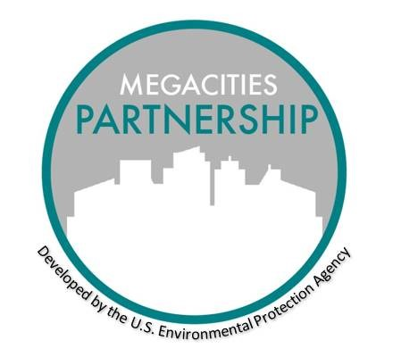

MEGACITIES PARTNERSHIP

Public Involvement Plan Template

May 2021

ACTION TITLE

Public Involvement Plan – Month, Year

Objectives

1 - 2 paragraph summary: What do you want to accomplish with the public involvement? How will it help your program succeed?

Key Message(s)/Statement:

2 - 3 key points explaining why you want the public involved and how you are going to use the input you receive.

Key Target Audiences:

List specific audiences in this section. When creating this list, consider the following audience characteristics:

* Active community groups who might be supportive (e.g, mothers groups, public health organizations)
* Those affected by the program

Research Audience Needs

* What do they need to know?
* Who do they trust?
* What are potential barriers?
* Are there partners who can help?

Methods and Costs

* How are you going to reach these audiences (e.g,. public meetings, door-to-door, advertising)
* Which set of involvement methods is suitable for this project (e.g. city hall meetings)?
* What is the timeline to make each happen?
* What is the cost for each method?
* Who will manage each method?

Resources Needs

* Budget
* Staffing

Proposed Schedule

* What steps, both logistically and politically, are needed for the involvement to happen?

Follow Up Activities

* What commitments may need to happen after involvement is completed?

Contacts for this Action:

Who within Environmental Agency or other Departments are the main points of contact?

Technical Lead:

Communications Lead: