# How’s My Waterway?

## Learning Objective

**Time**

45-60 minutes

**Learning Objectives**

At the end of this lesson, students will be able to:

* Describe a watershed and waterbody.
* Collect water quality data using an online environmental data tool.
* Construct and support an argument about how humans impact water quality.
* Evaluate different actions and design potential solutions to minimize human impacts to watersheds.
* Describe water policy including the Clean Water Act and Total Maximum Daily Loads (TMDLs).
* Become familiar with Environmental Justice topics.

**Next Generation Science Standards**

* [MS-ESS3-3](https://my.nsta.org/ngss/DisplayStandard.aspx?view=pe&id=214): Apply scientific principles to design a method for monitoring and minimizing a human impact on the environment.
* [MS-ESS3-4](https://my.nsta.org/ngss/DisplayStandard.aspx?view=pe&id=216): Construct an argument supported by evidence for how increases in human population and per-capita consumption of natural resources impact Earth's systems.

Students will learn how to use the United States (U.S.) Environmental Protection Agency (EPA) *How’s My Waterway* tool to explore and visualize water quality data and determine the health of their local waterbodies.

## Materials

* Internet access
* *How’s My Waterway* Activity Sheet (included below)
* [How's My Waterway Fact Sheet](https://www.epa.gov/waterdata/hows-my-waterway-fact-sheet)

## Background for Educators

A [watershed](https://www.epa.gov/hwp/basic-information-and-answers-frequent-questions) is a land area that drains into a stream or other waterbody, such as a lake or river. Although watersheds share similarities, all of them are different. Some are as small as a [footprint](https://www.usgs.gov/special-topic/water-science-school/science/watersheds-and-drainage-basins?qt-science_center_objects=0#qt-science_center_objects), while others are huge—for example, the Mississippi River watershed spans thousands of miles and 33 states!

We all live in a watershed, and every inch of land in the United States drains into a waterbody. That means that what we do on land directly affects the quality of our surrounding waterbodies. That also means we’re all responsible for protecting the health and quality of our watersheds.

A [healthy watershed](https://www.epa.gov/sites/production/files/2015-10/documents/2009_08_05_nps_healthywatersheds_highquality_hwi.pdf) has mostly natural land cover, especially near its waters; good water quality, quantity, and flow; and habitats that support aquatic life like fish, water bugs, plants, and other animals. You might not realize it, but all of us benefit from healthy watersheds in many ways. Without healthy watersheds, we wouldn’t have access to critical services like clean drinking water, productive fisheries, and outdoor recreation—all of which support our environment, quality of life, and economies.

Despite their importance, healthy watersheds are uncommon in the U.S., often as a result of human activities on land, such as agriculture, urbanization, and waste disposal. That’s because human activities create pollutants (or “impairments”) that eventually reach waterbodies after it rains. Once there, these pollutants can lead to excess nutrients like nitrogen and phosphorus, harmful algae growth, contaminated sediment, and many other stressors to water quality and aquatic life.

When the quality of a waterbody becomes too degraded, a state must report it as an “impaired water” to the U.S. EPA. U.S. EPA has been working with states for decades to protect and restore watersheds across the country to achieve the [Clean Water Act](https://www.epa.gov/laws-regulations/summary-clean-water-act) goals of restoring and maintaining, “the chemical, physical, and biological integrity of the Nation’s waters”.

U.S. EPA requires states with impaired waters to develop a [Total Maximum Daily Load](https://www.epa.gov/tmdl/overview-total-maximum-daily-loads-tmdls) (TMDL) restoration plan. A TMDL is the maximum amount of a pollutant allowed to enter a waterbody so that the waterbody will meet and continue to meet water quality standards for that particular pollutant under the Clean Water Act. By setting a TMDL, states have a pollutant reduction target—sometimes called a “pollution diet”—to work toward.

Because TMDLs focus on restoring water quality in waterbodies *after* they’ve become impaired, the U.S. EPA created the [Healthy Watersheds Program](https://www.epa.gov/sites/production/files/2015-10/documents/2009_08_05_nps_healthywatersheds_highquality_hwi.pdf), which takes a proactive approach to protecting high-quality waters. The Healthy Watersheds Program collaborates with citizens, states, territories, tribes, other government agencies, and private partners to assess and protect watersheds by addressing *future* threats such as:

* Emerging water quality problems
* Loss and fragmentation of aquatic habitat
* Altered water flow and availability
* Invasive species
* Climate change

The U.S. EPA also protects watersheds by developing scientifically sound and consistent data sources that provide reliable information about waterbody conditions, pollution sources, and factors that might influence efforts to restore and protect water quality. One of those data sources is the *How’s My Waterway* tool which empowers users to learn about what’s happening to water quality in their local community, state, or even the entire country.

## Vocabulary

**Watershed:** The land area that drains into a stream or other waterbody.

**Waterbody:** A river, stream, lake, or other type of water that has been assessed by the state. The assessed area may be an entire waterbody or just a segment of an individual river, stream, lake, pond, or wetland.

**Impaired waters:** Waterbodies not fully supporting their designated uses under the Clean Water Act. Once a waterbody is placed on the threatened and impaired waters list, it becomes one of many inline for evaluation and development of a plan for solving the problems.

**Impairment:** Dredged spoil, solid waste, incinerator residue, sewage, garbage, sewage sludge, munitions, chemical wastes, biological materials, radioactive materials, heat, wrecked or discarded equipment, rock, sand, cellar dirt and industrial, municipal, and agricultural waste discharged into water.

**Stressor:** A physical, chemical, or biological factor that may cause stress in the aquatic system or contribute to pollution.

**Environmental justice:** The fair treatment and meaningful involvement of all people regardless of race, color, national origin, or income, with respect to the development, implementation, and enforcement of environmental laws, regulations, and policies. This goal will be achieved when everyone enjoys the same degree of protection from environmental and health hazards, and equal access to the decision-making process to have a healthy environment in which to live, learn, and work.

## In-Class Activity

*NOTE: Educators can tailor students’ exploration of the tool according to available class time. You can choose to complete all of the activities listed on the following pages and the entire worksheet (see page 9) or focus on just a few of the activities and corresponding worksheet questions.*

1. As a class, review the [How's My Waterway Fact Sheet](https://www.epa.gov/sites/production/files/2020-06/documents/hmw_factsheet_06_12_20.pdf) to learn about types of information can be found in the tool.
2. If teaching in person, project the *How’s My Waterway* home page on the whiteboard for students; if teaching virtually, share the home page on your screen. Introduce students to the tool’s interface and features. Explain that students will be using the tool to explore the condition of their local waterways.
3. Have students go to the How’s My Waterway home page (<https://mywaterway.epa.gov/>). In the search box under “Let’s get started,” ask students to enter their home address or zip code and click “Go.”

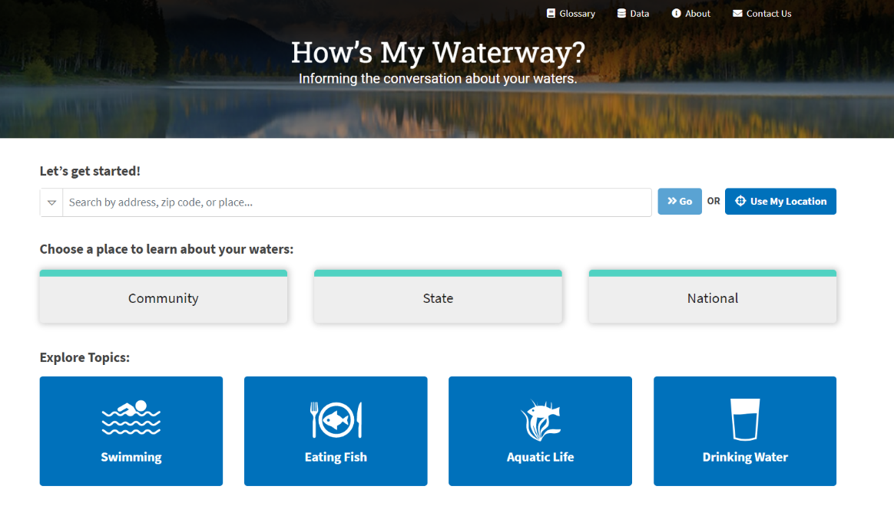

1. An “Overview” page will open. The left side of the page shows a map of the student’s watershed with waterbodies and their conditions. Students can click each waterbody to reveal a popup with the waterbody’s name, condition (good, impaired, or unknown), evaluated uses and conditions, and impairment categories (if applicable). The right side of the page provides the same information as text narrative. Explain what the various features on the map mean. See the graphic below for reference.

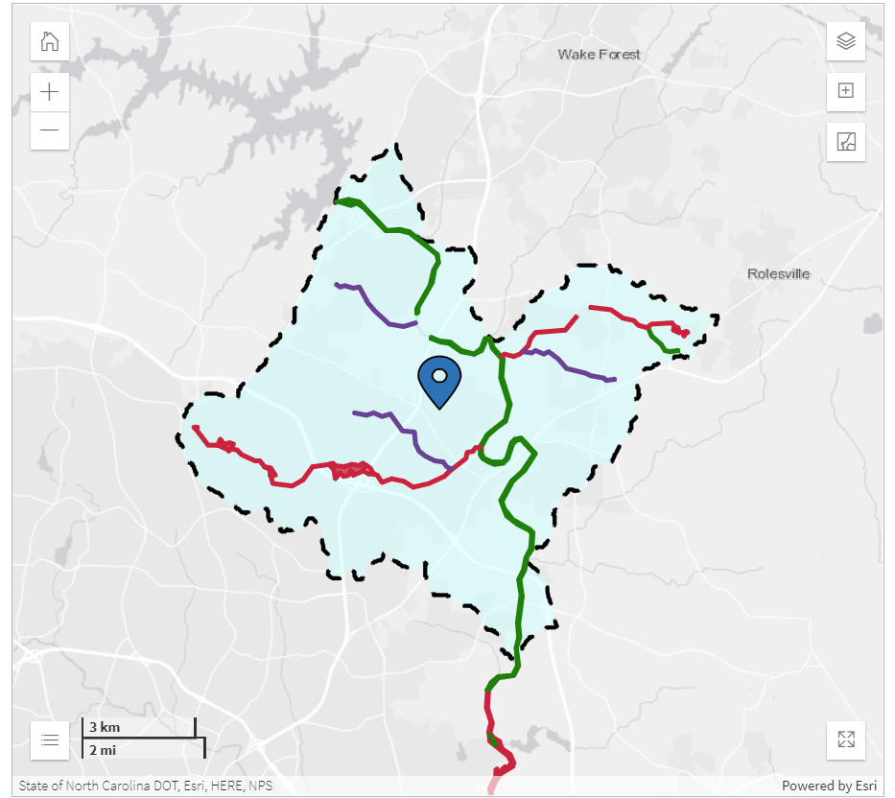

**Dashed line = watershed boundary**

**Green line = waterbody in good condition**

**Red line = impaired waterbody**

**Purple line = waterbody with unknown condition**

**Blue pin = your location**

1. On the right side of the page, draw students’ attention to the first sentence under the “Your Waters: What We Know” header that reads “Waters in your community are connected with a local watershed.” Have students click on the term “watershed,” which has a book icon next to it, so they can view its definition in the tool’s glossary. Tell students they can access the tool’s complete glossary at the top of the page (above “How’s My Waterway?” in the page banner). Students can use the glossary to answer the first two questions on the “How’s My Waterway Activity Sheet.”

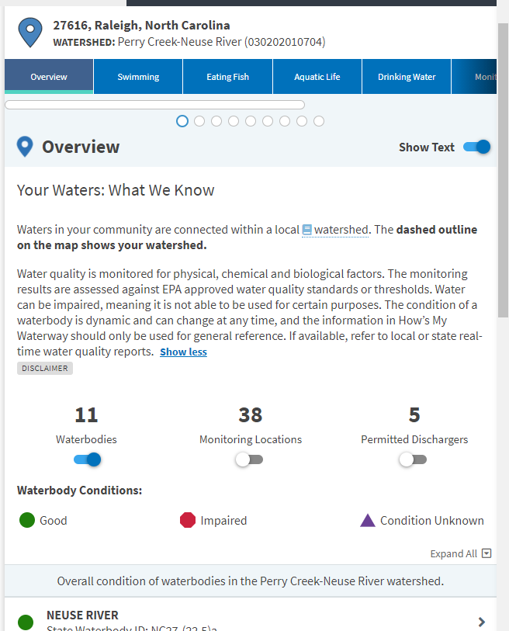

1. After they identify the name of their watershed in question 3, have students navigate to the “Protect” tab to find out their watershed’s health score in the first half of question 4. Make sure the “Watershed Health Scores” button is toggled on so that students can see how their watershed health compares to surrounding watersheds in the second half of question 4.

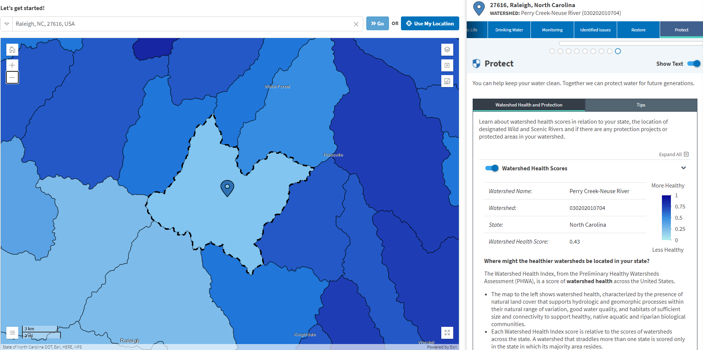

**Name of watershed**

1. Have students again use the glossary to define “upstream watershed” (question 5). Then, have them identify three upstream watersheds using the *How’s My Waterway* upstream watershed feature (the bottom button on the top right corner of the map). Make sure the “Watersheds” layer is turned on so students can easily click on three upstream watersheds to answer question 6.

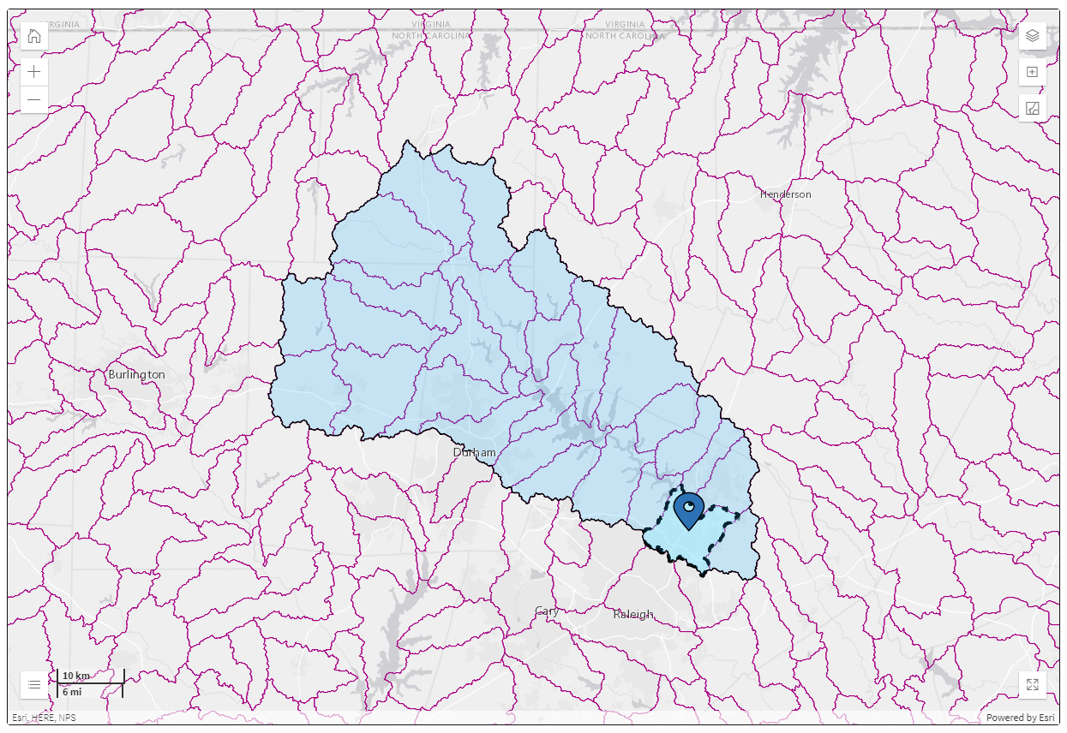

**Upstream watershed feature**

**Purple boundaries = individual upstream watersheds**

**Blue area = total area of all upstream watersheds**

1. Using the plus button on the top left corner of the map, have students zoom into the waterbody closest to their location. Then, have them click on that waterbody and use the popup information that appears to answer questions 7–11 on the activity sheet.

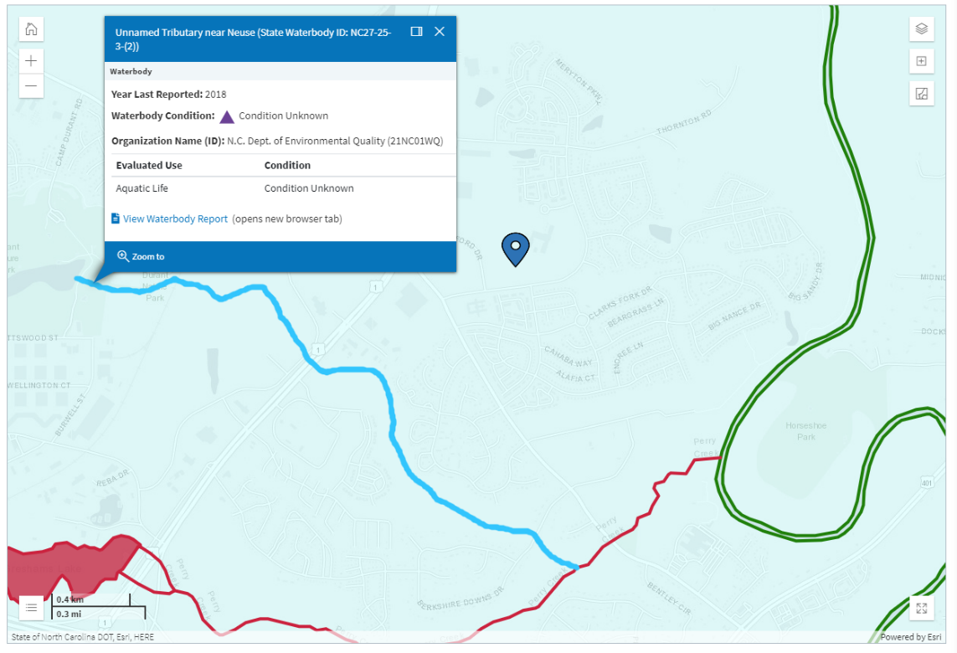

**Use info in popup to answer question 7 on activity sheet**

**Closest waterbody to blue pin**

1. Now provide students with the zip code of a watershed in your state that you know has at least three impaired waterbodies. After identifying the name of the watershed (question 12), have students list up to three waterbodies that are impaired in the blank table under question 13. Students can find these waterbodies by clicking on the red lines on the map OR by clicking on impaired waterbodies indicated by the red stop sign icon in the text list under “Overall condition of waterbodies in the __________________ watershed.”

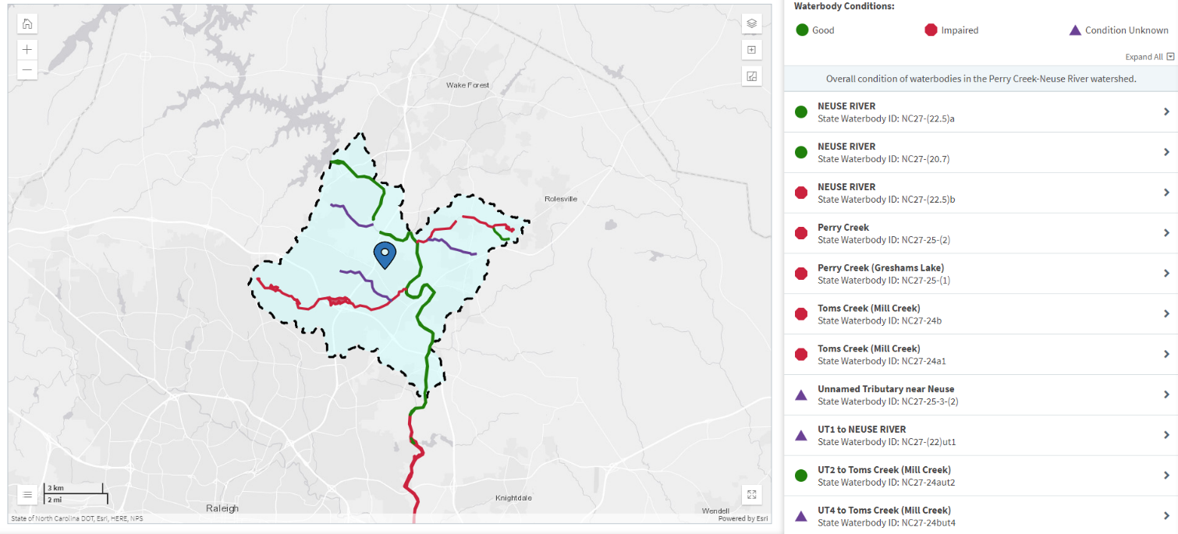

1. For the three impaired waterbodies that the students select, have them identify potential causes and solutions for those impairments (question 14). They can locate this information by clicking the name of the impairment category (with the book icon) in the popup window and reading the “definition” and “what you can do” text that appears in the glossary.

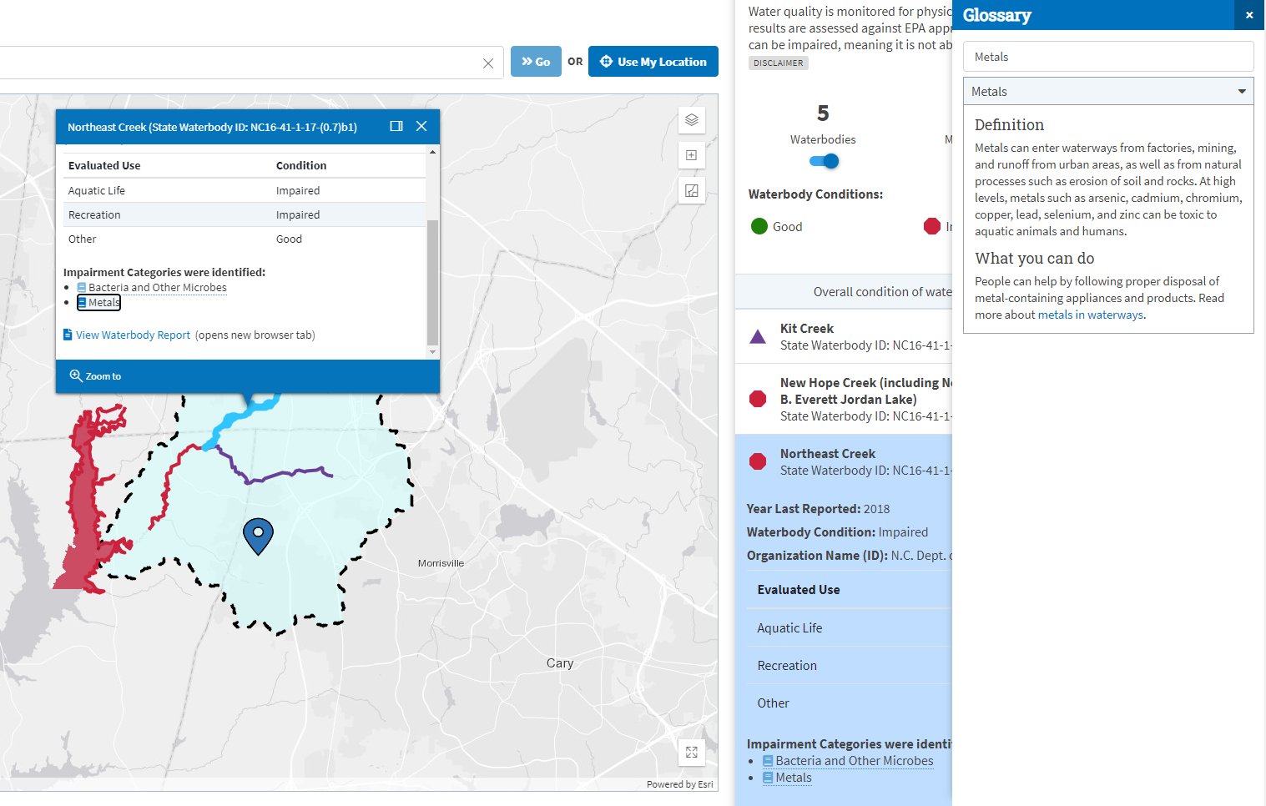

**Clicking the impairment category name will make definition/what you can do appear on the right.**

## Class Discussion

After all students complete the activity sheet, ask for volunteers to share their responses to question 15. Build on the discussion by navigating to the “Protect” tab and going over the quick tips for protecting water on the “Tips” tab.

## How’s My Waterway Activity Sheet

1. Define **watershed**: ­­­­­­­­­­­­­­­­­­______________________________________________________________________
2. Define **waterbody**: ______________________________________________________________________
3. What is the name of your watershed? _______________________________________________________
4. What is the health score of your watershed? Is it better, worse, or the same as the surrounding watersheds?

______________________________________________________­­­­­­­­­­­­­­­_______________________________

1. Define **upstream watershed**: ______________________________________________________________
2. Name three upstream watersheds in your area: **_____________________________________­­­­__________  
   ______________________________________________________________________________________**

**Zoom into the waterbody closest to your location (the blue pin) and answer the following questions:**

1. What is the name of your closest waterbody? ­_____________________­­­­­­­­­­­­­­­­­­­­­______________________________
2. What is the condition of your closest waterbody? ­________________________________________________
3. If your waterbody is impaired, what are its uses? List each use and its associated condition:

________________________________________________________________________________________________________________________________________________________________________________________________________________________________________________________________________

1. If your waterbody is impaired, what are the impairments? ________________________________________________________________________________________________________________________________________________________________________________________________________________________________________________________________________
2. Are your local waterbodies suitable for swimming or eating fish? How about aquatic life? If they aren’t, why not?

________________________________________________________________________________________________________________________________________________________________________________________________________________________________________________________________________________________________________________________________________________________________

**Return to the How’s My Waterway homepage. Type in the zip code or address that your teacher provides you.**

1. What is the name of the watershed? ­­­­­­­­­­­­­­­_____________________­­­­­­­­­­­­­­­­­­­­­______________________________
2. Identify three waterbodies in the watershed that are impaired. For each impaired waterbody, provide the waterbody’s name and impairments in the table below.

|  |  |
| --- | --- |
| **Name of Waterbody** | **Impairments** |
|  |  |
|  |  |
|  |  |

1. Pick three impairments that you listed in the table above and describe what types of human activities might have caused them. Then, list possible solutions to restore those waters to a healthy condition. (Hint: Click on the impairment categories with the book icons and read their definition and “what you can do.”)

|  |  |  |
| --- | --- | --- |
| **Impairment** | **Causes** | **Solutions** |
|  |  |  |
|  |  |  |
|  |  |  |

1. Reflection: How do you use your local waterbodies? What kind of activities do you do there? ­­­­­­­­­­­­­­­­­­­­­­­­­­­­­What can you do at home and in your everyday life help your waterbodies become or stay healthy?   
   _______________________________________________________________________________________________________________________________________________________________________________________________________________________________________________________________­­­­­­­­­­_________

## Extension 1: Spotlight on Environmental Justice (Homework or Group Activity)

Environmental justice is a term that means everyone should be able to live a healthy life in a safe and protected environment regardless of their race, color, national origin, or income. Unfortunately, some people in the United States live in places that have unhealthy environments, such as near a chemical plant that is emitting pollutants into the air or in buildings that have old lead pipes that are wearing away and letting lead, a toxic metal, enter people’s drinking water.

Research a community in the United States that has experienced disproportionate, negative impacts to water quality in its watersheds. [Potential communities that teachers can assign include Flint, Michigan; Fresno, California; Jacksonville, Florida; Houston, Texas; and Pittsburgh, Pennsylvania]

Develop a case study that answers:

* Who is affected?
* How are they impacted?
* Why does the problem exist?
* How did the community respond?
* What more could be done?
* Include data about the watershed in that community from the *How’s My Waterway* tool. To obtain this information, go to the *How’s My Waterway* homepage and type in the name or zip code of the community. When the map appears, click on the “layers” icon on the top right corner of the map. Then, scroll to the bottom of the list and click “**Demographic Indicators**”

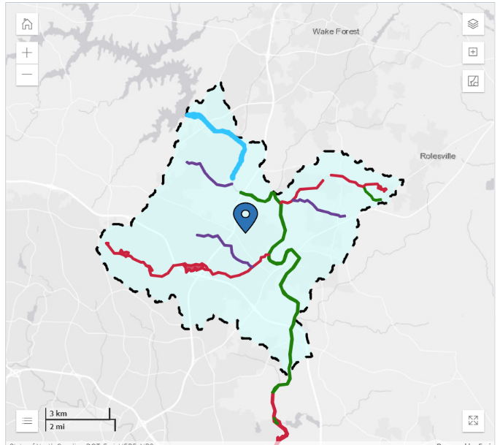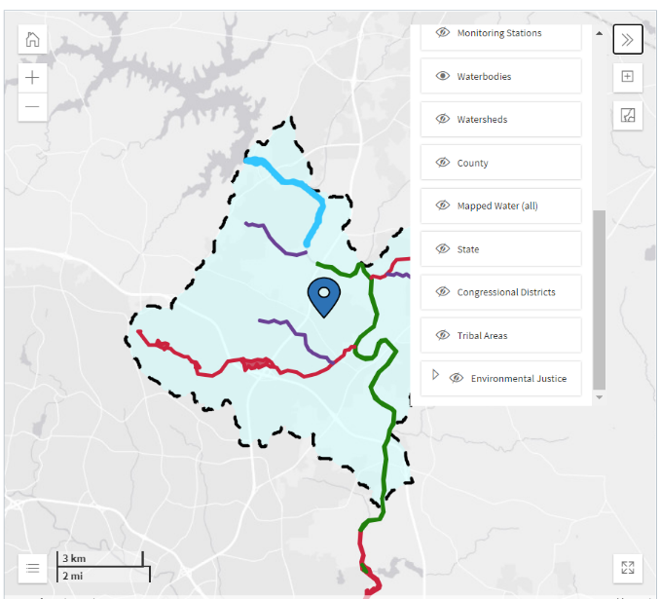

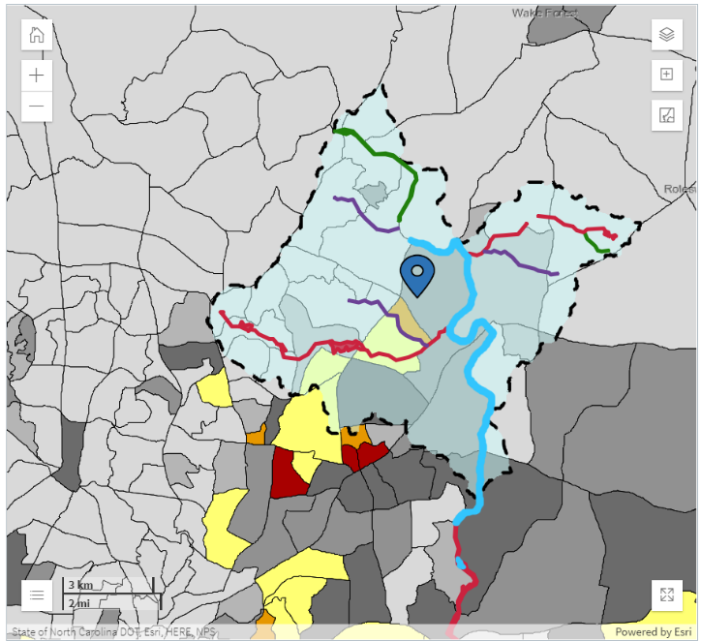The map will now display areas with environmental justice concerns in yellow, orange, and red. Communities in red areas are the most vulnerable to environmental inequalities.

Pick three areas with environmental justice concerns and describe the following:

* Watershed name
* Demographics information
  + Percent People of Color:
  + Percent Low Income:
  + Less Than High School Education:
  + Linguistic Isolation:
  + Individuals Under 5:
  + Individuals Over 64:
* Impairments to swimming
* Impairments to eating fish
* Impairments to aquatic life

## Extension 2: Spotlight on Action (Homework or Group Activity)

Identify an impaired waterbody in your assigned community [teachers assign each group a watershed in their state]. Develop a presentation (e.g., in Google Slides) to convince members of your community to take action to restore the health of their waters. Using *How’s My Waterway* as your data source, answer the following questions in your presentation:

* What impairments are affecting waterways?
* How do these impairments affect the community’s swimming, fish consumption, and aquatic life?
* How are community members contributing to the problem?

After identifying impairments and their causes, develop a checklist of things people can do to reduce and prevent these impairments in the future.