**Turbidity Exercise**

A stream has a water quality criterion for turbidity that states, “turbidity shall not exceed 25 NTU”. An industrial facility is permitted to discharge to this stream and its permit limits the effluent turbidity to a maximum of 25 NTU.

Water quality samples were collected upstream and downstream of the facility’s effluent discharge; the effluent was also sampled. These data are presented in the figure below.

Exercise questions:

1. When does it appear that the facility effluent has little to no effect upon in-stream turbidity?
2. When does it appear that the facility effluent had some effect upon in-stream turbidity?
3. Instead of the “turbidity shall not exceed 25 NTU”, if the in-stream criterion prohibited an increase of more than 5 NTU over background and background was 17 NTU for this stream, when does the facility contribute to an exceedance of the turbidity criterion?

**Nutrient Exercise**

The Nambe Tribe established a total inorganic nitrogen criterion for the high quality coldwater fishery use; the criterion is that total inorganic nitrogen “shall not exceed 1.0 mg/L”.

Water quality samples were collected from a stream that is designated a high quality coldwater fishery. The total inorganic nitrogen results are presented in the figure below.

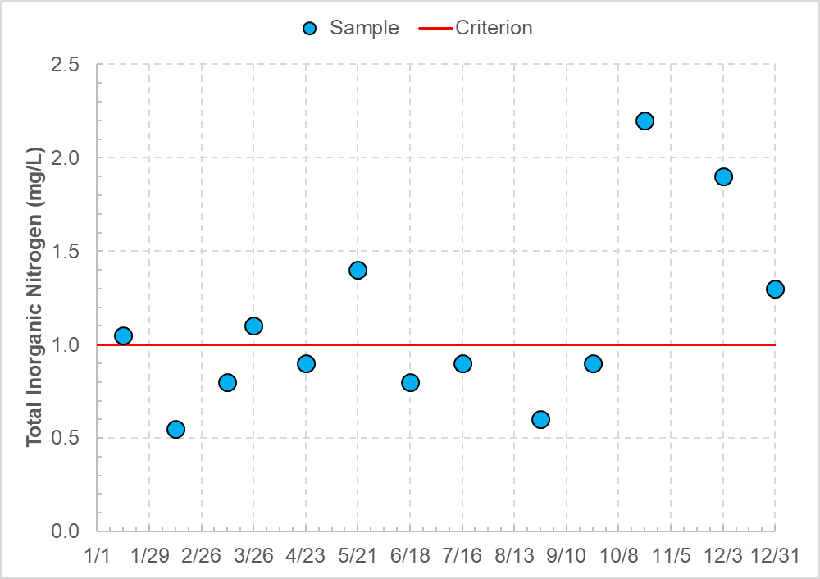

Exercise questions:

1. Do the water quality samples exceed the Nambe Tribe’s water quality criterion for total inorganic nitrogen?
2. If the criterion were a summer season average (June through September), would the water quality samples exceed the criterion?
3. If the criterion were a growing season average (March through September), would the water quality samples exceed the criterion?

**Biological Indices Exercise**

The state of Ohio adopted numeric biological criteria for fish and macroinvertebrate communities. The criteria vary by several factors including designated use and stream assessment method.

The Index of Biotic Integrity measures fish community health using 12 metrics that can each score a maximum of 5 points (i.e., a perfect IBI score is 60). The table below presents the biological criteria for two designated uses (warmwater habitat and exceptional warmwater habitat) and for two stream assessment methods (headwaters and wading).

|  |  |  |
| --- | --- | --- |
| **Assessment method** | **Warmwater Habitat score** | **Exceptional Warmwater Habitat score** |
| Headwaters | 40 | 50 |
| Wading | 38 | 50 |

Six sites in a watershed are sampled; four sites are sampled using headwaters assessment methods and two sites are sampled using wading assessment methods. The results are shown in the figure below.

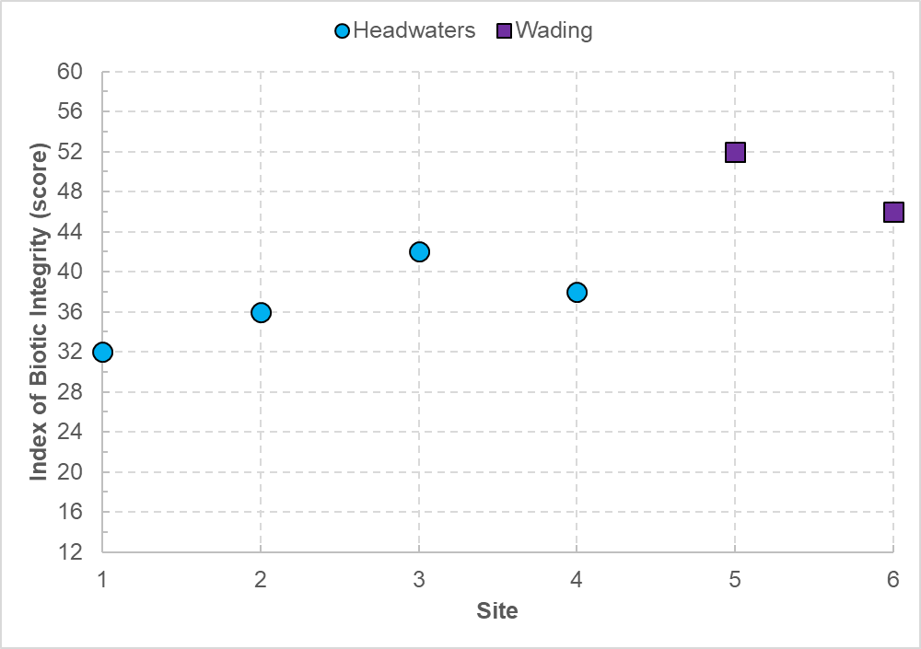

Exercise questions:

1. If the six sites were warmwater habitat, which sites would meet the biological criteria?
2. If the six sites were exceptional warmwater habitat, which sites would meet the biological criteria?
3. Ohio’s biological criteria allow for nonsignificant departure where a sample that is 4 points or less below the appropriate criterion will be considered “marginally” supporting its use. Which of the six sites marginally meet the warmwater habitat criteria? Which of the sites marginally meet the exceptional warmwater habitat criteria?

**Metals Exercise**

The zinc (total) criterion for Grand Portage Reservation varies by hardness (calcium and magnesium) and is expressed in an equation. However, the Grand Portage Band of Chippewa also published the zinc criteria at certain hardness concentrations; these “shall not exceed” criteria are presented in the table below. Note that the zinc criterion for any hardness concentration greater than 400 mg/L is set equal to the zinc criterion at a hardness of 400 mg/L (i.e., when the hardness is greater than 400 mg/L, the zinc concentration shall not exceed the criterion set for 400 mg/L hardness).

|  |  |
| --- | --- |
| **Hardness (mg/L)** | **Zinc (mg/L)** |
| 50 | 67 |
| 100 | 120 |
| 200 | 216 |
| 300 | 304 |
| 400 | 388 |

Four sites along the Pigeon River were sampled and the results are presented in the figure below.

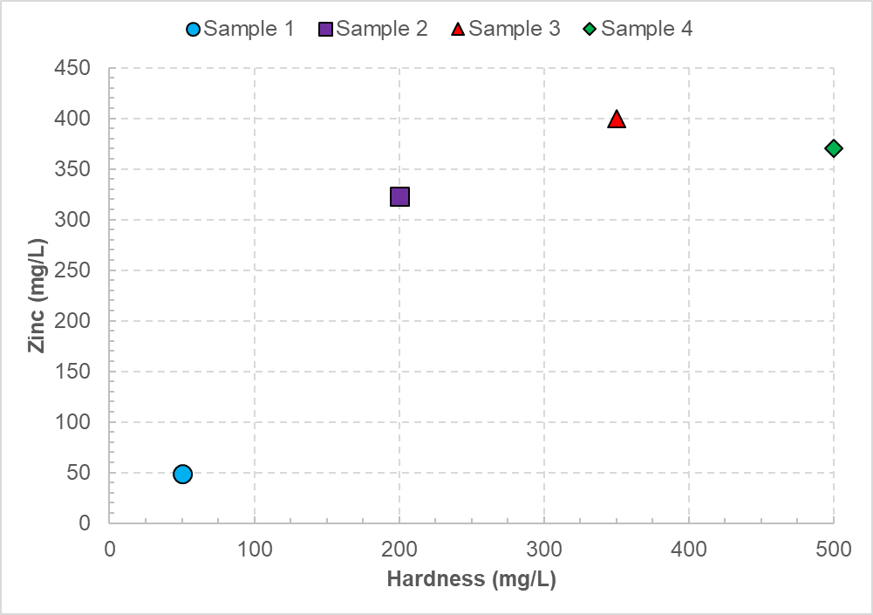

Exercise questions

1. Does sample #1 meet the zinc criterion?
2. Does sample #2 meet the zinc criterion?
3. Does sample #3 meet the zinc criterion? (Hint: You can still use the zinc-hardness criterion table)
4. Does sample #4 meet the zinc criterion? (Hint: The zinc criterion is in the zinc-hardness criterion table)

**Pathogen Exercise**

The Fort Peck Assiniboine and Sioux Tribes developed primary contact recreation use criteria for the Fort Peck Indian Reservation using *E. coli* as a pathogen indicator. The criteria are composed of two parts: a geometric mean criterion and a single sample maximum criterion. A geometric mean of five or more samples equally spaced over a 30-day period shall not exceed 126 counts per 100 milliliters. A single sample shall not exceed 235 counts per 100 milliliters.

Ten water quality samples were collected from a site on Big Porcupine Creek (designated for primary contact recreation use) during the recreation season. The E. coli densities for each sample are presented in the figure below.

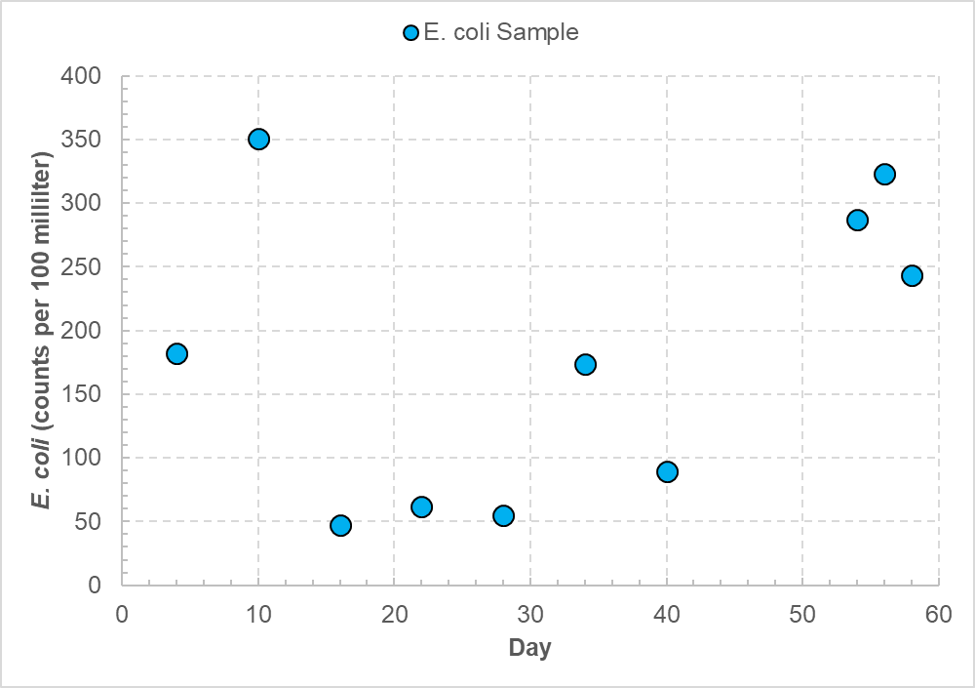

Exercise questions:

1. How many samples exceed the single sample maximum criterion?
2. The following geometric means were calculated as the specified 30-day periods. Do they exceed the criterion? Why or why not?
   1. Days 1-30 yield a geometric mean of 100 counts per 100 milliliters.
   2. Days 31-60 yield a geometric mean of 203 counts per 100 milliliters.
3. What other 30-day periods could a geometric mean be compared with the criterion? (Hint: There are two additional 30-day periods).
4. Do the geometric means for the additional 30-day periods exceed the criterion? (Hint: You don’t need a calculator)