Development and Collaboration for   
Emissions Estimation Methods

# Purpose:

The Emissions Inventory and Analysis Group (EIAG) within the U.S. Environmental Protection Agency’s (EPA) Office of Air Quality Planning and Standards (OAQPS) is responsible for developing the National Emissions Inventory (NEI), which is used by domestic and international stakeholders for a variety of environmental analyses. Given the many uses of the data, we believe that it is critical for the NEI data to be based on high quality, scientifically grounded approaches. This document outlines the approach for developing and improving emissions estimation methods for the NEI using a collaborative, science-driven approach. This document provides potential collaborators with an overview of our work with stakeholders to improve the NEI. We maintain a list of known emissions data needs, which is available on the Air Emissions Inventory website “Collaboration” page, https://www.epa.gov/air-emissions-inventories

# Background:

Emission inventories are key components for evaluating, managing, and regulating air pollutants. Refinements and innovations in instruments that measure air pollutants, models that calculate emissions, and techniques for data management and uncertainty assessment are critical to enhancing an emission inventory. To facilitate improvement in emissions inventories, communication and increased cooperation between developers and users are essential. To that end, nearly twenty years ago, the 2003 NARSTO/CEC Workshop on “Innovative Methods for Emission Inventory Development and Evaluation,” provided recommendations for improving emission factors, improving emission models, improving the science behind the methods, reducing inventory uncertainty, and improving communication among emission inventory developers, users, policy makers, and data analysts. In 2005, these discussions resulted in a report by the public/private partnership North American Research Strategy for Tropospheric Ozone (NARSTO) that evaluated the strengths and weaknesses of North American emissions inventories and made recommendations for improving their effectiveness. One focus of that assessment was improvement to the methods and the applied science behind inventory development[1].

In 2018, EPA published a paper (Day et al. 2019[2]) that describes these earlier NARSTO recommendations and what has been addressed in the interim, what remains unchanged, and new questions that have arisen. These findings reveal that all emissions inventory improvement areas identified by the earlier 2005 NARSTO publication have been explored and implemented to some degree. For example, it was found that the National Emissions Inventory (NEI) has become more detailed and has incorporated new research and improved methods into previously under-characterized sources and pollutants, such as biomass burning and fine particles, respectively. Additionally, it was noted that it is now easier to access the emissions inventory data and the documentation of the inventory via the internet. However, many emissions-related research needs still exist, especially on topics related to emission estimation methods, speciation of volatile organic compounds (VOCs) and particulate matter (PM), scalable emission factor development, incorporation of new emission measurement techniques, temporal and spatial allocation methods, estimation of uncertainty, top-down verification, and identification/analysis/inclusion of uncharacterized sources. In addition, Day et al. 2018 provided the following eight recommendations for inventory developers:

1. Reduce uncertainties associated with emissions from key under-characterized sources

2. Improve speciation estimates

3. Improve existing emissions inventory tools and develop new ones

4. Quantify and report uncertainty

5. Increase inventory compatibility and comparability

6. Improve user accessibility

7. Improve timeliness

8. Assess and improve emission projections

A common theme throughout this retrospective summary is also the need for increased coordination among stakeholders. Researchers, inventory developers and other stakeholders must work together to ensure that planned emissions research and new findings, methods, and data can be used to update the NEI. Emissions research is most beneficial when it can be applied in practice. As evidenced by the progress noted, continued investment in and coordination of emissions inventory activities will provide dividends to air quality management programs across the country and across the globe. [Figure 1](https://www.tandfonline.com/reader/content/17b806ed900/10.1080/10962247.2019.1629363/format/epub/EPUB/xhtml/f0001.xhtml) below is reproduced from the NARSTO assessment and represents a simplified emissions inventory development process. Red numbers have been added to indicate how each of the eight recommendations brought forth in Day et al. 2018 most closely corresponds to parts of the inventory development process. The red oval at left draws attention to those inventory development activities that deal with science, data and methods improvements.

**Figure 1:**  Emissions Inventory Development Process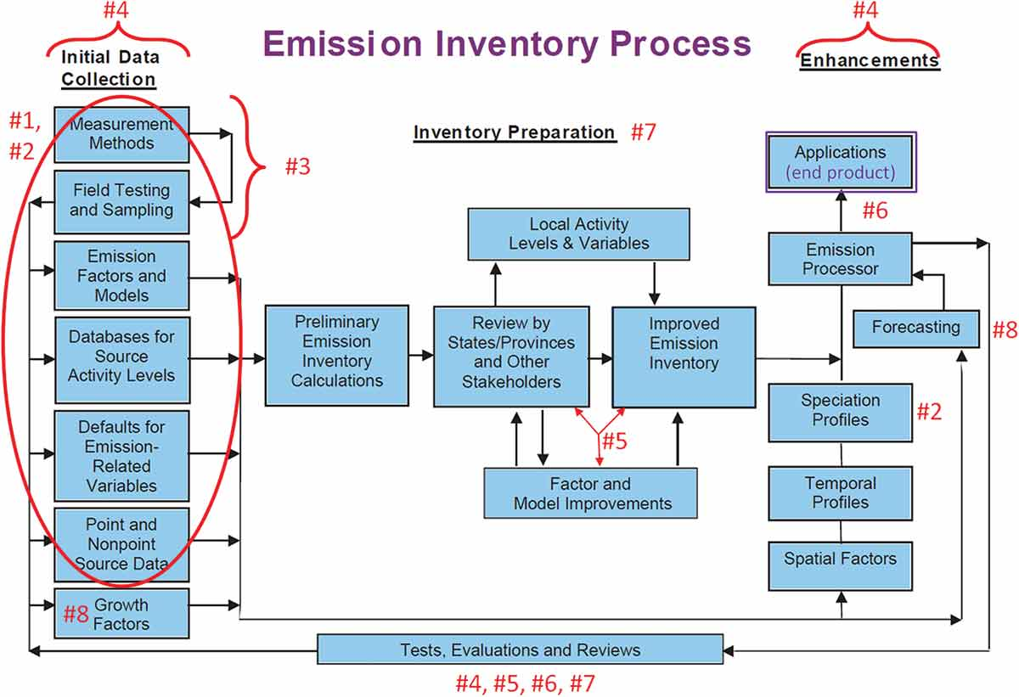

# NEI Goals

The NEI program has five key goals that support emissions methods improvements. These form the basis of work to continuously improve the NEI to meet stakeholder needs:

* Complete: The inventory should include all emissions to the atmosphere, whether regulated or unregulated, for all states, counties, tribes, and territories;
* Representative: The emissions values for a given year should represent, as best as possible, the emissions that occurred during that inventory year;
* Use best available information: The emissions values should rely on the best available emissions inventory methods and emissions factors;
* Transparent: The inventory and associated documentation should include metadata about the origin of the data, including which party made the estimate (e.g., state or EPA), any emission factors, activity data used, and emissions methods; and
* Timely: Develop inventories in time to support EPA and stakeholder needs.

These goals require a balancing of priorities and a commitment to continuous improvement because they often compete with one another. For example, the “representative” goal is consistent with the science-based improvement of methods, whereas the “timely” goal may conflict with the time that it may take to complete a significant scientific advancement. Several years ago, as a response to NARSTO review, EIAG compressed the NEI timeline, taking 6 months out of state/local/tribal time and about one year out of EPA time. These changes tried to reduce the release time after the end of the inventory year from 3 years to 1.5 year, and for point sources, this has been successful. EPA continues to work to balance being timely with the other goals.

Given these challenges, it is important that our data partners realize that it is not always possible to know which NEI year a method improvement will first be used. However, data partners should also note that since emissions inventories are now developed every year for emissions modeling purposes rather than only for the triennial NEI years a method improvement that misses one year of emissions inventories can be used in the next year in anticipation of the next triennial inventory year.

# A Focus on Methods and Science Improvements and Coordinating with our Stakeholders

A common theme in these remaining areas of necessary inventory improvements is to improve estimation methods and the science involved in estimating emissions for the various sectors. The types of activities that EPA and stakeholders can work together on include:

* Review and improvements to the underlying bottom- up methods used to estimate emissions for a given sector
  + Improvements to emission factors
  + Improvements to activity data
  + Improvements that lead to a better understanding of controls in emissions processes
* Addition of previously uncharacterized pollutants to existing NEI sectors to support creating a complete inventory (e.g., hazardous air pollutants, criteria air pollutants, greenhouse gases)
* Chemical speciation of VOC and PM2.5 (specific guidelines for these activities are provided on the [SPECIATE](https://www.epa.gov/air-emissions-modeling/speciate) website)
* Improvements to temporal allocations from annual to hourly emissions for modeling
* Improvements to spatial allocation techniques that translate emissions from the county-level to model grid cells for modeling
* Enhancing user confidence in inventory data by developing manuscripts to be submitted to peer-reviewed journals that outline improvements to emissions estimation methods
* Identification of previously unquantified but significant emissions sources and the creation of new methods to quantify their emissions.

As noted above, the current list of known emissions inventory needs and challenges is maintained on the Air Emissions Inventory website “Collaboration” page, at https://www.epa.gov/air-emissions-inventories. When we partner with researchers on methods development, a high degree of importance is given to documentation and peer-reviewed publications.

# Stakeholders Input Needed on Methods

In EIAG, we prioritize our resources to develop methods for improving emissions and adding new sectors to the NEI based on stakeholder input. For example, air quality modelers may describe model results that consistently under- or over-predicted a pollutant as compared to ambient data in a certain region, which may be due to model emissions. Investigations are then needed to try to determine if there are inventory-related causes, such as emission gaps or double counting, issues in the temporal or spatial allocation of emissions, or a mischaracterization in the chemical speciation of emissions. Sometimes such research finds interactions between inventory issues and model chemistry and/or physics that need improvements both to emissions inventories and air quality models. As we identify and develop methods to address these challenges, we to work with industry, academic researchers, and government researchers across the Federal and state spectrum. As a method comes closer to use for a specific emissions inventory year, we work closely with state, local, and tribal emissions inventory developers to ensure they understand methods improvements and can comment on those methods for possible use to represent emissions in their jurisdictions.

The types of stakeholder input that are helpful to our work is:

* Identification of ongoing air quality planning or research challenges that may have an emissions inventory component.
* Comments on priorities from a stakeholder perspective on known missing sectors or opportunities for methods improvements.
* Information about ongoing research that could be included in the NEI in the future.
* Review and comments on new methods that are released by EPA for comment, including the scientific basis, data that the EPA did not considered, or other information sources that could further improve EPA methods. Such information could include source testing results or published emissions factors that EPA did not consider.
* Interest in collaborating on method development for a possible future journal article or other citable publication.

# Timing

The NEI program publishes both triennial emissions inventories and develops annual modeling platforms. Thus, we release new data products each year and emissions method improvements are incorporated into each new release. This iterative approach provides researchers and other stakeholders with many opportunities to have their work included in the NEI, but advanced planning is needed to ensure that the work has a seamless transition from research into our products.

Depending on the complexity of the work and available personnel and resources, a new method or a method update can take between 1 and 3 years to be included in the NEI or modeling platform. Researchers who are interested in supporting the NEI program should reach out to the NEI methods lead (see [NEI Contacts](https://www.epa.gov/air-emissions-inventories/air-emissions-points-contact) website) to discuss. Early discussions can help facilitate an agreement on when collaborations can occur and what would specifically be needed for the NEI program to incorporate that work.

State, local, and tribal emissions inventory experts have a unique relationship with the NEI program. These experts are obligated to provide data to the EPA and are responsible for verifying that their jurisdiction’s emissions are properly represented in the NEI. This helps ensure that any future regulatory work using the NEI will reflect their emissions properly. The Air Emissions Reporting Requirements (AERR) rule (40 CFR Part 51) includes back-and-forth review of various data and materials leading up to each triennial emissions inventory. Each triennial inventory effort has its own development schedule, and in general, the EPA needs to finalize methods well in advance of that inventory year. The following list provides a general timeframe for when new methods should be completed prior to a given inventory year:

* **Nonpoint stationary sources**: Methods should be completed the year in which the emissions are occuring (for example, methods intended to be used for the 2020 NEI should be completed in 2020 for incorporation into the process for reporting during 2021).
* **Fires:** New fire models and emission factors should be completed the year in which the emissions are occuring (same as for nonpoint). This permits enough time for testing and quality assurance by EPA prior to creating draft emissions estimates for review by stakeholders.
* **Point:** New methods and improvements to methods should be completed the year in which the emissions are occurring, as discussed for both the fires and nonpoint categories.
* **Mobile Sources**: OAQPS to work with the Office of Transportation and Air Quality to improve needed methodologies and emission estimates in MOVES (onroad and offroad) in time for implementation in the next triennial inventory in the cycle. Included in this process would be suggestions for making improvements to various aspects of the MOVES model.
* **Speciation:** EPA incorporates speciation factors into the SPECIATE database and releases the database every two years. Speciation profile data can be provided to EPA at any time using the guidelines provided, and the EPA will incorporate this data into SPECIATE as resources permit. Once the profiles are in SPECIATE, the EPA will consider their use in its emissions estimation tools. In some cases, profiles can be used that are planned to be incorporated into SPECIATE but not officially in the database. Specific guidelines for data partners are provided on the [SPECIATE](https://www.epa.gov/air-emissions-modeling/speciate) website.
* **Temporal and spatial allocation:** The methods used to temporally and spatially allocate emissions from all sectors can be important for use in regulatory air quality modeling and in other assessments. For onroad and nonroad mobile, these data need to be completed with 15 months after the year in which the emissions are occuring. For other sectors, these data need to be completed by the same time the NEI emissions are complete for an associated data category. Thus, these data need to be available by 18 to 27 months after the year in which the emissions are occuring. For example, for the 2020 NEI and associated modeling, temporal and spatial data would be needed by July of 2022 for mobile and point sources at the earliest and by March of 2023 for nonpoint sources.

Once we undertake a collaborative project, we develop timelines and other plans and share with our stakeholder community so that stakeholders are aware of pending developments and have an opportunity to participate. As the work evolves, sometimes the research takes longer than expected and plans need to change. As such, the NEI program will have a backup plan to use for a given method, in the event the work on the new approach is not able to meet the timelines laid out to ensure the data can be incorporated into the targeted inventory year. While this can be disappointing to data partners, such an approach is needed to ensure appropriate time is available for other stakeholder review, quality assurance, and to incorporate the method into the standard NEI development processes needed to keep the program running smoothly.

For triennial inventories, this means including our plans for new and improved methods in the NEI plan, which is released in draft in the spring of a triennial year and then in final form 6-8 months into an emissions year (for example, the 2020 NEI plan was released in final form in August 2020, with stakeholder comments preceding that). This allows for comments to be made on our program priorities. For a method to be considered for inclusion in the NEI plan, the method is usually completed (or nearly so) with documentation already available on the expected impact to the inventory, even if all of the details and implementation for a given inventory year have not been completed.

# Conclusions

We encourage researchers and other stakeholders to participate with EPA in improving emissions inventory data. As described here, EPA provides numerous opportunities for collaboration. There is much important work to be done to further improve the science and methods for emissions estimates and the impact of new data on modeled air quality. For more information and a list of known needs, please refer to the Air Emissions Inventory website “Collaboration” page. For more information or to discuss a specific possible collaboration, please reach out to the NEI methods lead (see [NEI Contacts](https://www.epa.gov/air-emissions-inventories/air-emissions-points-contact) website).

1. # References

   NARSTO. 2006. Emission inventory. Accessed November 8, 2018. <https://www.narsto.org/emission_inventory_1>.
2. Melissa Day, George Pouliot, Sherri Hunt, Kirk R. Baker, Megan Beardsley, Gregory Frost, David Mobley, Heather Simon, Barron B. Henderson, Tiffany Yelverton & Venkatesh Rao (2019) Reflecting on progress since the 2005 NARSTO emissions inventory report, Journal of the Air & Waste Management Association, 69:9, 1023-1048, DOI: 10.1080/10962247.2019.1629363