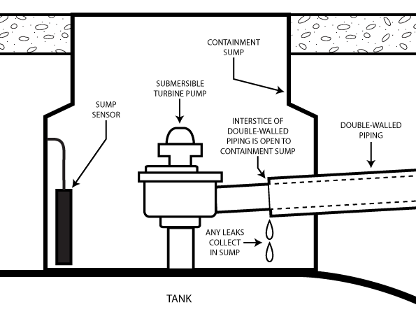

Owner and Operator Introduction:

Automated Interstitial Monitoring Systems for Underground Pressurized Piping on Emergency Power Generator UST Systems

**Contents**

**Purpose 1**

**Background 2**

**Section 1: General Discussion about using AIM Systems on Pressurized Piping Systems 3**

**Section 2: Description of AIM Systems 4**

**Section 3: Examples of AIM Systems 6**

**Section 4. O&M Testing and Inspection Requirements At-A-Glance 9**

**Section 5: Required Documentation from UST System Owners and Operators 12**

**Section 6: AIM Systems Inspection and Testing Checklists 16**

# Purpose

This document provides owners and operators of emergency power generator (EPG) underground storage tank (UST) systems with information about using automated interstitial monitoring (AIM) systems on their EPG UST systems. AIM systems monitor pressure, vacuum, or liquid levels or use liquid-detecting sensors located in containment sumps that are part of secondarily contained piping systems to meet federal release detection requirements for pressurized piping.

This document provides basic information and introduces EPG UST system owners and operators to AIM systems. It contains helpful forms and checklists to assist them with verifying AIM system compliance with their UST implementing agency and complying with periodic testing requirements for their AIM system.

The U.S. Environmental Protection Agency (EPA) encourages owners and operators to work with their UST system installer, fuel system designer, or other qualified professional, when installing or modifying their fuel storage system to meet federal UST regulatory requirements. This document does not address all issues regarding AIM systems. For a complete discussion about AIM systems, see EPA’s *In-Depth Discussion: Automated Interstitial Monitoring Systems for Underground Pressurized Piping Systems on Emergency Power Generator UST systems at* <https://www.epa.gov/ust/depth-discussion-automated-interstitial-monitoring-systems-underground-pressurized-piping>.

# Background

The 2015 federal UST regulation no longer defers EPG UST systems from release detection requirements. EPG UST systems contain unique features that are not characteristic of UST systems installed at conventional UST facilities, such as retail gas stations or convenience stores and non-retail facilities. Features unique to EPG UST systems include return product piping, day tanks, and a power generator. Prior to 2015, many EPG UST systems were understandably installed without consideration for meeting federal UST system release detection requirements.

***Note: This document uses the terms monthly or month and annually or annual. These terms in the context of federal release detection requirements mean at least once every 30 days and not to exceed 365 days, respectively.***

In addition to compliance with the UST regulations, various fire code requirements apply to power generator systems which owners and operators must consider and address. Some EPG UST systems include relatively long pipe runs that begin at underground locations, extend through multiple stories, run within walls, and continue through other building structures. These pipe runs contain underground and aboveground piping, some without transition sumps or separation points that more easily allow testing of the underground piping components, as required by the federal UST regulation.

For information on EPG compliance with the federal UST requirements, reference EPA’s *Federal UST Requirements for Emergency Power Generator UST Systems* at <https://www.epa.gov/ust/federal-ust-requirements-emergency-power-generator-ust-systems>.

# Section 1: General Discussion about Using AIM Systems on Pressurized Piping Systems

The federal UST regulation requires that UST system owners and operators with underground pressurized piping equip their systems with an automatic line leak detector that will alert the owner or operator to the presence of a leak. The alert either restricts or shuts off the flow of regulated substances through piping or triggers an audible or visual alarm. In addition to the automatic line leak detector, UST system owners and operators must have a second release detection method by meeting one of the two below requirements, as applicable:

* Pressurized piping installed on or before April 11, 2016, must have an annual line tightness test conducted according to 40 CFR § 280.44(b) or have monthly monitoring conducted according to 40 CFR § 280.44(c).
* Pressurized piping installed or replaced after April 11, 2016, must use monthly interstitial monitoring according to 40 CFR § 280.43(g). To comply with Energy Policy Act of 2005 requirements, most state UST implementing agencies established compliance dates for their secondary containment and interstitial monitoring requirements that pre-date the federal compliance date.

For all pressurized piping systems associated with EPG UST systems, regardless of the date of installation of the piping system, EPA recognizes the use of an AIM system as an option to meet both release detection requirements for pressurized piping systems.

# Section 2: Description of AIM Systems

AIM systems are secondary containment systems that include piping and all connected containment sumps, for example submersible turbine pump, transition, collection, and detection containment sumps. The piping and connected sumps have been specifically designed and constructed by the manufacturer and in accordance with a code of practice (UL or other nationally recognized association) for containment purposes and are compatible with fuels stored in the EPG UST system.

Note: Category 1 and 2 systems will likely also use containment sumps and liquid-detecting sensors to meet the piping interstitial monitoring requirement associated with secondary containment areas. Unless all piping components within a sump are double-walled or otherwise secondarily contained, the underlying sump is the secondary containment and must be monitored for releases. This typically is accomplished using a liquid-detecting sensor.

There are three categories of AIM systems: category 1, category 2, and category 3. An audible or visual alarm notifies a breach in any of these systems.

* Category 1 is a pressure or vacuum system. This system monitors for the change of either pressure or vacuum levels within the interstice. This system continually monitors the integrity of both the inner and outer walls of double-walled piping.
* Category 2 is a liquid-filled system that monitors for changes in the level of a liquid such as brine or propylene glycol solutions within the reservoir holding the interstitial liquid. This system also continually monitors the integrity of both the inner and outer walls of double-walled piping.
* Category 3 is a dry interstice system. This system uses float-based or other type sensors typically located in containment sumps to monitor dry interstitial spaces that are used for piping interstitial monitoring. Category 3 AIM system uses liquid-detecting sensors to monitor for a leak through the inner wall. A breach of product through the primary wall is conveyed through the interstice to the containment sump where it contacts the sensor.

Categories 1, 2, and 3 AIM systems are composed of the same components, except that category 1 and 2 systems contain a pressure or vacuum monitor or liquid monitoring reservoir, respectively, located at various places in the piping run.

## List of Key Components of AIM Systems

* Double-walled piping with full interstitial communication
  + Piping that is a secondary contained system. It is a pipe within a pipe, or pipe encased in an outer covering, with an interstitial space between the outer and inner piping walls. All components must be compatible with the product stored.
* Monitoring points: pressure, vacuum, or liquid reservoirs (category 1 and 2 systems) or containment sumps (primarily category 3 systems)
  + Dedicated areas used to monitor piping for loss of product or change in condition of pressure, vacuum, or liquid level.
* Sensors
  + Pressure sensors or liquid-detecting sensors (category 1 or category 2 systems, respectively)
    - Sensors designed to respond to changes in pressure (vacuum) or changes in liquid-level within monitoring reservoir)
  + Liquid-detecting sensors (category 3 systems) using various operating principles such as float-based, optical and hydrocarbon polymer sensitive.
* Leak detection monitoring console with alarm system (audible or visual)
  + An automatic tank gauging system or other system controller (i.e., console) that works in conjunction with the pressure, vacuum, or liquid reservoirs, or liquid-detecting sensors to determine potential product loss from the AIM system. They contain an audible or visual alarm component that is configured to relay an alarm condition to an appropriate alarm. The alarm condition must be conveyed to the attention of specific individuals such as a designated Class A, B, or C operator or petroleum or power services contractor within one hour of the suspected release.

# Section 3: Examples of AIM Systems

## Category 1 Systems: Continuous Monitoring using Pressure or Vacuum-Based Methods

### **Example 1.1 (Pressure)**

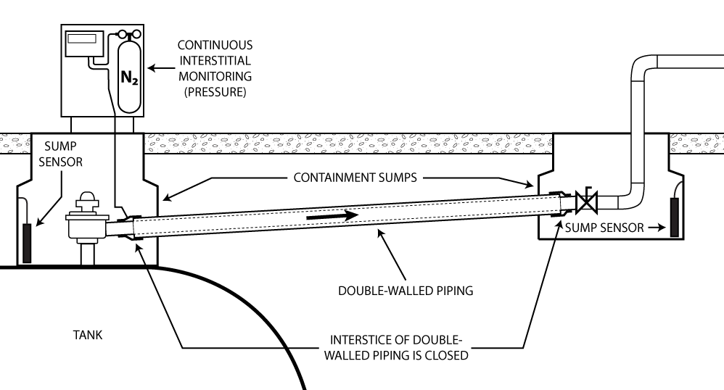

SYSTEM END POINTS

### 

### **Example 1.2 (Vacuum)**

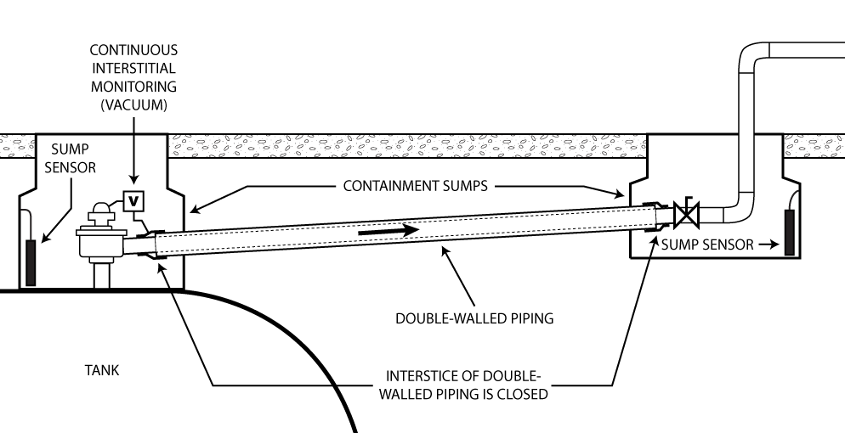

SYSTEM END POINTS

## Category 2 Systems: Continuous Monitoring using Liquid-Filled Piping Interstice Methods

### **Example 2.1**

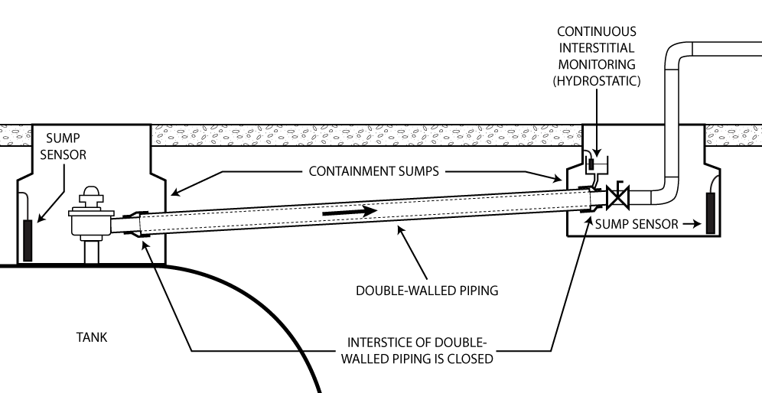

SYSTEM END POINTS

Page 17 of EPA’s *In-Depth Discussion: Automated Interstitial Monitoring Systems for Underground Pressurized Piping Systems on Emergency Power Generator UST Systems* discusses information presented on the National Work Group on Leak Detection Evaluation’s (NWGLDE) website. NWGLDE identifies several listings of equipment that have been third-party evaluated. These equipment evaluations are not specific for use on or as AIM systems detailed in this document. The equipment identified is potentially adaptable for use in category 1 and category 2 AIM systems designed for EPG UST systems.

## Category 3 Systems: Liquid-Detecting Sensors – Sump Monitoring to Sensor Activation Point

A basic category 3 AIM system design depicted below highlights two key system components of this standard design: double-walled piping and the sumps being monitored by dry interstitial sensors. The one-hour period for alarm system notification involves the combination of the time it takes for the total interstitial volume of the double-walled piping to fill up from a product leak from a breach in the primary wall to flow through the piping interstice and accumulate within the sump to where it activates the sensor at the sensor threshold.

### **Example 3.1**

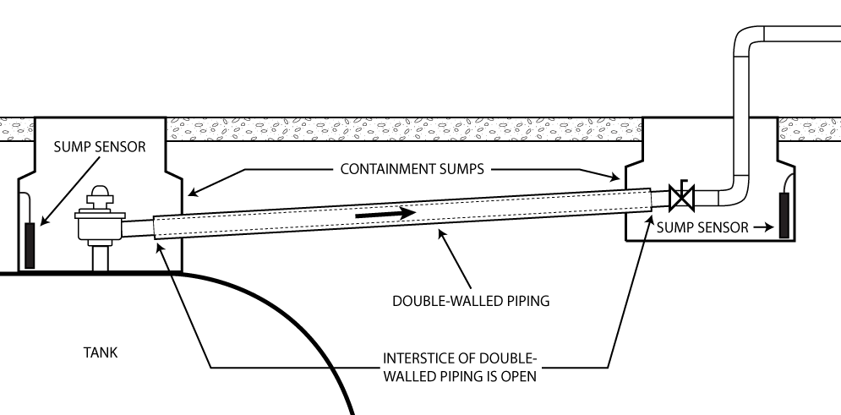

SUBMERSIBLE TURBINE PUMP (STP) SUMP

TRANSITION SUMP

Page 22 of EPA’s *In-Depth Discussion: Automated Interstitial Monitoring Systems for Underground Pressurized Piping Systems on Emergency Power Generator UST systems* discusses the design of category 3 systems. It provides:

* Tables that show maximum lengths of double-walled piping that can be used in category 3 AIM systems.
* Tables with examples of commercially available pipe with their corresponding interstitial volumes and general reference standards based on set interstitial volumes of double-walled piping.
* Step-by-step design of a basic category 3 system.
* Suggested system improvements to the basic design of category 3 systems.
* Several variations of the AIM system design for category 3 systems:
  + Use of a small container attached directly to the piping interstice as a concentrated collection point instead of a larger containment sump.
  + Use of a liquid-detecting cable run within the length of the piping interstice.This design provides multiple liquid contact points installed within secondary containment areas.

# Section 4. O&M Testing and Inspection Requirements at a Glance

| Type of AIM System, Components, and Required Actions  (As Applicable) | Required Testing Frequency | Regulatory Citation | Comments |
| --- | --- | --- | --- |
| Category 1 & 2 Systems | | | |
| Monitoring console   * Verify system configuration * Test alarm * Test battery backup | Annual | 280.40(a)(3)(i) | This can be an automatic tank gauge (ATG) or another controller |
| Sensors   * Test alarm operability for communication with controller | Annual | 280.40(a)(3)(ii) | For all sensors, pressure/vacuum and liquid detecting sensors |
| Sensors   * Inspect for residual buildup | Annual | 280.40(a)(3)(ii) | For liquid detecting sensors |
| Automatic Line Leak Detector (ALLD)  Test and inspect:   * Double-wall (DW) piping * Monitoring reservoir(s) * Containment sumps at end points | Annual | 280.40(a)(3)(iii) | * The piping interstitial space and the pressure, vacuum, or liquid monitoring reservoir(s) and sensors (pressure, vacuum, or stand-alone liquid detecting sensor, as applicable), and containment sumps at endpoints, comprise the automatic line leak detector. * Testing of monitoring reservoir and sensors follows vacuum pumps and pressure gauge testing, noted on the table. * Owners and operators must test their DW piping to verify the tightness of the interstitial space. This can be done with a system check. * Verification of the integrity of the containment sumps at endpoints is required annually. This could be by testing of the sump or if the sump is DW, proving that the interstitial space of the containment sump has integrity. * Annual integrity testing of containment sumps at endpoints that varies from that in 280.35(a)(1)(ii) may be used to test full area of sumps(s) or area of sump(s) to the point of each sensor’s activation threshold, if equipped with liquid detecting sensor(s). |
| Monitoring Points (reservoirs and sumps) | | | |
| Monitoring reservoir   * Ensure proper communication of vacuum pumps and pressure gauges with sensors and controllers | Annual | 280.40(a)(3)(iv) | Verify that the pressure, vacuum, or liquid detecting sensor triggers the alarm at the appropriate threshold and communicates that to the monitoring console. |
| Containment sumps at end points of category 1 or 2 systems (see example 1.1, 1.2 or 2.1)   * Test containment sumps used for piping interstitial monitoring.   Note: If DW containment sump with periodic monitoring of the integrity of both walls of the sump, sump testing to comply with 280.35(a)(1)(ii) is not required. | Every three years | 280.35(a)(1)(ii) | As a component of the ALLD, as noted on table, integrity/functionality of containment sumps at end points must be verified annually. Owners and operators testing annually using a recognized low-level sump testing procedure would meet the regulatory requirement. If the owner and operator use an annual test that varies from what is allowed under 280.35 (a)(1)(ii), then once every three years a test must be completed that complies with 280.35(a)(1)(ii). |
| Category 3 System | | | |
| Monitoring console (e.g., ATG or another controller)   * Verify system configuration * Test alarm * Test battery backup | Annual | 280.40(a)(3)(i) | --- |
| Sensors   * Test alarm operability for communication with controller * Inspect for residual buildup | Annual | 280.40(a)(3)(ii) | For liquid detecting sensors |

| Type of AIM System, Components, and Required Actions  (As Applicable) | Required Testing Frequency | Regulatory Citation | Comments |
| --- | --- | --- | --- |
| Category 3 System (Continued) | | | |
| ALLD  Test and inspect:   * DW piping * Area of containment sump(s) to the activation point(s) of the sensor(s)   Note: If DW containment sump with periodic monitoring of the integrity of both walls of the sump, sump testing is not required. | Annual | 280.40(a)(3)(iii) | * The piping interstitial space and the area of the sump(s) used for interstitial monitoring (to the point of each sensor’s activation threshold) and liquid detecting sensors comprise the automatic line leak detector. * Owners and operators must test their DW piping (by air test) to verify tightness of the interstitial space. * Verification of the integrity of the containment sump is required annually. This could be by testing of the sump or if the sump is DW, proving that the interstitial space of the containment sump has integrity. * Annual integrity test of containment sump that varies from that in 280.35(a)(1)(ii) may be used to test area of sump(s) to the point of each sensor’s activation point. |
| Containment sump   * Test containment sumps used for interstitial monitoring to ensure liquid tight using vacuum, pressure, or liquid testing. | Every three years | 280.35(a)(1)(ii) | * As a component of the ALLD, integrity/functionality of containment sump(s) must be verified annually. Owners and operators testing annually using a recognized low-level sump testing procedure would meet the regulatory requirement. If the owner and operator use an annual test that varies from 280.35 (a)(1)(ii) then once every three years a test must be completed that complies with 280.35(a)(1)(ii). |

For more information on low-level sump testing, see EPA’s [technical compendium.](https://www.epa.gov/ust/underground-storage-tank-ust-technical-compendium-about-2015-ust-regulation#:~:text=in%20Indian%20country.-,Containment%20Sump%20%E2%80%93%C2%A0Test%20Procedures,.,-UST%20Sump%20Test)

Section 10 of EPA’s “In-Depth Discussion: Automated Interstitial Monitoring Systems for Underground Pressurized Piping Systems on Emergency Power Generator UST systems,” discusses AIM system testing more in depth.

# Section 5: Required Documentation from UST System Owners and Operators

## Basic Documentation Design and Installation Criteria

40 CFR § 280.40(a)(4) requires that UST system owners and operators provide a method, or combination of methods, of release detection that meets the release detection performance requirements with any performance claims and their manner of determination described in writing by the equipment manufacturer or installer.

There are many variations among individual UST site conditions and system configurations across the United States. This is especially applicable to EPG UST systems. Because of these variations, a complete AIM system would have to be manufactured and installed onsite as a unit to meet the release detection method requirements. AIM systems are comprised of several components. No one component manufacturer can verify that applicable regulatory performance requirements can be met for the entire system.

UST system owners and operators can use the *Certification of Compliance Form* on page 14 to verify that their AIM systems meet design and installation criteria. The equipment installer, a licensed professional engineer, or other professional required by the applicable UST implementing agency must sign this form. EPG UST system owners and operators in Indian Country, where the federal UST regulation (40 CFR part 280) applies, may submit this form to the applicable EPA regional office. [EPA’s UST website lists EPA Regional UST contacts](https://www.epa.gov/ust/underground-storage-tank-ust-regional-contacts).

UST system owners and operators in other jurisdictions should contact their UST implementing agency to determine whether the agency allows use of an AIM system to meet its regulatory requirements and whether this sample form meets the agency’s documentation requirements. Note that many state UST implementing agencies require UST system installers to be licensed. [EPA’s UST website lists state UST contacts](https://www.epa.gov/ust/underground-storage-tank-ust-state-contacts).

The checklist below covers testing requirements applicable to AIM systems. This checklist helps owners and operators identify and comply with key operation and maintenance testing requirements associated with AIM systems. This checklist does not include all testing requirements that owners and operators of EPG UST systems must meet. For additional information on meeting federal UST requirements applicable to other equipment and components of EPG UST systems see EPA’s *Federal UST Requirements for Emergency Power Generator UST Systems* at <https://www.epa.gov/ust/federal-ust-requirements-emergency-power-generator-ust-systems>.

Fillable PDFs of the checklists below are available at <https://www.epa.gov/ust/certification-inspections-and-testing-forms-automated-interstitial-monitoring-systems>

|  |  |  |  |  |  |  |
| --- | --- | --- | --- | --- | --- | --- |
| Certification of Compliance Form: Use of AIM System for EPG UST Facility (Page 1 of 2) | | | | | | |
| Facility Name | | Facility ID # | | | | |
| Physical Address | | | | | | |
| City | County | | | | State | |
| UST Owner | | | | | | |
| Installer or PE’s Signature | | | | | | |
| Printed Name of Installer or PE | | | | | | |
| Description | | Line # / Product | Line # / Product | Line # / Product | | Line # / Product |
| Line Number / Product | |  |  |  | |  |
| Piping Manufacturer | |  |  |  | |  |
| Piping Model | |  |  |  | |  |
| Pipe Diameter / Length of Pipe | | **/** | **/** | **/** | | **/** |
| Approximate Pipe Interstice Volume (Gallons) | |  |  |  | |  |
| Type of AIM System (Category #) | | p 1 p 2 p 3 | p 1 p 2 p 3 | p 1 p 2 p 3 | | p 1 p 2 p 3 |
| Category 1 or Category 2 Aim Systems | | | | | | |
| Pressure (P) / Vacuum (V) / Liquid Reservoir Manufacturer | |  |  |  | |  |
| P / V / Liquid Reservoir Model | |  |  |  | |  |
| **Note:** Some category 1 and 2 systems may also have containment sumps with liquid-detecting sensors like those used in category 3 systems. These sumps may not be monitored by the pressure, vacuum, or liquid reservoirs. The sumps may be needed to monitor single-walled piping components inside the sump. As a containment sump used for interstitial monitoring of piping, the sumps must be tested for integrity once every three years.  **Note:** Containment sump testing is not required if the containment is double-walled and uses periodic interstitial monitoring that monitors the integrity of both walls of the sump. | | | | | | |
| **Comments** | | | | | | |

|  |  |  |  |  |
| --- | --- | --- | --- | --- |
| Certification of Compliance Form: Use of AIM System for EPG UST Facility (Page 2 of 2) | | | | |
| Category 3 Aim Systems | | | | |
| Sump Sensor Manufacturer |  |  |  |  |
| Sump Sensor Model |  |  |  |  |
| Secondary Pipe Open to Secondary Containment Sumps or Collection Point? | p Yes p No | p Yes p No | p Yes p No | p Yes p No |
| Secondary Containment Sumps | | | | |
| Containment Sump Manufacturer |  |  |  |  |
| Containment Sump Model |  |  |  |  |
| Automatic Tank Gauge or Monitoring Console | | | | |
| Monitoring Console Manufacturer |  |  |  |  |
| Monitoring Console Model |  |  |  |  |
| With Alarm | p Yes p No | p Yes p No | p Yes p No | p Yes p No |
| Alarm | | | | |
| Alarm Manufacturer |  |  |  |  |
| Alarm Model |  |  |  |  |
| **Comments** | | | | |

Attach relevant site diagram, pictures, as-built drawings and other supporting documentation as required by UST implementing agency.

# Section 6: AIM Systems Inspection and Testing Checklis

Fillable PDFs of the checklists below are available at <https://www.epa.gov/ust/certification-inspections-and-testing-forms-automated-interstitial-monitoring-systems>

|  |  |  |  |  |  |  |
| --- | --- | --- | --- | --- | --- | --- |
| AIM System Inspection and Testing Checklist: Category 1 or 2 (Page 1 of 2) | | | | | | |
| UST Facility | | | | Person Completing Checklist | | |
| Facility Name | | Facility ID # | | Name | | |
| Physical Address | | | | Company | | |
| City | County | | State | City | | State |
| UST Owner | | | | Signature | | Date Completed |
| Description | | Line 1 | | Line 2 | Line 3 | Line 4 |
| Type of AIM System (Category #) | | p 1 p 2 | | p 1 p 2 | p 1 p 2 | p 1 p 2 |
| Attach a copy of the Certification Form for detailed system description. | | | | | | |
| Walkthrough Inspections [280.36] | | | | | | |
| **Annual** | | | | | | |
| * Visually check containment sumps at end points for damage and leaks to the containment area or releases to the environment. Remove water and debris. | | p | | p | p | p |
| * For double-walled sumps with interstitial monitoring, check for a leak in the interstitial area. | | p | | p | p | p |
| **Every 30 Days** | | | | | | |
| * Check that system is operating with no alarms or unusual operating conditions. | | p | | p | p | p |
| * Ensure records of system component testing listed below are reviewed and current | | p Pass  p Fail | | p Pass  p Fail | p Pass  p Fail | p Pass  p Fail |
| **Note:** The steps below are not required to be performed every 30-days as part of the walkthrough inspection. Most steps must be performed annually. Use this checklist to verify that each step has been performed within one year (i.e., 365 days) of the previous test, unless otherwise noted. If *No* is checked for any of the steps, the AIM system fails. Provide copies of all relevant test forms upon request to the UST implementing agency. | | | | | | |
| Testing (Required Annually - Unless Otherwise Noted) | | | | | | |
| **Monitoring Console 280.40(a)(3)(i)** | | | | | | |
| * Verify system configuration. | | p Yes p No | | p Yes p No | p Yes p No | p Yes p No |
| * Test alarm | | p Yes p No | | p Yes p No | p Yes p No | p Yes p No |
| * Test battery backup | | p Yes p No | | p Yes p No | p Yes p No | p Yes p No |
| **Date Last Test** | |  | |  |  |  |
| **Test Results** | | p Pass  p Fail | | p Pass  p Fail | p Pass  p Fail | p Pass  p Fail |
| **Sensors 280.40(a)(3)(ii)** | |  | |  |  |  |
| * Test alarm operability for communication with controller/monitoring console. | | p Yes p No | | p Yes p No | p Yes p No | p Yes p No |
| * Inspect for residual buildup. | | p Yes p No | | p Yes p No | p Yes p No | p Yes p No |
| **Date Last Test** | |  | |  |  |  |
| **Test Results** | | p Pass  p Fail | | p Pass  p Fail | p Pass  p Fail | p Pass  p Fail |
| AIM System Inspection and Testing Checklist: Category 1 or 2 (Page 2 of 2) | | | | | | |
| Testing (Continued) | | | | | | |
| Description | | Line 1 | | Line 2 | Line 3 | Line 4 |
| **ALLD 280.40(a)(3)(iii)** | | | | | | |
| * DW piping.   Verify integrity of interstitial space by air testing piping. Ensure vacuum pumps and pressure gauges are operating within manufacturer’s specifications. | | p Yes p No | | p Yes p No | p Yes p No | p Yes p No |
| * Monitoring reservoir.   **Note:** Testing of this component covered below. Listed to show as part of ALLD. | | p Yes p No | | p Yes p No | p Yes p No | p Yes p No |
| * Containment sumps at endpoints.   **Note:** Verification of integrity could be by testing of the sump or if the sump is DW, proving that the interstitial space of the containment sump has integrity. Annual integrity testing of containment sumps at endpoints that varies from that in 280.35(a)(1)(ii) may be used to test full area of sumps(s) or area of sump(s) to the point of each sensor’s activation threshold, if equipped with liquid detecting sensor(s). | | p Yes p No | | p Yes p No | p Yes p No | p Yes p No |
| **Date Last Test** | |  | |  |  |  |
| **Test Results** | | p Pass  p Fail | | p Pass  p Fail | p Pass  p Fail | p Pass  p Fail |
| **Monitoring Points 280.40(a)(3)(iv)** | | | | | | |
| * **Monitoring Reservoir (P / V / Liquid)** | | | | | | |
| * Ensure proper communication of vacuum pumps and pressure gauges with sensors and controllers, as applicable. Verify that the pressure, vacuum, or liquid detecting sensor triggers the alarm at the appropriate threshold and communicate that to the monitoring console. | | p Yes p No | | p Yes p No | p Yes p No | p Yes p No |
| * P / V System Calibrated Per Manufacturer’s Instructions. 280.40(a)(2) | | p Yes p No | | p Yes p No | p Yes p No | p Yes p No |
| **Describe calibration completed and frequency:** | | | | | | |
| **Containment Sumps At End Points 280.35(a)(1)(ii) – Required Once Every Three Years** | | | | | | |
| * Test containment sumps used for piping interstitial monitoring to ensure liquid tight by using vacuum, pressure, or liquid testing. | | p Yes p No | | p Yes p No | p Yes p No | p Yes p No |
| **Notes:** If DW containment sump with periodic monitoring of both walls of the sump, sump testing to comply with 280.35(a)(1)(ii) is not required. | | | | | | |
| Owners and operators testing annually using a recognized low-level sump testing procedure would meet the regulatory requirement. If the owners and operators use an annual test that varies from what is allowed under 280.35 (a)(1)(ii), then a test that complies with 280.35(a)(1)(ii) must be completed once every three years. | | | | | | |
| **Date Last Test** | |  | |  |  |  |
| **Test Results** | | p Pass  p Fail | | p Pass  p Fail | p Pass  p Fail | p Pass  p Fail |
| **Comments** | | | | | | |
| AIM System Inspection and Testing Checklist: Category 3 (Page 1 of 2) | | | | | | |
| UST Facility | | | | Person Completing Checklist | | |
| Facility Name | | Facility ID # | | Name | | |
| Physical Address | | | | Company | | |
| City | County | | State | City | | State |
| UST Owner | | | | Signature | | Date Completed |
| Description | | Line 1 | | Line 2 | Line 3 | Line 4 |
| **Attach a copy of the Certification Form for detailed system description.** | | | | | | |
| Walkthrough Inspections [280.36] | | | | | | |
| **Annual** | | | | | | |
| * Visually check containment sumps at end points for damage, leaks to the containment area, or releases to the environment. Remove water and debris. | | p | | p | p | p |
| * For double-walled sumps with interstitial monitoring, check for a leak in the interstitial area. | | p | | p | p | p |
| **Every 30 Days** | | | | | | |
| * Check that system is operating with no alarms or unusual operating conditions. | | p | | p | p | p |
| * Ensure records of system component testing listed below are reviewed and current – Date of last test is not beyond 1-year (i.e., 365 days) from previous test. | | p Pass  p Fail | | p Pass  p Fail | p Pass  p Fail | p Pass  p Fail |
| **Note:** If any of the items below are marked as ***No***, then the AIM system fails. Provide copies of all relevant test forms upon request to the UST implementing agency. | | | | | | |
| Testing (Required Annually - Unless Otherwise Noted) | | | | | | |
| **Monitoring Console 280.40(a)(3)(i)** | | | | | | |
| * Verify system configuration. | | p Yes p No | | p Yes p No | p Yes p No | p Yes p No |
| * Test alarm | | p Yes p No | | p Yes p No | p Yes p No | p Yes p No |
| * Test battery backup | | p Yes p No | | p Yes p No | p Yes p No | p Yes p No |
| **Date of Last Test** | |  | |  |  |  |
| **Test Results** | | p Pass  p Fail | | p Pass  p Fail | p Pass  p Fail | p Pass  p Fail |
| **Sensors 280.40(a)(3)(ii)** | |  | |  |  |  |
| * Test alarm operability for communication with controller/monitoring console. | | p Yes p No | | p Yes p No | p Yes p No | p Yes p No |
| * Inspect for residual buildup. | | p Yes p No | | p Yes p No | p Yes p No | p Yes p No |
| **Date of Last Test** | |  | |  |  |  |
| **Test Results** | | p Pass  p Fail | | p Pass  p Fail | p Pass  p Fail | p Pass  p Fail |

|  |  |  |  |  |
| --- | --- | --- | --- | --- |
| AIM System Inspection and Testing Checklist: Category 3 (Page 2 of 2) | | | | |
| Description | Line 1 | Line 2 | Line 3 | Line 4 |
| Testing (Continued) | | | | |
| ALLD 280.40(a)(3)(iii) | | | | |
| * DW piping.   Test by air test to prove tightness of the interstitial space. | p Yes p No | p Yes p No | p Yes p No | p Yes p No |
| * Area of containment sump(s) to the activation point of the sensor.   **Note:** Integrity could be verified by testing the sump or if the sump is DW, by proving that the interstitial space of the containment sump has integrity. Annual integrity testing of containment sumps at end points that varies from that in 280.35(a)(1)(ii) may be used to test full area of sumps(s) or area of sump(s) to the point of each sensor’s activation threshold, if equipped with liquid detecting sensor(s). | p Yes p No | p Yes p No | p Yes p No | p Yes p No |
| **Date Last Test** |  |  |  |  |
| **Test Results** | p Pass  p Fail | p Pass  p Fail | p Pass  p Fail | p Pass  p Fail |
| **Monitoring Points 280.40(a)(3)(iv)** | | | | |
| **Containment Sumps used for Piping Interstitial Monitoring 280.35(a)(1)(ii) – Required Once Every Three Years** | | | | |
| * Test containment sumps used for piping interstitial monitoring to ensure liquid tight by using vacuum, pressure, or liquid testing. | p Yes p No | p Yes p No | p Yes p No | p Yes p No |
| **Notes:** If DW containment sump with periodic monitoring of both walls of the sump, sump testing to comply with 280.35(a)(1)(ii) is not required. | | | | |
| Owners and operators testing annually using a recognized low-level sump testing procedure would meet the regulatory requirement. If the owner and operator use an annual test that varies from what is allowed under 280.35 (a)(1)(ii), then once every three years a test must be completed that complies with 280.35(a)(1)(ii). | | | | |
| **Date Last Test** |  |  |  |  |
| **Test Results** | p Pass  p Fail | p Pass  p Fail | p Pass  p Fail | p Pass  p Fail |
| **Comments** | | | | |