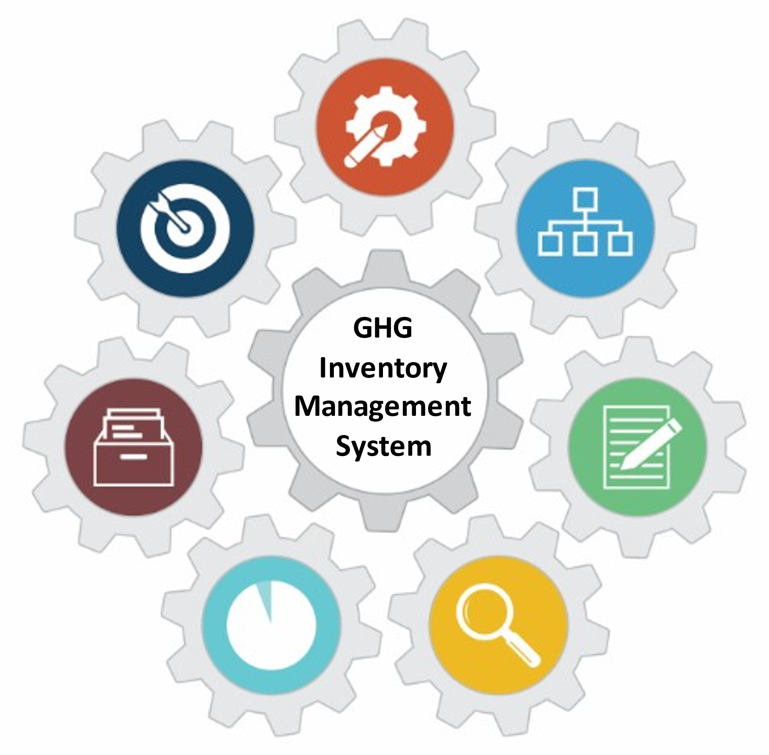

# U.S. EPA Toolkit for Building National GHG Inventory Systems

1. Inventory Planning

|  |  |
| --- | --- |
|  | **1. Inventory Planning** |
|  | 2. Institutional Arrangements |
|  | 3. Methods and Data Documentation |
|  | 4. QA/QC Procedures |
|  | 5. Key Category Analysis |
|  | 6. Archiving System |
|  | 7. National Inventory Improvement Plan |

Staff Member Responsible for Populating the Template: Contact Information

|  |  |  |  |
| --- | --- | --- | --- |
| Name: | [Enter text] | Organization name: |  |
| Title/Position: |  | Organization postal address: |  |
| Phone number: |  | Organization web address: |  |
| Email: |  | Organization phone number: |  |

Template 1. Inventory Planning Overview

|  |  |
| --- | --- |
| Introduction to Template 1. Inventory Planning | |
| Instructions | |
| Overview of Steps | |
| STEP 1 | Record the due dates for each stage of national GHG inventory preparation cycle in Table 1-1, below. |
| STEP 2 | Record progress towards completing each template in the series in Table 1-2, below. |
| Revision History | |

Abbreviations

ETF Enhanced Transparency Framework

GHG greenhouse gas

IPCC Intergovernmental Panel on Climate Change

MPG modalities, procedures, and guidelines

MRV measurement, reporting, and verification

NDC nationally determined contribution

QA/QC quality assurance/quality control

UNFCCC United Nations Convention on Climate Change

## Introduction to Template 1. Inventory Planning

The EPA has developed the *Toolkit for Building National Greenhouse Gas Inventory Systems* (‘Toolkit’) to help developing countries build their institutional capacity to establish, maintain, and improve sustainable inventory management systems, which facilitate and support preparing complete, high-quality greenhouse gas (GHG) inventories using the [*2006 Intergovernmental Panel on Climate Change Guidelines*](https://www.ipcc-nggip.iges.or.jp/public/2006gl/) (*2006 IPCC Guidelines*) and the [*2019 Refinement of the 2006 IPCC Guidelines*](https://www.ipcc.ch/site/assets/uploads/2019/12/19R_V0_01_Overview.pdf)(*2019 Refinement*) on a biennial basis.[1]

In the EPA’s Toolkit, this is Template 1. Its purpose is to explain how to use the Toolkit and provides tables to develop a national GHG inventory schedule and track progress with completing each template in the series. This template helps the National GHG Inventory Coordinator initiate and manage inventory planning and provides a table to record due dates for key compilation stages.[2] This template can facilitate GHG inventory planning for current (i.e., Biennial Update Report, National Communications) and future (i.e., Biennial Transparency Report, National Communications) reporting under the Enhanced Transparency Framework[3] to the United Nations Framework Convention on Climate Change (UNFCCC).

Under the Paris Agreement, the Enhanced Transparency Framework (ETF) established new common Modalities, Procedures, and Guidelines (MPGs) for reporting under Article 13. The MPGs are based on a set of guiding principles that allow for flexibility in reporting, in light of national circumstances, while promoting the consistency, completeness, and reliability of reports. The MPGs define the reporting information to be provided, the technical expert review methods, institutional arrangements, and a process by which nations inform the national community of progress toward their goals. The ETF provides built-in flexibility to those developing countries that need it, owing to their national capacities. Through the detailed guidance on the reporting, review, and consideration processes for the information to be submitted and by making these reports publicly available, the ETF will make it possible to track the progress made by each country. In this way, it will be possible to compare a country’s actions against its plans and ambitions as described in its Nationally Determined Contributions (NDCs).[4]

**Transition to Enhanced Transparency Framework (ETF)**

|  |  |
| --- | --- |
| Measurement, reporting, and verification (MRV) activities under the UNFCCC are transitioning to the Enhanced Transparency Framework (ETF) under Article 13 of the Paris Agreement. The ETF establishes a framework for all Parties to operate under a common set of modalities, procedures and guidelines (MPGs), with flexibility for developing country Parties.  A schedule for the ETF transition is shown here. |  |

## Instructions for Completing and Customizing Each Template

The intended user of the Toolkit is a country’s National Inventory Coordinator and members of its inventory compilation team. The introduction in each template provides guidance to the user on how to use and complete the template, such as a list of steps to complete and an explanation of the purpose of each step.

Each template in the Toolkit includes tables to be filled in with information about the national GHG inventory system that is being built or improved. These tables may be customized by adding, removing, or modifying columns or rows to better reflect your country’s particular needs or circumstances.

|  |  |
| --- | --- |
| Complete the cells that are shaded this color: |  |

Enter new information about your inventory in black text.

The blue text throughout each template provides detailed instructions and example responses to help you complete the tables. Once the tables are complete, delete all the blue text throughout the template. The remaining text or tables in black text may be used for reporting or to contribute to a National GHG Inventory System Manual.

### Suggested Roles and Responsibilities

Template 1 helps the National Inventory Coordinator prepare an overview of the inventory compilation schedule and cycle. To complete this template, the National Inventory Coordinator will carry out the steps defined below and follow the instructions throughout the remainder of this template. Suggested roles and responsibilities for this template are:

Role: National Inventory Coordinator

Responsibilities:

Complete the template

### Overview of Steps

|  |  |
| --- | --- |
| **Step** | **Purpose** |
| 1. **After reading this template, browse the other six templates in the Toolkit.** | Become familiar with all the elements in the series and develop a sense of their purpose that will facilitate you and your team’s completion of the template. Prepare to produce a manual describing your inventory management system. |
| 1. **Explain to all GHG inventory team members the purpose and intended outcomes of using these templates.** | Ensure a consistent understanding and approach of the whole team to completing these templates. Maximize the extent and quality of information that the team documents in the templates. |
| 1. **Complete the tables in this template.** | The tables in this template will provide you and the inventory team with an overview of progress towards completing the templates and documenting your inventory management system. |
| 1. **Periodically return to and update Table 1-2 Overall Template Progress.** | Maximize the benefits from completing these templates and use them as a resource for you and the inventory team throughout the inventory compilation process and for each subsequent inventory. EPA recommends including time in the national GHG inventory schedule at the beginning of each cycle and during compilation as appropriate to review and update the templates. |

### National GHG Inventory Schedule

Table 1-1below notes when each stage of the current national GHG inventory cycle should conclude. In establishing these due dates, the National Inventory Coordinator should consult with the inventory agency management, other inventory team members, and stakeholders to select the most suitable dates.

The IPCC Inventory Software is a free tool which helps countries create and report their GHG inventories. It promotes efficient inventory compilation by providing default emission factors, directly calculating emissions, identifying Key Categories, and supporting sector expert collaboration and archiving. The software is available for download at <https://www.ipcc-nggip.iges.or.jp/software/>.

To the extent possible, the National Inventory Coordinator and inventory team should recognize that data providers have their own schedules for the publication of relevant information and data, so the schedule should include time for consultations with data providers and for collecting data. This also accounts for time needed for communications and outreach regarding data and information needs to compile and review the inventory, and to share inventory results when completed. Figure 1-1 illustrates the stages of the overall GHG inventory compilation cycle.

During each stage of inventory compilation, efforts are made to improve the current inventory, relative to the previous inventory. Note that Quality Assurance and Quality Control (QA/QC) do not appear in the table below because they should occur throughout the inventory preparation cycle. Even so, it is useful to have a final due date for submitting completed QA/QC checklists and findings from QC checks to the National Inventory Coordinator or QA/QC Coordinator (e.g., end of the “Review” stage shown in Table 1-1). Documentation of how QA and QC findings are addressed should be collected and archived with each completed inventory.

#### STEP 1: Record the due dates for each stage of national GHG inventory preparation cycle in Table 1-1, below.

|  |  |
| --- | --- |
| Purpose | To determine and record when each stage of inventory preparation should be completed |
| How to use it when done | The National Inventory Coordinator may return to this template periodically for a reminder of due dates or share this template with others who may need to know when each stage of inventory compilation is due. |
| Instructions | 1. As needed, consult with the Inventory Agency management, Sector Leads, and Data Providers to select the most suitable due dates, based on your target date to finalize and submit your inventory. When you have the information you need, fill in the table below. Note that data providers may have different schedules for the publication of relevant information and data, so plan for adequate time for data collection, including any communication or outreach. Sometimes agencies may be able to provide preliminary information and data in advance of final release of information so that review and draft write-ups of estimates are not delayed.  2. Once due dates are recorded here, add them to the supporting template, *National GHG Inventory Inception Memorandum Template*, specifically the “Work Plan and Schedule for Inventory Development” in Section 2 of that resource. The completed *Inventory Inception Memorandum* supporting template is a resource you can use to establish the overall inventory work plan which you may distribute to Sector Leads, the QA/QC Coordinator, the Uncertainty Coordinator, and other relevant staff and consultants. The completed Inventory Inception Memorandum can be annexed to this completed Overview section as a resource for future teams to update and maintain in future inventory cycles. The *National GHG* *Inventory Inception Memorandum* *Template* is available here: <https://www.epa.gov/ghgemissions/toolkit-building-national-ghg-inventory-systems>. |

Table 1-1. Inventory Compilation Schedule

|  |  |  |  |
| --- | --- | --- | --- |
| Improve | Stage | Due date  (e.g., Month, day, and year) | Comments |
| Plan | [Enter text] |  |
| Collect |  |  |
| Estimate |  |  |
| Write |  |  |
| Review |  |  |
| Finalize and Submit |  |  |
| Archive |  |  |

Figure 1-1. Inventory Compilation Cycle [Insert a Figure Specific to Your Country.]

Below are examples of inventory compilation cycle graphics from the U.S. and Chile. Develop a graphic specific to your country’s compilation cycle.

Figure 1-2. Example Inventory Compilation Cycle from the U.S. [Delete After Inserting Figure Specific to Your Country.]

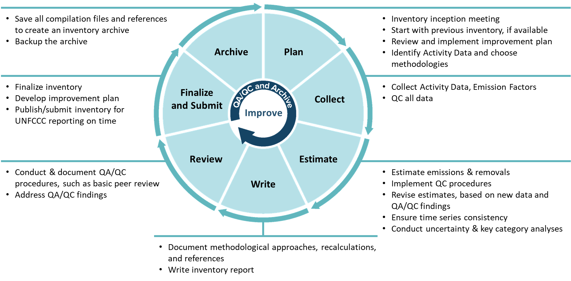

Figure 1-3. Example Inventory Compilation Cycle from Chile for 2017-2018. [Delete After Inserting Figure Specific to Your Country.]

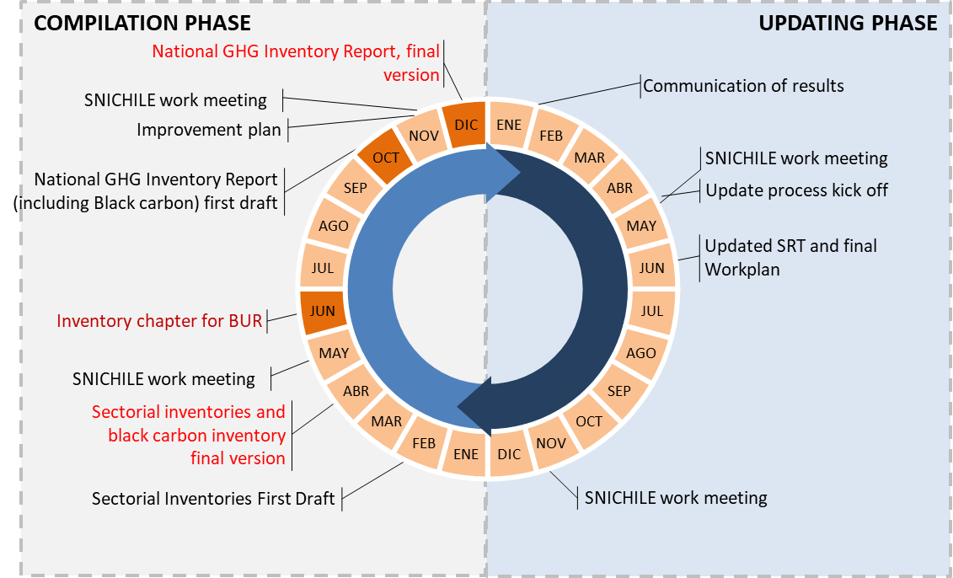

Source: Technical Team Coordinator, Ministry of Environment (Ministerio del Medio Ambiente (MMA))

Each stage of Inventory compilation involves a series of activities and outputs. A more detailed work plan, including interim deadlines for activities during each stage, is outlined in the National GHG Inventory Inception Memorandum.

### Overall Template Progress

Table 1-2presents a summary of progress towards completing each template in theToolkit. The table also includes space to document obstacles encountered while completing the templates and the status of each template.

#### STEP 2: Record progress towards completing each template in the series in Table 1-2, below.

|  |  |
| --- | --- |
| Purpose | To track progress towards completing all the templates in the series |
| When to fill it in | The National Inventory Coordinator should update this table periodically throughout the inventory compilation cycle. |
| How to use it when done | The National Inventory Coordinator may find it useful to consult this table before starting the next inventory in order to recall the obstacles faced while preparing the present inventory. By doing so, the National Inventory Coordinator may be able to avoid these obstacles in the future. |
| Instructions | Communicate with those responsible for completing the templates as needed to obtain the information needed to complete this template. When you have the information you need, fill in the table below. |
| Instructions by column | Summary of progress towards completing the template: Record the most important steps taken to complete each template in the left-most column. Use bullet points or sentences, according to your preference. |
| Obstacles and possible solutions: Record the most important obstacles and possible solutions to completing the template. |
| Status: Indicate when the chapter is “Completed,” “In Progress,” “Not Started,” or “Not Used.” |

Table 1-2. Overall Template Progress

| Template | Summary of progress towards completing the template | Obstacles and possible solutions | Status |
| --- | --- | --- | --- |
| 1. Inventory Planning | [Enter text] |  |  |
| 2. Institutional Arrangements |  |  |  |
| 3. Methods and Data Documentation |  |  |  |
| 4. QA/QC Procedures |  |  |  |
| 5. Archiving System |  |  |  |
| 6. Key Category Analysis |  |  |  |
| 7. National Inventory Improvement Plan |  |  |  |

## Revision History

January 2025: Updated formatting to add layout and list of abbreviations to be consistent with other toolbox template updates.

1. The EPA Toolkit for Building National GHG Inventory Systems is available at <https://www.epa.gov/ghgemissions/toolkit-building-national-ghg-inventory-systems>.
2. See *Introduction to U.S. EPA Toolkit for Building National GHG Inventory Systems* for more information about the national GHG inventory compilation cycle, available at <https://www.epa.gov/ghgemissions/toolkit-building-national-ghg-inventory-systems>.
3. See 18/CMA.1, *Modalities, Procedures and Guidelines (MPGs)*, Annex Chapter II, Section B. National Circumstances and Institutional Arrangements guidance for National Greenhouse Gas Inventory Report, available at <https://unfccc.int/sites/default/files/resource/CMA2018_03a02E.pdf>.
4. For more information, see <https://unfccc.int/process-and-meetings/transparency-and-reporting/reporting-and-review-under-the-paris-agreement>.