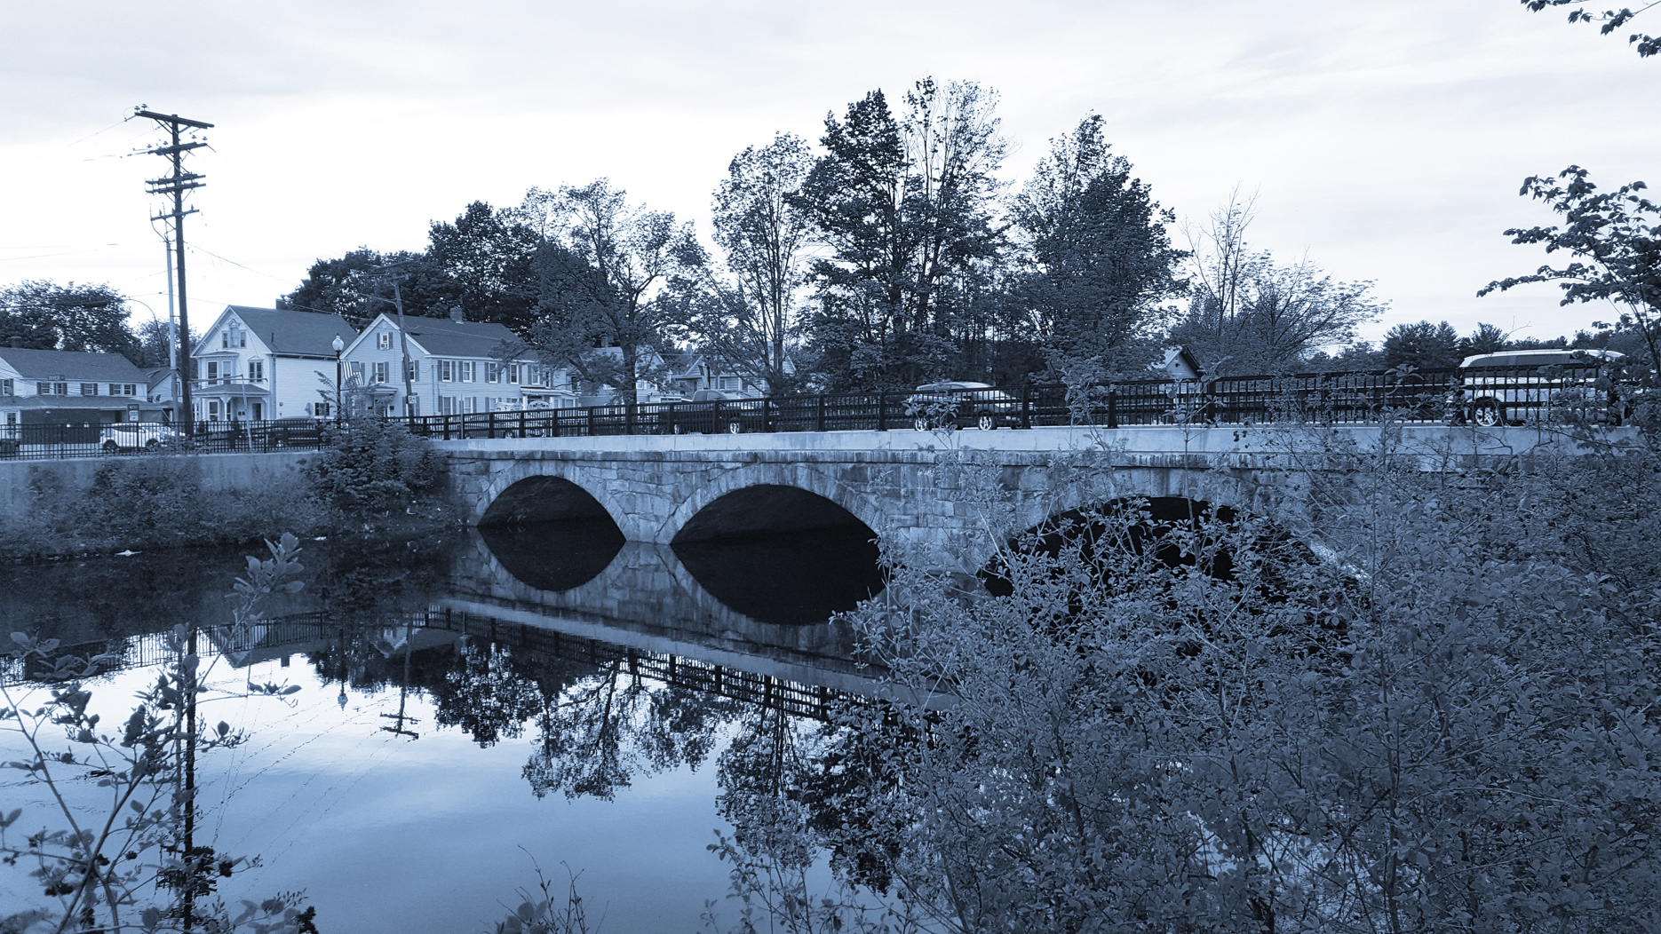

**Long-Term Stormwater Planning**

*Part of the Suite of Integrated Planning Resources*

**Describe Relevant Requirements and Goals**



# Worksheet 3: Identify Goals

This worksheet is part of a series of 10 worksheets referenced in [Long-Term Stormwater Planning: A Voluntary Guide for Communities](https://www.epa.gov/system/files/documents/2024-01/long-term-stormwater-planning-guide-communities.pdf). The worksheets present questions and prompts for each step in the planning process to help communities document their process and decisions. They are intended to be an easy-to-use tool that a community can reference; populate; expand upon; and even incorporate directly into an integrated plan, long-term stormwater plan, or other community plan.

This worksheet supports one of the first parts of the planning process, which is assessing where you are now. Answering the groundwork questions in the worksheet below will help you identify and prioritize your long-term stormwater planning goals. Remember that the long-term stormwater planning process should be tailored to your community. Feel free to add questions and/or modify this worksheet to best suit your needs.

This worksheet helps a community identify requirements and drivers as part of Element 1 of the [Integrated Planning Framework](https://www.epa.gov/npdes/integrated-municipal-stormwater-and-wastewater-planning-approach-framework).

## Groundwork Questions to Identify Goals

| Groundwork Questions | Response |
| --- | --- |
| Based on the issues and challenges identified in Worksheet 2, what are your initial goals?  Be as specific as you can. Goals can be in any order at this stage. |  |
| How will you use previously obtained stakeholder input to prioritize the initial list of goals? |  |
| Based on stakeholder input, what prioritized goals does your community intend to focus on during the long-term stormwater planning process? |  |
| What existing community documents and plans can you use or reference to support your long-term stormwater planning goals?  For example, capital improvement plans, master plans, transportation plans, and economic development plans. |  |
| How can you align stormwater goals with existing community goals and stakeholder priorities?  For example, addressing neighborhood flooding, street beautification, transportation, or revitalization efforts. |  |