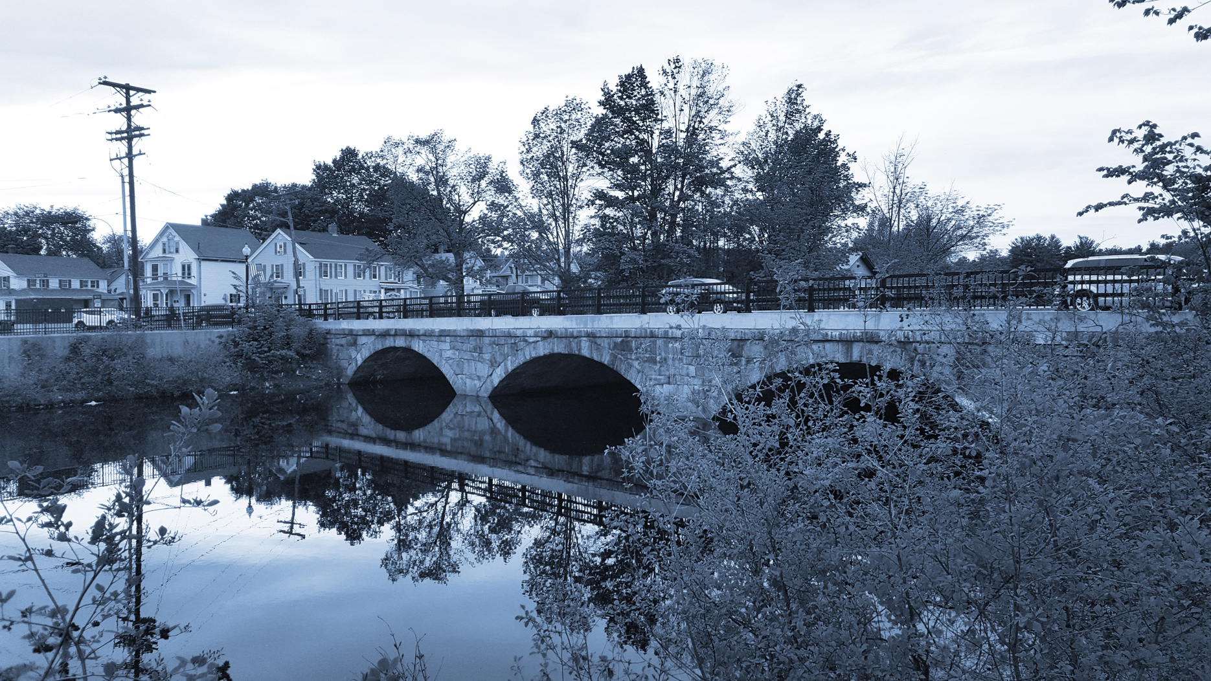

**Long-Term Stormwater Planning**

*Part of the Suite of Integrated Planning Resources*

**Characterize Existing Systems**



# Worksheet 5: Asset Conditions

This worksheet is part of a series of 10 worksheets referenced in [Long-Term Stormwater Planning: A Voluntary Guide for Communities](https://www.epa.gov/system/files/documents/2024-01/long-term-stormwater-planning-guide-communities.pdf). The worksheets present questions and prompts for each step in the planning process to help communities document their process and decisions. They are intended to be an easy-to-use tool that a community can reference; populate; expand upon; and even incorporate directly into an integrated plan, long-term stormwater plan, or other community plan.

This worksheet supports one of the first parts of the planning process, which is assessing where you are now. Answering the groundwork questions in the worksheet below will help characterize the condition of your existing stormwater assets. Remember that the long-term stormwater planning process should be tailored to your community. Feel free to add questions and/or modify this worksheet to best suit your needs.

This worksheet helps a community characterize existing systems as part of Element 2 of the [Integrated Planning Framework](https://www.epa.gov/npdes/integrated-municipal-stormwater-and-wastewater-planning-approach-framework).

## Groundwork Questions to Characterize the Condition of Existing Stormwater Assets

| Groundwork Questions | Response |
| --- | --- |
| What are your most critical stormwater system assets? |  |
| What happens if they fail? |  |
| What areas have had issues with flooding?  Describe the extent of the issues and the typical conditions that cause flooding in those areas. |  |
| How might current system performance be affected by changes in climate (e.g., an increase in the intensity and frequency of storms)?  Using the most recent available data ensures that any changing precipitation patterns and trends are captured in the estimates calculated for the expected amount, frequency, intensity, and duration of precipitation. |  |
| How might current system performance be affected by changes in development or the population served? |  |
| How do you inventory and track your stormwater assets?  Is there a particular system you use or is the process tracked in some other way? |  |
| How do you track maintenance schedules for your stormwater assets to ensure operation and maintenance occur? |  |
| Are your stormwater assets mapped in GIS? If so, which ones? |  |