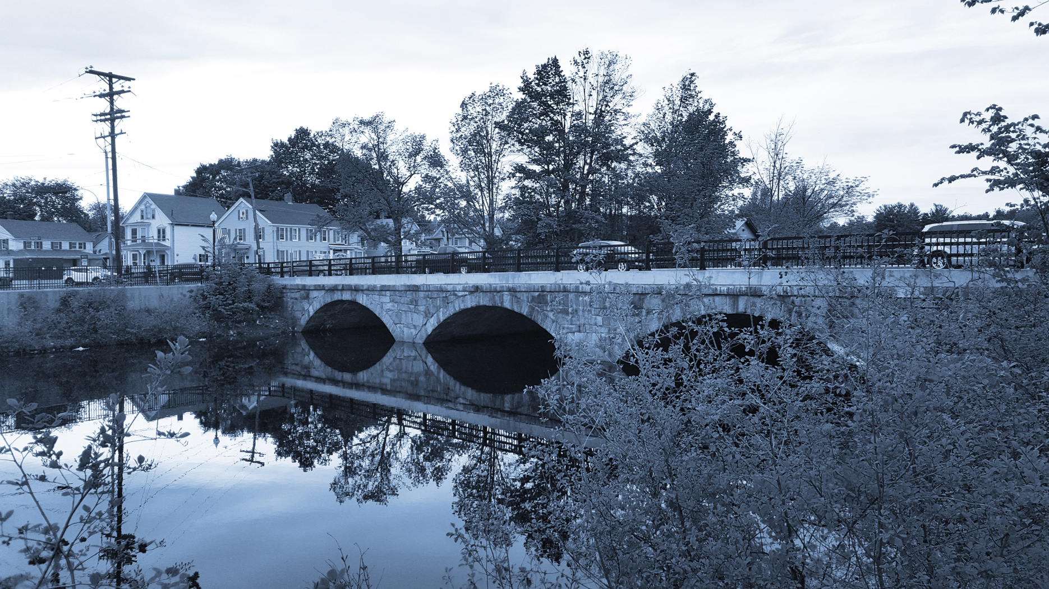

**Long-Term Stormwater Planning**

*Part of the Suite of Integrated Planning Resources*

**Characterize Existing Systems**



# Worksheet 6: Capital Improvements

This worksheet is part of a series of 10 worksheets referenced in [Long-Term Stormwater Planning: A Voluntary Guide for Communities](https://www.epa.gov/system/files/documents/2024-01/long-term-stormwater-planning-guide-communities.pdf). The worksheets present questions and prompts for each step in the planning process to help communities document their process and decisions. They are intended to be an easy-to-use tool that a community can reference; populate; expand upon; and even incorporate directly into an integrated plan, long-term stormwater plan, or other community plan.

This worksheet supports one of the first parts of the planning process, which is assessing where you are now. Answering the groundwork questions in the worksheet below will help you assess capital improvement project needs and plans for projects related to stormwater. Remember that the long-term stormwater planning process should be tailored to your community. Feel free to add questions and/or modify this worksheet to best suit your needs.

This worksheet helps a community characterize existing systems as part of Element 2 of the [Integrated Planning Framework](https://www.epa.gov/npdes/integrated-municipal-stormwater-and-wastewater-planning-approach-framework).

## Groundwork Questions to Assess Capital Improvement Project Needs

| Groundwork Questions | Response |
| --- | --- |
| What areas of the stormwater system require improvement?  Describe them and their location. |  |
| Do you have any planned major upgrades or systemwide projects? |  |
| How will you fund upgrades to the existing stormwater system? |  |
| Is current funding sufficient to meet critical needs?  (See [Worksheet 9](https://www.epa.gov/system/files/documents/2024-01/worksheet9-financial-needs.docx)) |  |