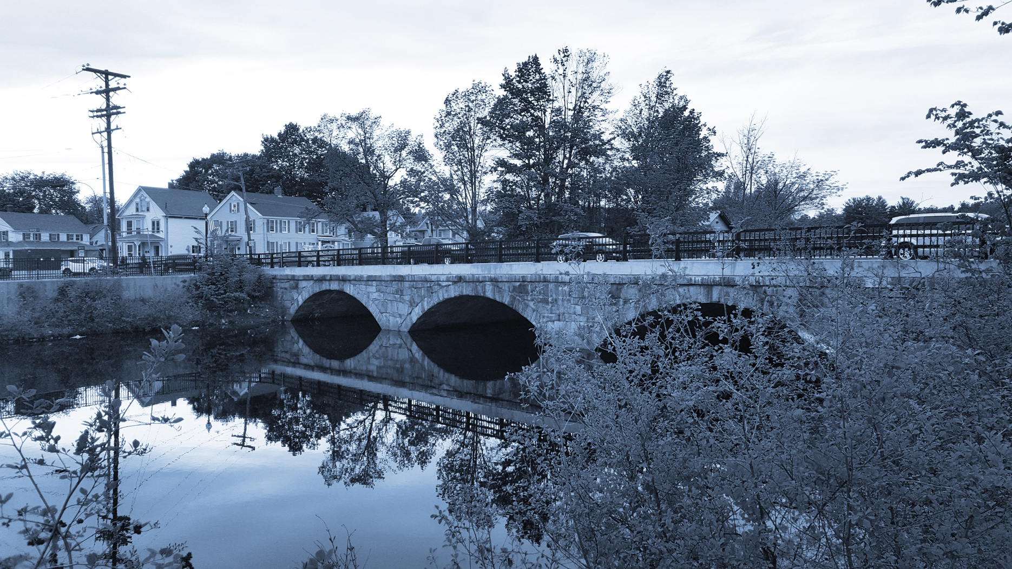

**Long-Term Stormwater Planning**

*Part of the Suite of Integrated Planning Resources*

**Develop, Evaluate, and Select Preferred Alternatives**

**Adapt for Success**





# Worksheet 7: Strategy Implementation Summary

This worksheet is part of a series of 10 worksheets referenced in [Long-Term Stormwater Planning: A Voluntary Guide for Communities](https://www.epa.gov/system/files/documents/2024-01/long-term-stormwater-planning-guide-communities.pdf). The worksheets present questions and prompts for each step in the planning process to help communities document their process and decisions. They are intended to be an easy-to-use tool that a community can reference; populate; expand upon; and even incorporate directly into an integrated plan, long-term stormwater plan, or other community plan.

This worksheet is part of the middle and end portions in the planning process: analyze opportunities and move toward implementation and adapt for success. Identify one or more strategies for each of the goals identified in [Worksheet 3](https://www.epa.gov/system/files/documents/2024-01/worksheet3-identify-goals.docx). Fill in a copy of the worksheet below for each strategy to clearly outline how your community plans to implement that strategy and then identify a process that will be followed to adapt for success. Download as many blank versions of the worksheet as you need. Remember that the long-term stormwater planning process should be tailored to your community. Feel free to add questions and/or modify this worksheet to best suit your needs.

Goal, Strategy, and Objective

Goal. A broad qualitative statement of desired achievements. Examples: Increase the amount of green infrastructure installed in the community to minimize pollutant loads, reduce localized flooding and enhance visual appeal.

Strategy. A general approach or method: how you plan to achieve the goal. Example #1: Update the city ordinance to require on-site retention for redevelopment and new development projects. Example #2: Perform a desktop green infrastructure site suitability assessment with geospatial data to identify potential public sites for green infrastructure installation throughout the community. Example #3: Update the city's masters plan to include green infrastructure projects.

Objective. A specific, measurable statement of what will be done to achieve goals within a particular timeframe. Example #1: Gallons of stormwater treated annually on-site via retention. Example #2: percent of public projects that install green infrastructure annually. Example #3: Acres of impervious area treated by green infrastructure in implemented master plan projects.

This worksheet helps a community develop, evaluate, and select preferred alternatives as part of Element 4 of the [Integrated Planning Framework](https://www.epa.gov/npdes/integrated-municipal-stormwater-and-wastewater-planning-approach-framework). It can also be used to help a community identify how it will adapt for success as a part of Element 6 of the [Integrated Planning Framework](https://www.epa.gov/npdes/integrated-municipal-stormwater-and-wastewater-planning-approach-framework).

## Strategy Implementation Summary Table

| Goal Name:  Strategy Name: | |
| --- | --- |
| People responsible for implementation and their responsibilities  Including department/‌organization |  |
| Tools needed  For example, software, models, and web-based applications that will help the strategy succeed |  |
| Other community efforts and goals with overlap |  |
| Ways you will continue to engage with your stakeholders |  |
| Estimated cost  Rough order of magnitude is sufficient if more detailed costs cannot be estimated |  |
| Potential funding sources  See the resources listed under Step 4 in the Long-Term Stormwater Planning: A Voluntary Guide for Communities |  |
| Impacts to the community  For example, pros, cons, disproportionate burdens |  |
| Potential implementation barriers |  |
| Strategy objective(s) and proposed performance metric(s) |  |
| Proposed timeline  Start and end date |  |
| What process will you use to adapt to new data and information over time? |  |
| How often will you review strategy progress and adapt your approach? |  |
| How will you periodically measure strategy progress and adjust priorities as needed to meet your objectives?  *See* [*Worksheet 10*](https://www.epa.gov/system/files/documents/2024-01/worksheet10-strategy-status-evaluation.docx) *for an example of a Strategy Evaluation exercise* |  |