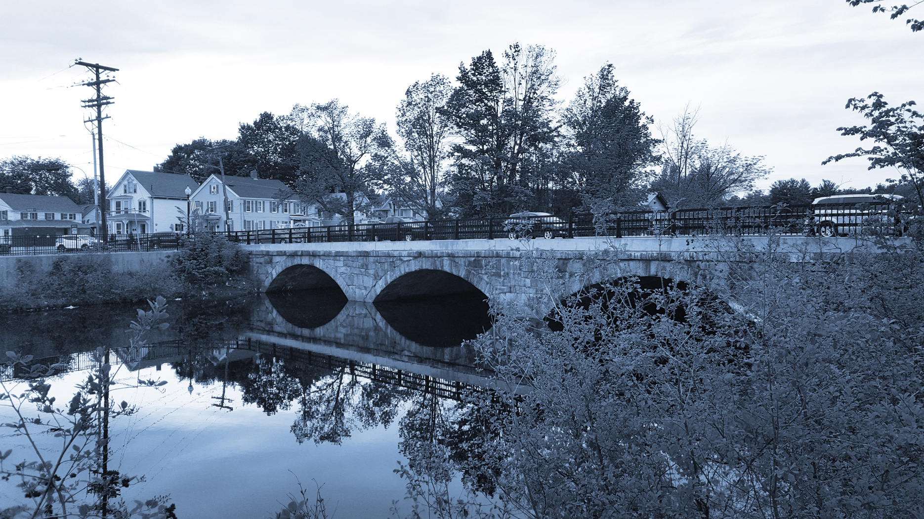

**Long-Term Stormwater Planning**

*Part of the Suite of Integrated Planning Resources*

**Develop, Evaluate, and Select Preferred Alternatives**



# Worksheet 8: Strategy Prioritization

This worksheet is part of a series of 10 worksheets referenced in [Long-Term Stormwater Planning: A Voluntary Guide for Communities](https://www.epa.gov/system/files/documents/2024-01/long-term-stormwater-planning-guide-communities.pdf). The worksheets present questions and prompts for each step in the planning process to help communities document their process and decisions. They are intended to be an easy-to-use tool that a community can reference; populate; expand upon; and even incorporate directly into an integrated plan, long-term stormwater plan, or other community plan.

This worksheet is part of the middle portion of the planning process: analyze opportunities. After you list the strategies for each goal ([Worksheet 7](https://www.epa.gov/system/files/documents/2024-01/worksheet7-strategy-implementation-summary.docx)), fill in the worksheet below to compare prioritization metrics between strategies. Remember that the long-term stormwater planning process should be tailored to your community. Feel free to modify this worksheet to best suit your needs.

This worksheet helps a community develop, evaluate, and select preferred alternatives as part of Element 4 of the [Integrated Planning Framework](https://www.epa.gov/npdes/integrated-municipal-stormwater-and-wastewater-planning-approach-framework).

Using prioritization metrics to rank strategies can help identify which strategies to work on first. Example metrics are listed in the table below. You should plan to assess the metrics that make sense for your community, which may be in addition to or in lieu of the examples below.

| Example Metric | Definition |
| --- | --- |
| Positive community impacts | Long-term impacts that the key action will have on community members. Positive impacts may include preservation of open space, sidewalks, bike lanes, traffic calming, and addition of green space. A high ranking demonstrates a positive impact on the community. |
| Adaptability and Resilience | Ability for the strategy to adapt to long-term changes, including climate change, regulatory changes, and policy change. This metric also represents the strategy’s ability to be scaled within the community. A high ranking demonstrates that the strategy has a high potential to adapt to long-term changes. |
| Strong community interest/support | Based on stakeholder input, strong support and interest from the community. A high ranking demonstrates that the community supports the strategy and wants the city to pursue it. |
| Water quality improvement | The extent to which the strategy benefits water quality and meets the city’s regulatory and community goals. A high ranking demonstrates that the strategy provides a great water quality benefit. |
| Addressing of environmental/social justice | The addressing of environmental and social justice issues, such as historical inequality, the protection of current uses by socioeconomic class, or effects on an already impacted area. A high ranking demonstrates that the strategy will protect or address environmental and social issues. |
| Low capital cost | Implementation that requires a low capital cost from the city. A high ranking indicates that the strategy has a relatively low capital cost, whereas a low score represents a higher capital cost for the city. |
| Minimal O&M | Implementation that requires a minimal level of effort for O&M from the city. A high ranking indicates that the strategy requires minimal effort to operate and maintain. |
| Funding available | Availability of outside funds, such as grants or loans, to assist the city with implementation of the strategy. A high ranking indicates that significant funding sources are available to the city. |
| Support for regulatory compliance | Helping the city comply with regulations, such as meeting nutrient targets under a NPDES wastewater discharge permit or NPDES MS4 permit. A high ranking indicates that the strategy will assist the city in meeting its regulatory obligations. |

The table on the next page is a template that you can use to identify and summarize strategy priority rankings. The first row is an example of what a completed row might look like after you complete a priority ranking exercise. The following gray rows contain example goals and strategies in italicized font.

After you customize the table based on your community’s goals, you should assign each metric an unweighted score of low (1), medium (2), or high (3). You may also choose to weight the metrics using a multiplier to distinguish those that may be more important based on community priorities. The template below has nine metrics, so the range of strategy priority scores is from 9 (if every metric was given a low priority of 1) to 27 (if every metric was given a high priority of 3). For each strategy row, sum the scores of each metric to obtain a strategy priority score. It may also be helpful to assign a range of scores as either low, medium, or high priorities. You can use the strategy priority scores to identify which strategies equate to an overall low, medium, or high priority for implementation.

Example Score Ranges for Strategy Priority Score

|  |  |
| --- | --- |
| Strategy  Score Range | Strategy Priority |
| 9 to 14 | Low |
| 15 to 19 | Medium |
| 20 to 27 | High |

This prioritization exercise can help organize the implementation of strategies based on ranked priority. You may choose to revisit the prioritization ranking process as needed to adjust the metrics or weightings based on current needs and priorities. This process is meant to be iterative throughout the implementation of goals to support the long-term stormwater planning process.

|  |  |  |  |  |  |  |  |  |  |  |  |
| --- | --- | --- | --- | --- | --- | --- | --- | --- | --- | --- | --- |
| Example Long-Term Stormwater Planning Goals | Example Long-Term Stormwater Planning Strategies | Example Prioritization Metrics  (Unweighted scores: 3 = High; 2 = Medium; 1 = Low) | | | | | | | | | Strategy Priority Score |
| Positive Community Impacts | Adaptability and Resilience | Strong Community Interest/ Support | Water Quality Improvement | Addressing of Environmental/ Social Justice | Low Capital Cost | Minimal O&M | Funding Available | Support for Regulatory Compliance |
| Establish an asset management program | Develop and implement an asset management program to evaluate asset condition, performance, value, remaining useful life, and replacement cost | 3 | 3 | 1 | 1 | 1 | 1 | 2 | 3 | 3 | **18**  **Medium Priority** |
| Sustainably Fund the stormwater program | Assess revenue and expenditures | 1 | 1 | 2 | 1 | 1 | 3 | 3 | 1 | 1 | **14**  **Low Priority** |
| Evaluate funding and finance options | 1 | 1 | 2 | 1 | 1 | 3 | 3 | 1 | 1 | **14**  **Low Priority** |
| Update development and redevelopment policies | Update regulatory codes and ordinances | 2 | 3 | 2 | 3 | 2 | 2 | 3 | 1 | 3 | **21**  **High Priority** |
| Update the city’s design guidelines | 2 | 3 | 2 | 2 | 2 | 2 | 3 | 1 | 3 | **20**  **High Priority** |
| Establish incentive mechanisms for using green infrastructure | 2 | 3 | 2 | 3 | 2 | 3 | 2 | 1 | 2 | **20**  **High Priority** |
| Integrate green stormwater management practices into public property and projects | Identify public parcels and projects | 1 | 1 | 2 | 1 | 1 | 3 | 3 | 1 | 1 | **14**  **Low Priority** |
| Assess potential site suitability for green infrastructure | 1 | 2 | 2 | 2 | 2 | 3 | 3 | 1 | 1 | **17**  **Medium Priority** |
| Develop design concepts | 1 | 2 | 2 | 2 | 2 | 2 | 3 | 1 | 1 | **16**  **Medium Priority** |
| Develop an O&M plan for public green infrastructure | 1 | 2 | 2 | 2 | 1 | 2 | 3 | 1 | 1 | **15**  **Medium Priority** |

**Example Strategy Implementation Table**

**Strategy Implementation Table Template**

| Long-Term Stormwater Planning Goals | Long-Term Stormwater Planning Strategies | Prioritization Metrics  (Unweighted scores: 3 = High; 2 = Medium; 1 = Low) | | | | | | | | | Strategy Priority Score |
| --- | --- | --- | --- | --- | --- | --- | --- | --- | --- | --- | --- |
| Positive Community Impacts | Adaptability and Resilience | Strong Community Interest/ Support | Water Quality Improvement | Addressing of Environmental/ Social Justice | Low Capital Cost | Minimal O&M | Funding Available | Support for Regulatory Compliance |
|  |  |  |  |  |  |  |  |  |  |  |  |
|  |  |  |  |  |  |  |  |  |  |  |  |
|  |  |  |  |  |  |  |  |  |  |  |  |
|  |  |  |  |  |  |  |  |  |  |  |  |
|  |  |  |  |  |  |  |  |  |  |  |  |
|  |  |  |  |  |  |  |  |  |  |  |  |
|  |  |  |  |  |  |  |  |  |  |  |  |
|  |  |  |  |  |  |  |  |  |  |  |  |
|  |  |  |  |  |  |  |  |  |  |  |  |
|  |  |  |  |  |  |  |  |  |  |  |  |
|  |  |  |  |  |  |  |  |  |  |  |  |
|  |  |  |  |  |  |  |  |  |  |  |  |
|  |  |  |  |  |  |  |  |  |  |  |  |