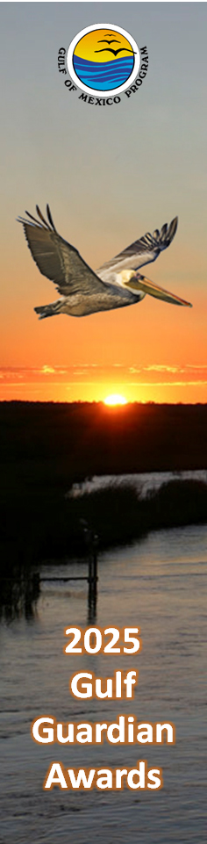
NOMINATION FOR A

GULF GUARDIAN AWARD 2025

Gulf of Mexico Division

One Gulf . . . One Community

The Gulf of Mexico Division and its Mission: The Gulf of Mexico Division was initiated in 1988 by the U.S. EPA as a non-regulatory program. Founded on the threefold principle of partnership, science-based information, and citizen involvement, the Gulf of Mexico Division applies an adaptive management approach to large coastal freshwater and marine ecosystems. The mission of the Division is to facilitate collaborative actions to protect, maintain, and restore the health and productivity of the Gulf of Mexico in ways consistent with the economic well-being of the Region.

The Gulf Guardian Awards
The Gulf Guardian Awards were created in 2000 to recognize environmental excellence towards achieving and preserving healthy and resilient coasts in Florida, Alabama, Mississippi, Louisiana, and Texas. The Gulf Guardian Awards recognize efforts within the 31 States that comprise the Gulf of Mexico watershed. The Awards are presented on a Bi-annual basis. The official categories for nomination are: Business/Industry, Environmental Justice/Cultural Diversity, Civic and Nonprofit Organizations, Youth Environmental Education, Phil Bass Individual Achievement, Ben Scaggs Gulf Partnerships, and Government Entities. First, Second and Third place winners are awarded and presented at a special ceremony.
Sponsored by the partnership of the U.S. Environmental Protection Agency, Gulf of Mexico Division, to recognize extraordinary environmental stewardship towards protecting the Gulf of Mexico.

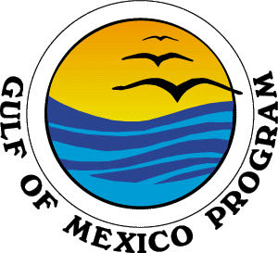

2025 APPLICATION INSTRUCTIONS
Application deadline for the 2025 Gulf of Mexico Division
is July 31, 2024

Winners will be notified in September of 2024 and awarded at a special function on May 7th, 2025 in Biloxi, MS.

Award categories are:
- Business/Industry
- Environmental Justice/Cultural Diversity
- Civic/Nonprofit Organization
- Youth Environmental Education
- Ben Scaggs Gulf Partnership
- Phil Bass Individual Achievement
- Government Entities

The Gulf of Mexico Division has renamed two categories to honor exceptional past employees who made a huge impact in the Gulf of Mexico region.

The Partnership Award is now the Ben Scaggs Gulf Partnership Award. Ben Scaggs loved the Gulf of Mexico. Gulf restoration called to him and he was critical to bringing attention to the challenges and solutions to improve the health of the Gulf and its communities. Ben lived his life serving the State of Mississippi, Gulf of Mexico Region, and the American public in many leadership roles in his career in government. Placing himself directly in the middle of these challenges, Ben forged and nurtured key partnerships that helped ensure billions of dollars in once-in-a-lifetime Gulf restoration funding went directly to improve the Gulf ecosystem and benefit its communities that rely on this national treasure. This award honors Ben’s memory and his drive every day to empower partnerships.

The Individual Award is now the Phil Bass Individual Achievement Award. Phil Bass’s smile, humor, and humble genius opened many doors for Gulf of Mexico science and shared sense of Gulf community. Phil’s deep love for the State of Mississippi and its people still resonates strongly through those he mentored and served. His keen sense of knowing when a decision had to be made while shouldering the individual responsibility of success or failure as a leader, balanced with his expertise in putting together winning teams to inform decision making, made Phil a superstar, though he never did seek the limelight. Phil would be the first to acknowledge the efforts of those around him, over his recognition for individual success. This award honors Phil’s memory and all those individuals he helped to succeed.

2025 APPLICATION INSTRUCTIONS
(CONTINUED)

Application deadline for 2025 Gulf Guardian Award Nomination is July 31, 2024.

Choose the category that best describes your organization by checking the appropriate box on the first page of your application. The Gulf of Mexico Division will make the final decision on the appropriate category for your project. Applications will be scored in only one category.

Please consider the following requirements when filling out your application. Applications that do not meet these requirements will not be considered.

Please complete one application per project using only the space provided on the application. Email your application to GulfGuardian@epa.gov.

Your application must be electronically submitted by July 31, 2024, to qualify for a 2025 Gulf Guardian Award.

The Gulf Guardian Awards are awarded on a biannual basis.

Type sizes should be no smaller than Times 12-point or comparable.

Projects must show measurable results. Projects must either be complete or demonstrating measurable results as an ongoing effort.

Support material (videos, brochures, press clips, photos, manuals, etc.) will not be accepted. However, you may be asked to submit additional materials at a later date.

2025 APPLICATION INSTRUCTIONS
(CONTINUED)

Application deadline for 2025 Gulf Guardian Award Nomination is July 31, 2024.

Selection of the winning projects will be based on the following evaluation criteria for all categories except for the Phil Bass Individual Achievement Award:

Results:
- Clear accomplishment of stated goals.
- Results are defined in measurable terms.
- Environmental benefits are explicitly identified.
- Describes how the project, program or activity influenced the environment or people’s understanding of it.
- Explains how project achieved environmental improvements, energy savings, resource conservation, waste reductions, etc.

Transferability:
- Clear ability of the program/activity to be replicated or widely shared Gulf-wide.

Environmental/Resource/Conservation Impact:
- Project or organization has made a significant contribution to the health and productivity of the Gulf of Mexico.
- The project, organization or program has long lasting and sustainable impacts for the environment and/or provides useful information or potentially changes the way people react to the health of the Gulf of Mexico.

Level of commitment and leadership:
- Commitment and leadership is evidenced by the timeliness of the project.
- Promotes collaborative partnerships or other support for the program or activity.
- Provides education and outreach to others; and, for businesses and organizations; strategic environmental management is demonstrated.

Innovation/Uniqueness:
- Demonstrates or advances an improved or different approach, technique and/or technology to complete a project, provide a service, or to work with others to solve environmental problems.
- Contributes new or improved information to benefit the Gulf of Mexico.
- Serves as a model for other efforts.
- May address or support other social needs.

Cultural Diversity/Environmental Justice:
- States how this project benefits disadvantaged communities.

Climate Change:
- States how this project addressed climate change.

2025 APPLICATION INSTRUCTIONS
(CONTINUED)

Application deadline for 2025 Gulf Guardian Award Nomination is July 31, 2024.

Selection of the Phil Bass Individual Achievement Award will be based on the following evaluation criteria:

Results:
- Contributed to the protection, restoration, and conservation of the Gulf of Mexico through environmental management, environmental education, scientific discovery, innovation, inspiration, diligence, volunteerism or communication to the public.

Environmental/Resource/Conservation Impact:
- Achieved broad recognition inside the nominee’s area of specialization.
- Fostered awareness of environmental science and technology and/or education among broad segments of the population.
- Raised awareness of critical issues.

Level of commitment and leadership:
- Influenced, mentored, inspired or encouraged other environmental scientists, colleagues, peer and/or the general public.
- Served as a model for others.

Innovation/Uniqueness:
- Demonstrated an exceptional dedication, devotion, talent, service or capability to advance and/or improve the health and productivity of the Gulf of Mexico and the protection, conservation and restoration of the Gulf’s resources.
- Contributed new or improved information, techniques and/or methodologies to benefit the Gulf of Mexico.

