EPA Region 3 Air and Radiation Division

Grant Opportunities

Map shows federally recognized Tribes located in Region 3.

The federally recognized Tribes in Region 3 include:

Chickahominy Indian Tribe
Chickahominy Indian Tribe -Eastern Division
Monacan Indian Nation
Nansemond Indian Nation
Pamunkey Indian Tribe
Rappahannock Tribe
Upper Mattaponi Tribe

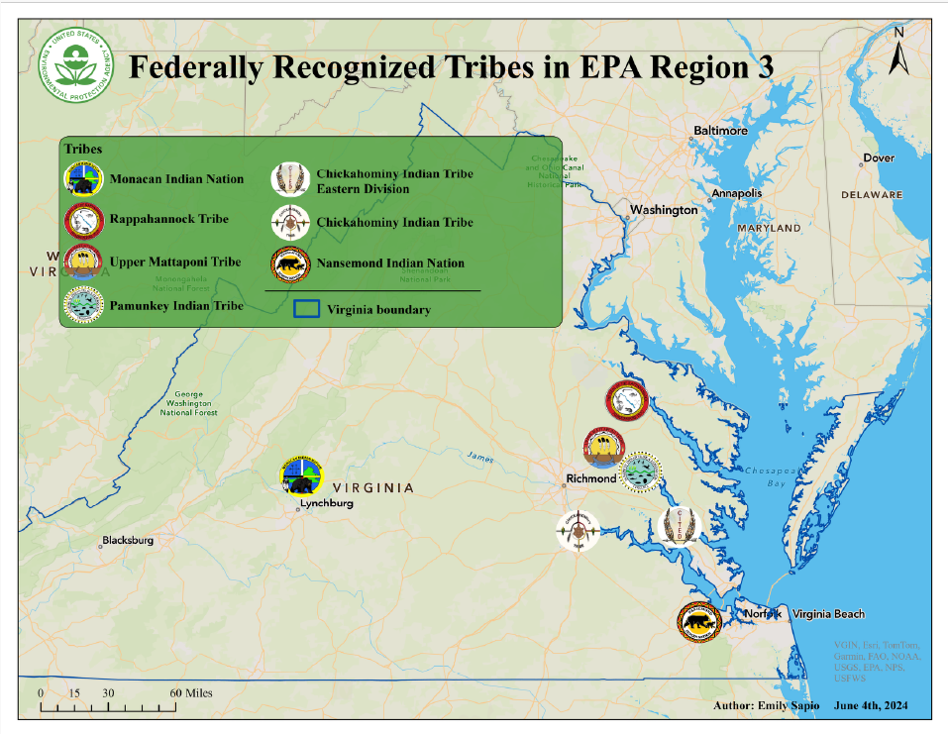

About the Air and Radiation Division
The Region 3 Air and Radiation Division (R3 ARD) is responsible for the management and implementation of the Region's programs to protect, preserve and improve air quality. R3 ARD administers programs authorized by the Clean Air Act (CAA) and Toxic Substances Control Act (TSCA). R3 ARD also coordinates non-statutory programs and priorities such as energy efficiency, renewable energy, radiation, and education/outreach programs designed to reduce pollutant emissions to the environment.

R3 ARD is committed to working with the Tribes located in Region 3 to develop and implement air grant programs on Tribal lands. Following National efforts to award CAA grants to Tribes, R3 ARD will work with Tribes to help build Tribal knowledge and increase capacity to identify and manage air quality issues.

“EPA’s Air and Radiation Division is strongly committed to ensuring that Indian Tribes play an integral role in the region’s overall environmental mission.”

Cristina Fernandez, Director
Air and Radiation Division
U.S. EPA – Region 3

Tribal Air Grant Opportunities

- Clean Air Act 103 Grant Program
- Clean Air Act 105 Grant Program
- Diesel Emission Reduction Act Grant Program
- State Indoor Radon Grant Program

- Performance Partnership Grant Program
- Other Grant Programs:
  - General Assistance Grant Program
  - Environmental Justice Grants

Page 1

Clean Air Act 103 Grant Program

Air Monitoring Equipment

Monitoring Equipment Examples

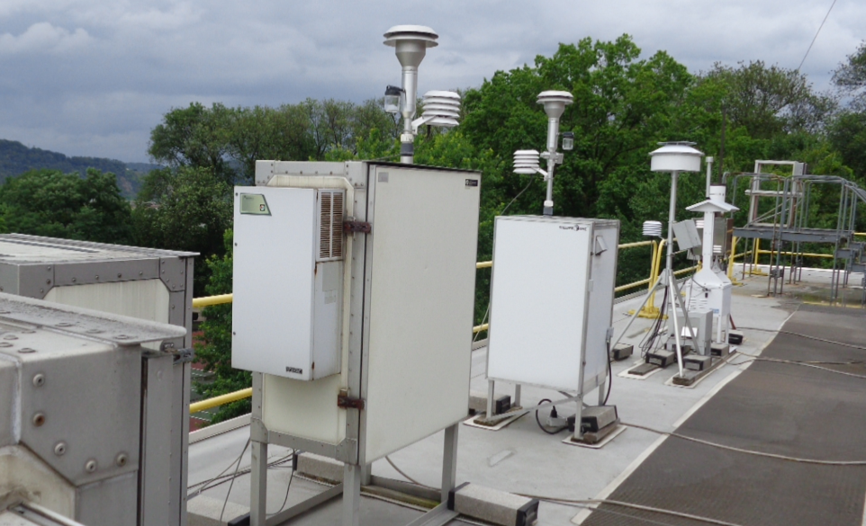
Supports short term projects aimed at conducting and promoting research, investigations, experiments, demonstrations, surveys, and studies relating to the causes, effects, extent, prevention, and control of air pollution. Tribal governments have both Clean Air Act (CAA) authority over lands within their jurisdiction and discretion to address air pollution under the CAA. Grant funding is available to improve Indoor Air Quality (IAQ) in Tribal communities under the Indoor Air Quality Grants Program and Resources. More information can be found here:
- epa.gov/indoor-air-quality-iaq/indoor-air-quality-tribal-communities
- epa.gov/tribal-air/tribal-air-grants-framework
- https://www.epa.gov/burnwise/wood-burning-changeout-resources-tribes

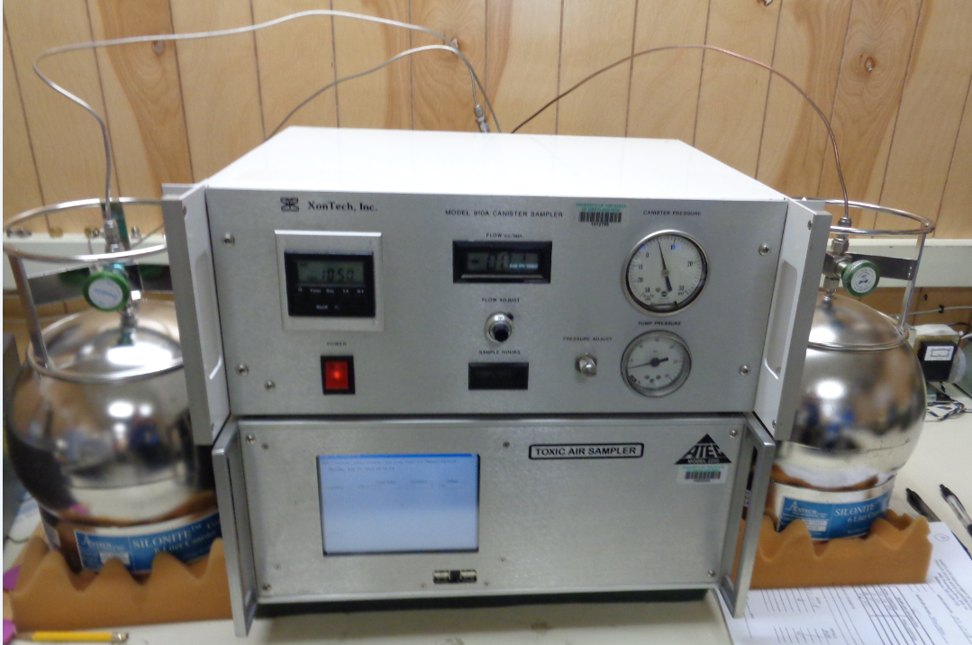

Clean Air Act 105 Grant Program

Funds activities that implement programs for the prevention and control of air pollution. Includes any activity related to the planning, developing, establishing, carrying out, improving or maintaining of such programs. This grant program has a required funding match. Activities may include: preparing emissions inventories, identifying unique air quality issues and implementing solutions, and participating in policy development workgroups.
For more information:
- epa.gov/tribal-air/tribal-air-grants-framework
- epa.gov/laws-regulations/summary-clean-air-act

Examples of vehicles eligible under DERA
“Sections 103 and 105 of the Clean Air Act allow EPA to provide grant support to Tribes to help build Tribal knowledge and increase Tribes' capacity to manage air quality issues”

GAP Grant Program Picture

Diesel Emissions Reduction Act Grant Program

Provides support for projects that reduce emissions from diesel engines. This program includes grants and rebates funded under the Diesel Emissions Reduction Act (DERA). EPA’s Office of Transportation and Air Quality solicits applications nationwide for Tribal projects that achieve significant reductions in diesel emissions and diesel emissions exposure, particularly in areas designated as having poor air quality.

Eligible diesel vehicles, engines and equipment may include school buses, Class 5 – Class 8 heavy-duty highway vehicles, locomotive engines, marine engines, and more!

For more information:
- epa.gov/cleandiesel/clean-diesel-tribal-grants

Page 2

State Indoor Radon Grant Program
Funds are available to Tribes to help finance radon risk-reduction programs. Matching funds are required, although they may be reduced to 0% in a Performance Partnership Grant (PPG).
The program’s focus is to build new homes with radon-reducing features where appropriate, to have existing homes tested and fixed by homeowners when appropriate (especially by home sellers and buyers during residential real estate transfers), to build new schools with radon-reducing features where appropriate, and to have existing schools tested and fixed when necessary.
For more information:
- epa.gov/radon/state-indoor-radon-grant-sirg-program
- epa.gov/sites/production/files/2014-08/documents/guidance_and_handbook.pdf

State and Tribal radon programs are critical to EPA's national goal of minimizing and preventing radon-related lung cancer.

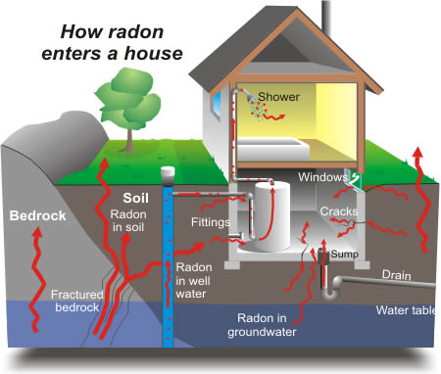

For many years, states and Tribes wanted greater flexibility in
how they use and manage their EPA
grant funds. In 1996, Congress responded
by authorizing EPA to award Performance Patnership Grants. Tribes can now choose to combine two or more environmental
programs into a single PPG.

Performance Partnership Grants (PPG)

EPA provides financial assistance to states and Tribes to help them develop and implement environmental programs. A Performance Partnership Grant (PPG) is a mechanism which enables Tribes and inter-Tribal consortia to combine funds from more than one federal environmental program grant into one grant with one budget. There are currently 19 environmental program grants eligible for inclusion in a PPG. Recipients do not need to account for PPG funds in accordance with the funds' original environmental program sources; they need only account for total PPG expenditures.
With PPGs, states and Tribes can:
- Reduce administrative costs through streamlined paperwork and accounting procedures;
- Direct EPA grant funds to priority environmental problems or program needs; and
- Attempt multi-media approaches and initiatives that were difficult to fund under traditional categorical grants.

For more information:
- epa.gov/ocir/national-environmental-performance-partnership-system-nepps##Per%20Par%20Grants
- epa.gov/ocir/nepps-implementing-performance-partnerships

Page 3
General Assistance Program (GAP) Grants
GAP grants provide funds to federally recognized Tribes and inter-Tribal consortia for the planning, development, and establishment of environmental protection programs. epa.gov/general-assistance-program-gap

Environmental Justice Grants
EPA offers multiple types of grants that target Environmental Justice (EJ) communities. More information on these grants and technical assistance opportunities can be found at the following link:
https://www.epa.gov/environmentaljustice/environmental-justice-grants-funding-and-technical-assistance

Other Grants and Resources
EPA Region 3
Contacts

Krista Gonzalez
Tribal Air Grants Coordinator
215-814-3300 gonzalez.krista@epa.gov

AJ McCullough
Tribal Air Grants Liaison
215-814-2093
mccullough.amanda@epa.gov

Katharine Payne
Tribal Air Consultations Coordinator
215-814-2183
payne.katharine@epa.gov

Brian Hamilton
Regional Tribal Program Coordinator
215-814-5497
hamilton.brian@epa.gov

For More Information

Region 3 Tribal Program

Check out this page for updated grant opportunities and resources for all programs available to Tribes located in Region 3: https://www.epa.gov/tribal/region-3-tribal-program

Tribal Air & Climate Resources
This webpage contains resources related to air and climate programs within EPA for Tribes including relevant regulations, emissions inventories, policy examples, and contact information: https://www.epa.gov/tribal-air

EPA in Indian Country
This page contains information about all ways that EPA works with Tribes including topics of interest, consultations, and grant programs: epa.gov/tribal

Tribal Air Grants Framework
This presentation covers the difference between Clean Air Act (CAA) 103, 105 and GAP grants and details what activities are allowable: epa.gov/tribal-air/tribal-air-grants-framework

Grants.gov instructions
This page covers how you register to apply for grants in SAM.gov and grants.gov systems: epa.gov/grants/how-register-apply-grants

Air Pollution Training Institute – APTI:
This website contains trainings on the Clean Air Act and includes a specific webpage that local and Tribal governments can register to use: https://epaapti.csod.com/client/epaapti/default.aspx

Page 4

