Thank you for joining our eight and final Crisfield/EPA ORD Technical Working Group (TWG) providing technical feedback on proposed nature-based solutions (NBS) for Crisfield’s coastal resilience!
AGENDA for August 26:
Ryan Hostak of TetraTech discussing the top 6 implementable (<$10M) NBS projects suggested for Crisfield based on the results of the storm attenuation modeling. Those projects include:
- Long Point and Cedar Island Marsh Sanctuary living breakwaters
- Northwest Cedar Island marsh restoration and edging
- Great Point living breakwater and north Cedar Island marsh edging
- Central Janes Island marsh restoration
- North Janes Island dune restoration
- Central Janes Island offshore artificial oyster reefs
Slide deck is available here: https://cfpub.epa.gov/si/si_public_record_Report.cfm?dirEntryId=367066&Lab=CPHEA

Attendees:
Organization | Expertise
City of Crisfield, climate resilience projects | Local knowledge, funding
Center for Watershed Protection | Watershed planning, providing engineering support for Crisfield
National Oceanic and Air Administration (NOAA) Fisheries, Habitat and Ecosystem Services Division | Local fisheries regulatory considerations, fish habitat consultations, and co-benefits
Eastern Shore Regional GIS Cooperative | Local mapping, spatial data
University of Maryland, Environmental Finance Center | Finance and green infrastructure, coastal resilience
Maryland Sea Grant Extension Program | Coastal climate assessment
Maryland Department of Natural Resources | Coastal development planning
Lower Shore Land Trust | Local marsh knowledge
EPA Region 3, Wetland regulatory | Wetlands ecology and permitting
EPA Region 3, Climate coordinator | Climate planning
Tetra Tech | Coastal engineering
EPA Office of Research and Development | Project Navigator
EPA Office of Research and Development | Ecosystem co-benefits
EPA Office of Research and Development | Evaluation, community capacity

Process recap of initial literature review that identified types of coastal NBS that have been successful in areas that share environmental characteristics with Crisfield, narrowing down to marsh restoration, dune restoration, artificial reefs and living shorelines and areas in Crisfield regions which each is appropriate.

Coastal natural infrastructure is designed to integrate with upland hard infrastructure for Crisfield.
Two batches of hydrodynamic storm modeling conducted to understand how NBS would perform at mitigating coastal hazards, attenuating waves, storm surge, mitigating erosion. NBS were modeled as changes in land cover, elevation, bathymetry, and roughness – all of which affect wave size and path.
Six top projects were identified based on protection, independence and qualitative cost-benefit:
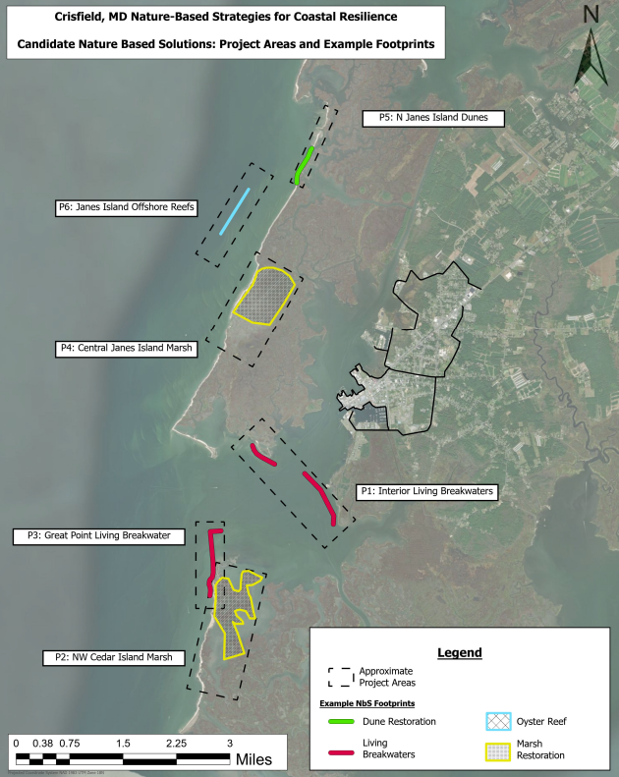
Projects sizes ~$10M each by NBS category are:
- 34,000 square feet of oyster reef,
- 2,900 linear feet of dune restoration,
- 260 acres of marsh restoration, and
- 5,000 linear feet of living breakwaters
Protection against coastal hazards was evaluated quantitatively by looking at wave impact forces on the borders of Crisfield (assuming proposed hard infrastructure in place), wave heights with constant NW and SW winds as well as during Hurricane Dorian circular winds, shear stress anomalies (indicator of sediment mobility due to water force, which is a way of looking at erosion potential), and tidal circulation (magnitude of back and forth flow in an area as opposed to circular flow, which could cause channelization, higher water levels, and higher erosion).

Wave impact forces showed that higher wave force shifts to lower wave force in many shoreline locations when NBS are implemented. Decreases along Daugherty Creek are likely attributable to the breakwaters or Janes Island marsh restoration. Wave force appears to increase at the entrance of Somers Cove (potentially due to channelling caused by the interior breakwaters) and at Wellington Beach (where Daugherty Creek narrows which might be channelizing flow reflected off the higher elevation of a restored eastern edge of Janes Island), both of which would need to be considered more carefully during design phases of these projects.

Wave height attenuation for oyster reefs is biggest along Janes Island, and along the west of Cedar Island when wind is constant and waves are moving directly across them. Reefs will not attenuate waves all the way over within the interior of Daugherty Creek, but they play a supporting role by dampening wave energy and potentially mitigating erosion along the sandy shorelines of Janes and Cedar Islands. There is also the option to explore a patch reef near Island Point, that is not currently modeled. Marshes and dunes show significant attenuation throughout model domain when wind is constant but not as much during circular hurricane winds. Breakwaters have significant attenuation locally, and the interior ones extend attenuation into the bottom of Daugherty Creek.

NBS lower shear stress below the critical threshold that would induce erosion. This is visible along offshore oyster reefs, and marshes interior to Daugherty Creek, and in the Lower Annemessex River. Tidal circulation plots show that breakwaters cause tides to flow more back and forth across the northern edge of Cedar Island, and between the two interior breakwaters—these flow alterations need to be considered in the breakwater design phase. Also need to consider how this might affect the navigation channel to prevent scouring out of that channel.

Adaptive, independent, and additive evaluation determined whether projects could be part of a longer-term adaptive management strategy, being able to grow over time, and be adjusted, as needed, when environmental conditions change. Also considered was whether projects could successfully be installed independently, as stand-alone features subject to hydraulic loads and geotechnical forces. Another aspect of this prioritization involved an understanding of which projects needed to be installed first in order for other projects to be able to build on them additively.

Cost estimation was done using ranges available from the NOAA guidance based off a compiled database of nature-based solutions (https://coast.noaa.gov/digitalcoast/training/gi-database.html). Projects were scaled to sizes that would each cost roughly $10M, to be able to potentially be funded through a single grant. Cost of breakwaters ($9.M) are from a 2012 Army Corps estimate not adjusted for inflation. Costs of projects could have large ranges, however, depending on design specifics. Project map shows example projects pre-design phase.

Prioritization scoring and ranking results (ordered based on protection for Crisfield):
Project | Description | Prioritization |  |  | Score
 |  | Coastal hazard protection | Adaptive, Independent, Additive | Cost-Benefit
P1: Interior Living Breakwaters | Long Point and Cedar Island Marsh Sanctuary living breakwaters | 5 | 5 | 3 | 13
P2: NW Cedar Island Marsh | Marsh creation, restoration, runnels, and edging along the Tangier Sound shoreline of Cedar Island | 4 | 3 | 4 | 11
P3: Great Point Living Breakwater | Living breakwater at Great Point with marsh edging along northern shore of Cedar Island | 3 | 5 | 3 | 11
P4: Central Janes Island Marsh | Marsh creation, restoration, runnels, and edging along Tangier Sound shoreline of central Janes Island | 3 | 3 | 4 | 10
P5: N Janes Island Dunes | Dune restoration along Tangier Sound shoreline of north Janes Island near green kayak trail tidal inlet | 2 | 4 | 3 | 9
P6: Janes Island Offshore Reefs | Subtidal oyster reefs along Janes Island bay-ward of green kayak trail tidal inlet | 1 | 2 | 5 | 8

All of these are reasonably implementable projects that would provide a benefit to the community. The interior breakwaters (P1) scored highest because they provide direct protection to Crisfield. Next, Northwest Cedar Island Marsh (P2) and Great Point Breakwater (P3) both scored the same; they are complimentary projects, since the NW corner of Cedar Island (Great Point) has eroded significantly over the past couple of decades, and that area is critical for narrowing the Annemessex and protecting Crisfield. Restoring highlight degraded marsh in central Janes Island (P4) showed significant attenuation. Restoring dunes on north Janes Island (P5) across from state park marina area offers protection and can be stand-alone project. Offshore Janes Island oyster reefs (P6) provide protection and oyster cobenefits.

Feedback from TWG:
- The City of Crisfield is pursuing funding for the Southern & Northern Flood Mitigation Projects, either phases or non-BRIC FEMA sources. US Army Corps of Engineers is doing Hydrology & Hydraulics analysis right now within City limits.
- Are the worst storms in the Crisfield area are typically September and October? That is when Crisfield typically has the biggest flooding. Tetra Tech said yes, and the simulated Hurricane Dorian was in mid late September 2019, which would represent those worst conditions. Calibrations run with January data ensured baseline hydrology was calibrated correctly for the region before storm conditions were layered on top of that. There was also storm condition calibration, so dual calibration under two sets of conditions.
- It looks like there is higher wave force in the area of the Tidal Health hospital assisted living and nursing home with NBS implementation so we definitely want to protect that area. Tetra Tech agrees and says that will need to be further evaluated during engineering analysis for a specific project to be implemented. Crisfield mentioned that George Mason University put in a National Fish and Wildlife Foundation application with the City to do more of those kinds of analyses. ORD wanted to make sure that Tetra Tech shared their modeling results with George Mason so that they can be built in rather than reinventing the wheel.
- Why is there wave attenuation outside of the oyster reefs in the NW and SW wind panels (slide 16 of presentation: https://cfpub.epa.gov/si/si_public_record_Report.cfm?dirEntryId=367066)? Tetra Tech says it’s likely related to the rebound effect of the oyster reefs or the higher elevation restored marshes – this type of effect is seen in various places throughout the storm modeling, especially in the Little Annemessex with waves rebounding off the interior breakwaters and heading away from Crisfield back towards the Bay, and off of the Great Point breakwater, as well.
- What year are the NBS cost estimates from? Was inflation included in cost? Crisfield used MDE or another Maryland source when applying for the NOAA grant for a Great Point breakwater, which listed costs up to $2000 per linear foot. Tetra Tech cost table (slide 20) shows estimates were from a 2012 US Army Corps of Engineers study, which estimated that costs could greatly exceed $1000 per linear foot (and do not include inflation between 2012 and 2025).
- Would be helpful to have map showing top six projects and their scores. (Per this request, ORD shared GIS files for top six projects with the Eastern Shore Regional GIS Cooperative for posting to their Crisfield Proposed Projects map, as well as with the City of Crisfield on 08/26/2025).
- NOAA requested to review draft reporting detailing process and logic of defining top six NBS candidate projects for Crisfield and provide written comments to offer guidance on citing and other considerations should these projects move forward into the design phase, because this information is a lot to digest in an hour meeting. Crisfield requested a copy of comments. ORD shared draft technical report for comments with TWG on 08/28/2025.
- University of Maryland Environmental Finance Center has been working with Crisfield as one of the communities included in their NFWF grant for Resilience Action Planning for Maryland’s Coastal Communities Project and will take this information into consideration for implementation and explore permitting and regulatory feasibility with their advisory group, based on the shared draft technical report. ORD pointed out there is also a co-benefits analysis as part of this project that has been developed through multiple rounds of community iterations and feedback that will likely be useful for grants, as well.
ORD shared that the final community input meeting will occur on Thursday, September 11, 2025, in Crisfield where Tetra Tech will summarize final top NBS project results and discuss next steps with the community.

Questions?
Kashuba.Roxolana@epa.gov
Yee.Susan@epa.gov
Ryan.Hostak@tetratech.com
[END MEETING]

