LEAD AND COPPER RULE IMPROVEMENTS:

School and Child Care Facility Sampling Waiver Checklists

Background
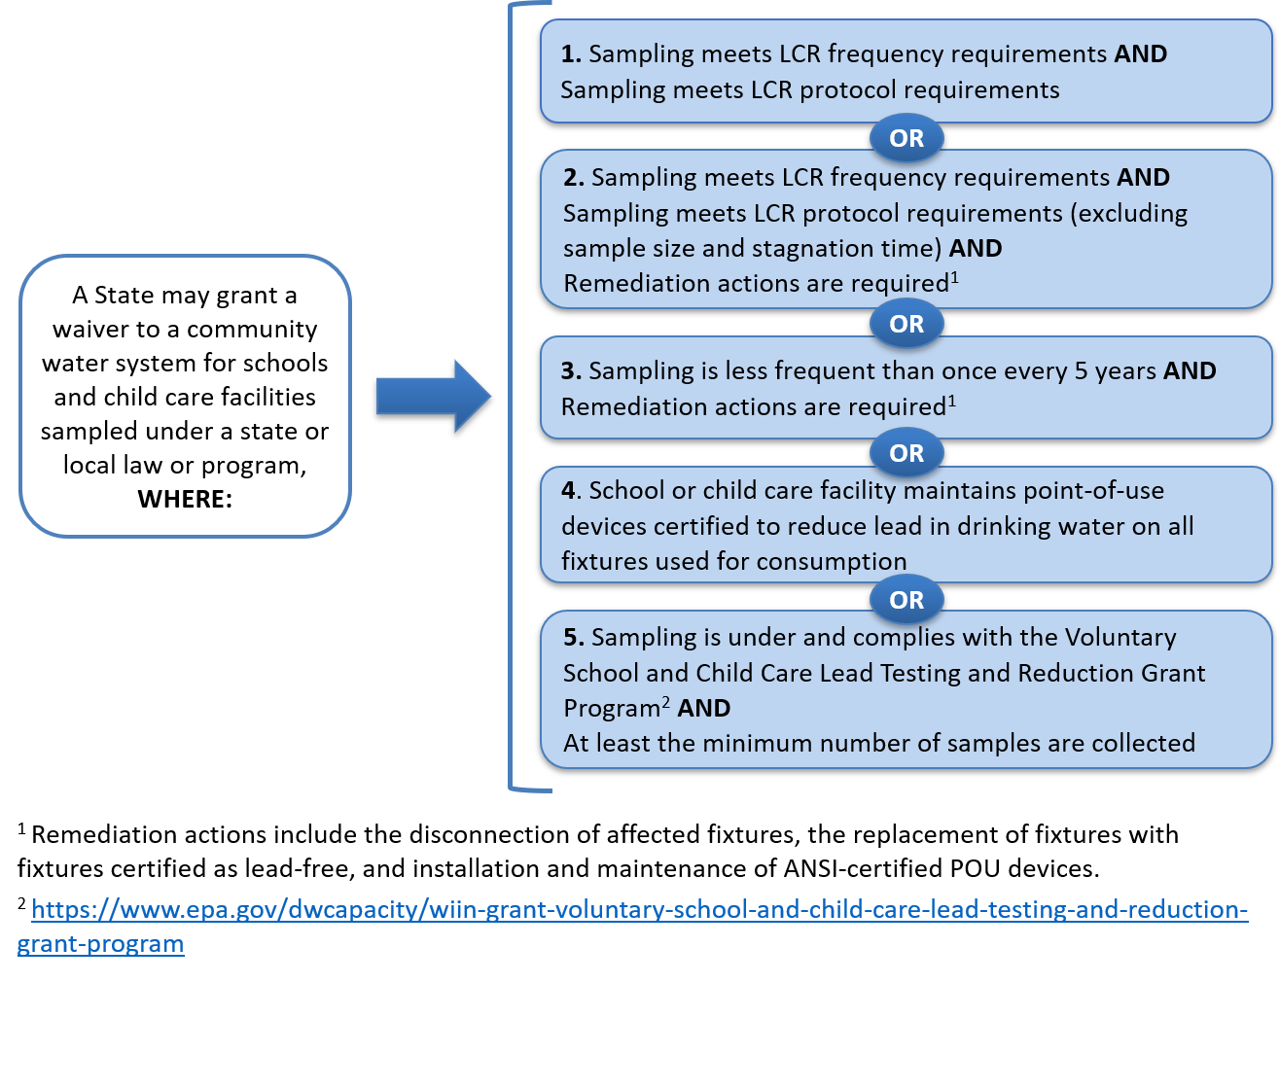
The U.S. Environmental Protection Agency (EPA) is committed to ensuring that all Americans can rely on clean and safe water, including by reducing exposure to lead in drinking water. In 2021 and 2024, the EPA revised the Lead and Copper Rule (LCR). One component of these revisions established the first ever requirements for sampling drinking water in schools and licensed child care facilities. Under the LCR, a community water system must take drinking water samples and provide outreach materials to the schools and child care facilities that they serve (Title 40 Code of Federal Regulations § 141.92, 40 CFR 141.92). However, if the drinking water at these schools and child care facilities is sampled for lead under a state or local law or program, the State may exempt the community water system(s) from redundant federal requirements by issuing a written waiver. Water systems receiving such a waiver must meet certain eligibility conditions described in the regulation. Figure 1 shown on this page summarizes these eligibility conditions according to 40 CFR 141.92(h)(1).
Figure 1. Summary of Waiver Eligibility Conditions in 141.92(h)(1)(i)-(v)
¹ Remediation actions include the disconnection of affected fixtures, the replacement of fixtures with fixtures certified as lead-free, and installation and maintenance of ANSI-certified point-of-use devices.
² https://www.epa.gov/dwcapacity/wiin-grant-voluntary-school-and-child-care-lead-testing-and-reduction-grant-program

A State’s primacy program revision application must describe how the State will determine whether any existing State or local testing program for schools and child care facilities is at least as protective as the federal requirements, including how the State will use the definitions of elementary school, secondary school, and child care facility as defined in 40 CFR 141.2 to issue waivers. [40 CFR 142.16(d)(13)].

This document provides two checklists that can assist States that choose to exempt one or more community water systems from redundant federal requirements based on state or local requirements. The first checklist provides a summary description of the five waiver conditions. The second checklist provides detailed requirements for each condition.

Federal Waiver Checklist for State or Local Laws or Programs for Drinking Water at Schools and Child Care Facilities
This checklist is designed to aid States that choose to evaluate alternative school and child care lead sampling laws or programs according to LCR waiver eligibility requirements described in 40 CFR 141.92(h). Note, the LCR does not require a State to issue sampling waivers if the applicable criteria are met; rather this checklist is a tool a State can use to help in the decision-making process if the State chooses to implement the waiver authority.
Only one eligibility condition must be met for waiver eligibility (See 40 CFR 141.92(h)(1)). If one of the conditions that includes remediation is selected, at least one remediation activity from the three identified in Checklist Element 4 in the following section must also be conducted for waiver eligibility (See 40 CFR 141.92(h)(1)(ii) and (iii),).
The EPA recommends that States track additional information and resources that describe the State or local law or program. This could include the names of schools and/or child care facilities in community water systems that have completed or will complete sampling under this alternative program.
Rule Citation  40 CFR 141.92 | Waiver conditions for alternative school and child care facility lead sampling programs | Check
(h)(1)(i) | 1 - Sampling Frequency + Sampling Protocol: State or local sampling program meets sampling frequency and protocol requirements for schools and child care facilities. | ☐
(h)(1)(ii) | 2 - Sampling Frequency + Modified Protocol + Remediation: State or local sampling program meets LCR sampling frequency requirements, sampling protocol for schools and child care facilities (except for sample size and stagnation time) and requires one of the remediation actions in the rule. Checklist Element 4 below includes boxes to select which remediation action(s) is/are part of the program. | ☐
(h)(1)(iii) | 3 - Sampling Protocol + Remediation: State or local sampling program frequency is less than once every 5 years and requires one of the remediation actions in the rule. Checklist Element 4 includes boxes to select which remediation action(s) is/are part of this program. . | ☐
(h)(1)(iv) | 4 – Point-of-Use (POU) Devices: The schools or child care facilities maintain point-of-use devices as defined in 40 CFR 141.2 on all outlets (e.g., faucets or drinking fountains) used to provide water for human consumption (e.g., drinking and cooking). | ☐
(h)(1)(v) | 5 – Voluntary School and Child Care Lead Testing and Reduction Grant Program: Sampling is conducted under a grant awarded under section 1464(d) of the Safe Drinking Water Act (SDWA), consistent with the requirements of the grant, and the minimum number of samples required in 141.92(f), or more, are collected. | ☐

Checklist to Review CWS Waiver Requests
This second checklist is designed to aid States evaluate waivers for individual community water systems (CWSs) that may meet the adopted State or local equivalent of the requirements described in 40 CFR 141.92(h). The EPA recommends identifying the time period that sampling was conducted and specifying a duration for the waiver. Sampling conducted prior to 1/1/2021 is not eligible for a sampling waiver [40 CFR 141.92(h)(5)].
This checklist contains elements of each of the five waiver conditions, broken out into:
Element 1 – Sampling Frequency
Element 2 – Sample Numbers and Locations
Element 3 – Sample Collection Protocol
Element 4 – Remediation Actions
Rule Citation 40 CFR 141.92 | Checklist Element 1 - Sampling Frequency | Check
(d)(1) & (h)(5) | - For waivers for sampling requirements at elementary schools and child care facilities within the first five years after the LCR compliance date on 11/1/2027, the alternative sampling was or will be conducted:  ☐ 1/1/2021 through 11/1/2027; and/or  ☐ 11/1/2027 through 10/31/2032. | ☐
(d)(1) | - For a waiver covering all elementary schools, 20 percent of the total elementary schools served were or will be sampled each year, such that all elementary schools are sampled at least once in a five-year period. | ☐
(d)(1) | - For a waiver covering all child care facilities, 20 percent of total child care facilities served were or will be sampled each year, such that all child care facilities are sampled at least once in a five-year period. | ☐
(d)(1) | - All facilities were or will be sampled at least once between 11/1/2021 and 11/1/2032 (for a waiver for an individual or a subset of facilities). Note, this requires State approval for alternative schedule. | ☐
(d)(2) | - For waivers for sampling requirements at elementary schools and child care facilities starting 11/1/2032, the alternative sampling must at least be upon request by the individual facility. Note, CWSs are not required to sample more than 20 percent of these facilities each year, and not more than once per facility in any five-year period. | ☐
(e) | - For waivers to sample at secondary schools, the alternative sampling must at least be upon request by the individual facility. Note, CWSs are not required to sample more than 20% of these facilities each year. | ☐

Rule Citation  40 CFR 141.92 | Checklist Element 2  Sample Numbers and Locations | Check
Samples must be collected according to one or more of the following:
(f)(1)(i) | - At least 5 samples at schools from the following locations without point-of-use devices* installed:  - 2 drinking water fountains,  - 1 kitchen faucet used for drinking or cooking,  - 1 classroom faucet or other faucet used to provide water for human consumption, and  - 1 nurse’s office faucet, as available. | ☐
(f)(1)(ii) | - At least 2 samples from child care facilities at the following locations without point-of-use devices installed:  - 1 drinking water fountain, and  - 1 kitchen faucet used for cooking or drinking, or other faucet used to provide water for human consumption. | ☐
(f)(1)(iii) | - From all outlets (e.g., faucets and drinking fountains) used to provide water for human consumption (e.g., drinking or cooking)* if the school or child care facility has fewer than the minimum number of required outlets. | ☐
(f)(1)(v) | - From another type of outlet that is used to provide water for human consumption to meet the required number of samples if the school or child care facility does not have the required types of faucet, fountain, or fixture. | ☐
(f)(1)(iv) | *If the facility has point-of-use devices on every faucet, fountain, and fixture typically used to provide water for human consumption, they may sample these outlets. A point-of-use device is a water treatment device physically installed or connected to a single fixture, outlet, or tap to reduce or remove contaminants in drinking water [40 CFR 141.92(f)(1)(iv)]. | ☐

Rule Citation  40 CFR 141.92 | Checklist Element 3  Sample Collection Protocol | Check
Samples collected must be:
(f)(2)(i) | - 1st draw from cold water faucets. | ☐
(f)(2)(ii) | - 250 mL in volume. | ☐
(f)(2)(iii) | - collected after water has been stagnant for 8-18 hours. | ☐
(f)(2)(iv) | - analyzed using acidification and the corresponding EPA analytical methods. | ☐
(f)(3) | - collected by CWS, school or child care facility staff; or other trained personnel. | ☐

Rule Citation  40 CFR 141.92 | Checklist Element 4 – Remediation Actions | Check
(h)(1)(ii)(A) | - Disconnect affected fixtures. | ☐
(h)(1)(ii)(B) | - Replace affected fixtures with fixtures certified as lead free. | ☐
(h)(1)(ii)(C) | - Install and maintain point-of-use devices certified by an American National Standards Institute accredited certifier to reduce lead levels. | ☐

Waiver Condition #1 – Sampling Frequency and Protocol (40 CFR 141.92(h)(1)(i))
To meet waiver condition #1, the alternative sampling must meet sampling frequency and protocol requirements for schools and child care facilities.
Element 1 – Sampling Frequency: For full or partial waivers for schools and child care facility sampling during the first five years after the LCR compliance date (11/1/2027), check item 1 and either one or more of items 2 through 4. For full or partial waivers for schools and child care facilities beginning five years after the compliance date (11/1/2032), check only item 5, since the frequency of sampling is upon request by individual facilities. For a waiver to sample secondary schools upon request, check only item 6.
Element 2 – Sample Numbers and Locations: Check at least one of items 7 through 10 for waiver eligibility.
Element 3 – Sample Collection Protocol: Check all items in items 11 through 15 for waiver eligibility.

Waiver Condition #2 – Sampling Frequency, Modified Protocol and Remediation (40 CFR 141.92(h)(1)(ii))
To meet waiver condition #2, the alternative sampling must meet sampling frequency requirements, protocol requirements with the exception of sample size and stagnation time, and include one or more remediation actions.
Element 1 – Sampling Frequency: For full or partial waivers for schools and child care facility sampling during the first five years after the LCR compliance date (11/1/2027), check item 1 and either one or more of items 2 through 4. For full or partial waivers for schools and child care facilities beginning five years after the compliance date (11/1/2032), check only item 5, since the frequency of sampling is upon request by individual facilities. For a waiver to sample secondary schools upon request, check only item 6.
Element 2 – Sample Numbers and Locations: Check at least one of items 7 through 10 waiver eligibility.
Element 3 – Sample Collection Protocol: Check items 11, 14, and 15.
Element 4 – Remediation Actions: Check one or more of items 16, 17 and/or 18.

Waiver Condition #3 – Sampling Protocol and Remediation (40 CFR 141.92(h)(1)(ii))
If the sampling is conducted in schools and child care facilities served by the community water system less frequently than once every five years, at least one of the actions to remediate lead in drinking water must be conducted in addition to the sampling.
Element 1 – Sampling Frequency: For full or partial waivers for schools and child care facility sampling during the first five years after the LCR compliance date 11/1/2027, check item 1. For full or partial waivers for schools and child care facilities beginning five years after the compliance date (11/1/2032), check item 5. For a waiver to sample secondary schools upon request, check item 6.
Element 2 – Sample Numbers and Locations: Check at least one of items 7 through 10 waiver eligibility.
Element 3 – Sample Collection Protocol: Check all items in items 11 through 15.
Element 4 – Remediation Actions: Check one or more of items 16, 17 and/or 18.

Waiver Condition #4 – Point-of-Use Devices (40 CFR 141.92(h)(1)(iv))
If the school or child care facility maintains point-of-use devices on all outlets used to provide water for human consumption (e.g., drinking or cooking), they could be eligible for a waiver under waiver condition #4.
Element 4 – Remediation Actions: Check item 18.

Waiver Condition #5 – Voluntary school and child care program lead testing and reduction grant program (40 CFR 141.92(h)(1)(v))
To meet waiver condition #5, the sampling must be conducted under a grant awarded under section 1464(d) of the Safe Drinking Water Act (SDWA). The sampling must also be consistent with the requirements of the grant (e.g., using EPA’s 3Ts sampling protocols in Lead Sample Collection Field Guide for Schools and Child Care Facilities or more stringent state regulations or guidance) and at least the minimum number of samples collected.
Element 2 – Sample Numbers and Locations: Check at least one of items 7 through 10 for waiver eligibility.
For more information on EPA’s grant program under section 1464(d) of SDWA, please visit Voluntary School and Child Care Lead Testing and Reduction and Grant Program.

Disclaimer: This document includes descriptions of statutory and regulatory requirements applicable to public water systems and States. This document is not a regulation itself, nor does it change or substitute for those provisions and regulations. Thus, it does not impose legally binding requirements on EPA, States, or the regulated community, and may not apply to a particular situation based upon the circumstances. Although the EPA has made every effort to ensure the accuracy of this document, the applicable legally binding requirements are determined by statutes and regulations. In the event of a conflict between the content of this document and any applicable statute or regulation, this document would not be controlling.

“State” means the agency of the state, territory, or Tribal government which has authority over public water systems. During any period when a state, territorial, or Tribal government does not have primary enforcement responsibility per section 1413 of the Act, the term “State” means the Regional Administrator, U.S. Environmental Protection Agency.
See 40 CFR 141.92(h).
See definitions in 40 CFR 141.2 and eligibility criteria in 40 CFR 141.92(a). Under LCR, the State can only issue a waiver for the subset of the schools or child care facilities served by the system that meet those requirements and are designated under 40 CFR 141.92(b) (40 CFR 141.92(h)(3)).
As defined in 40 CFR 141.2, a point-of-use device is a water treatment device physically installed or connected to a single fixture, outlet, or tap to reduce or remove contaminants in drinking water. It must be certified by an American National Standards Institute accredited certifier to reduce lead in drinking water.
EPA approved analytical methods per 40 CFR 141.89 and 40 CFR 141.23(k)(1).

